

**Infocomm Sales and Marketing**

Year 2/3 (2024), Semester 3/5

**SCHOOL OF INFOCOMM TECHNOLOGY**

Diploma in Information Technology

Diploma in Data Science

**Assignment II**

|  |  |  |
| --- | --- | --- |
| **Deadline:** | **Report and Slides Softcopy & Report Hardcopy** | **By 7 Aug 2024 @ 2359 hrs** |

|  |  |
| --- | --- |
| **Tutor:** | Mr Leonard Lee |
| **Tutorial Group:** | T02 |
| **Student Name:** | Ang Wei Xuan Senderos (S10257398D)  Tan Jun Yu Zavier (S10255651D)  Muhammad Aleem S/O Al Mohamed Alli (S10255778D)  Muhammad Afiq Alias (S10262556H) |

**Penalty for late submission:**

* 10% of the marks will be deducted for everyday (inclusive of Saturdays, Sundays, and Public Holidays) after the deadline.
* **NO** submission will be accepted after 7th August 2024 @ 1700hrs

**Table of Contents**

**1. Background of Snap Inc.** 6

**2. Michael Porter’s 5 Force Analysis** 8

**2.1 Threat of New Entrants (Moderate Risk)** 8

**2.2 Buyer’s Power (High Risk)** 9

**2.3 Supplier Power (Low-Moderate Risk)** 10

**2.4 Threat of Substitutes (High Risk)** 10

**2.5 Competitive (High Risk)** 11

**3. Industry Segmentation Analysis** 12

**3.1 Demographics Segmentation** 12

**3.1.1 Age Groups** 12

**3.1.2 Gender** 13

**3.1.3 Income** 15

**3.2 Geographic Segmentation** 16

**3.2.1 Regional Use** 16

**3.2.2 Country Specific Platforms** 17

**3.3 Behavioral Segmentation** 17

**3.3.1 Usage Patterns** 17

**3.3.2 Content Interaction** 17

**3.4 Psychographic Segmentation** 18

**3.4.1 Interests & Lifestyles** 18

**4. Industry Life Cycle** 19

**4.1 Demand** 19

**4.2 Costs** 20

**4.3 Revenue & Profits** 20

**4.4 Distribution Channels** 20

**4.5 Products** 20

**5. Snap Inc. Management Orientation** 21

**5.1 Marketing Concept** 21

**5.2 Societal Marketing** 21

**6. Snap Inc. Value Chain Analysis** 22

**6.1 Inbound Logistics** 22

**6.2 Operations** 23

**6.2.1 User Experience & Interface Design** 23

**6.2.2 Technical Infrastructure** 23

**6.2.3 Product Development & Maintenance** 24

**6.3 Outbound Logistics** 24

**6.3.1 Content Distribution** 24

**6.3.2 App Store Distribution** 24

**6.4 Marketing & Sales** 25

**6.4.1 Advertising Solutions** 25

**6.4.2 Brand Collaborations** 25

**6.4.3 Pricing Models** 25

**6.5 Services** 25

**6.5.1 Snapchat App** 25

**6.5.2 Customer Support** 26

**7. Snap Inc. Generic Strategy** 27

**7.1 Snap Inc’s Cost Structure** 27

**7.2 Snap Inc’s Market Scope** 27

**8. Snap Inc. SWOT Analysis** 28

**8.1 Strength** 28

**8.1.1 Strong Brand Recognition** 28

**8.1.2 Innovative Products** 29

**8.1.3 Expansive Partner Ecosystem** 30

**8.2 Weaknesses** 30

**8.2.1 Heavy Reliance on Advertising Revenue** 30

**8.2.2 Privacy concerns & data security issues** 30

**8.2.3 Historical Operating Losses** 31

**8.3 Opportunities** 31

**8.3.1 Increasing Adoption of Social Media Apps** 31

**8.3.2 Expansion into established markets** 31

**8.3.3 Partnerships with brands & content creators** 32

**8.3.4 Rise of e-commerce** 32

**8.4 Threat** 33

**8.4.1 Intense Competition** 33

**8.4.2 Regulatory Changes** 33

**8.4.3 Economic Downturns** 33

**8.4.4 Potential Future Cyberattacks** 33

**9. Snap Inc. BCG Matrix** 34

**9.1 Low Market Share** 34

**9.2 High Industry Growth** 34

**10. Snap Inc. Product Life Cycle** 35

**11. Snap Inc. Marketing Segmentation & Mix** 36

**11.1 Product** 36

**11.1.1 Core Products** 36

**11.1.2 Actual Products** 37

**11.1.3 Differentiation** 39

**11.2 Pricing** 41

**11.2.1 Freemium Model** 41

**11.2.2 Premium Features** 41

**11.3 Place** 41

**11.3.1 Indirect Distribution** 41

**11.4 Promotions** 42

**11.4.1 Aleem’s Individual Report** 43

**11.4.1.1 Introduction** 43

**11.4.1.2 Getting to know the app** 43

**11.4.1.3 Link to Application** 43

**11.4.1.4 Design Mocks of the Application** 44

**11.4.1.5 Application Feedback** 50

**11.4.1.6 Concept and Rationale** 51

**11.4.1.7 Reflection** 52

**11.4.1.8 Comparison with other AI Tools** 53

**11.4.1.9 Cross Referencing Info and Having Critical Thinking Skills** 56

**11.4.1.10 Sign off** 57

**11.4.1.11 References** 57

**11.4.2 Afiq’s Individual Report** 58

**11.4.2.1 Overview** 58

**11.4.2.2 Concept & Design of App** 58

**11.4.2.3 Rationale** 61

**11.4.2.4 App Feedback** 61

**11.4.2.5 Reflection** 62

**11.4.2.6 Conclusion** 64

**11.4.3 Senderos’s Individual Report** 65

**11.4.3.1 SnapContent Creator: Personalized Social Media Content Designer** 65

**11.4.3.2 Reflection on Using PartyRock as a GenAI Tool for SnapContent Creator** 66

**11.4.3.3 Rationale & Concept for SnapContent Creator** 67

**11.4.3.4 Marketing Concepts Implemented from ISM** 68

**11.4.3.5 Comparison with other GenAI Tools** 70

**11.4.3.6 Reflection on using GenAI for Group Report** 72

**11.4.3.7 Conclusion** 77

**11.4.3.8 Citation & References** 77

**11.4.4 Zavier’s Individual Report** 78

**11.4.4.1 Introduction** 78

**11.4.4.2 Preview** 78

**11.4.4.3 Objective** 78

**11.4.4.4 App Development using PartyRock** 79

**11.4.4.5 Promotional Technique** 81

**11.4.4.6 Rationale & Purpose for Snap4Biz** 81

**11.4.4.7 Reflection on Using PartyRock as a GenAI Tool** 83

**11.4.4.8 Comparison with other GenAI Tool** 83

**11.4.4.9 Feedback** 86

**11.4.4.10 Reflection on using GenAI Tools for Group Report** 88

**11.4.4.11 Personal Reflection** 92

**12. Reflection** 95

**12.1 Is the marketing strategy adopted appropriate for the industry it is competing in?** 95

**12.2 Is the marketing mix adopted by the company well suited to its marketing strategy?** 95

**12.3 What is the value proposition to the target market segments? Is this a valid value proposition?** 95

**13. Recommendations** 96

**13.1 Expanding into E-commerce & Digital Services** 96

**13.2 Data Privacy & Security** 97

**14. Summary** 98

**15. Citations & References** 99

# **1. Background of Snap Inc.**



**2011**

Snapchat Inc. was founded by Evan Spiegel, Bobby Murphy, and Reggie Brown, who were former students from Stanford University. On the same year, they launched Snapchat as ‘Picaboo’ on the iOS operating system on July 8, renaming it to what is now known as Snapchat in September.

**2014**

Multiple large funding rounds took place for Snapchat, examples include its Series D, Series E and Series F funding rounds. Snapchat also aggressively improved the product, with changes such as the introduction of stickers, and new monetization strategies. Its growth in terms of daily video views was high, from 2 billion in May to 6 billion in November.

**2016**

Snapchat Inc. rebranded itself to Snap Inc and revealed its new product, Spectacles, which are smart glasses dedicated to recording video for the Snapchat service.

**2021**

Spectacles 4 is Snap Inc.'s first AR-based product, introduced in May 2021. The glasses feature AR effects called Lenses, dual 3D waveguide displays, and run on the Qualcomm Snapdragon XR1 chip. They include RGB cameras, microphones, and speakers. Over 250,000 Lens creators have produced 2.5 million Lenses for Spectacles 4, which support various AR experiences.

[](https://www.youtube.com/embed/pDZ4Li5hFao?feature=oembed)

# **2. Michael Porter’s 5 Force Analysis**

Porter's Five Forces is a model that identifies and analyzes five competitive forces that shape every industry and helps determine an industry's weaknesses and strengths. Five Forces analysis is frequently used to identify an industry's structure to determine corporate strategy. Porter's model can be applied to any segment of the economy to understand the level of competition within the industry and enhance a company's long-term profitability.

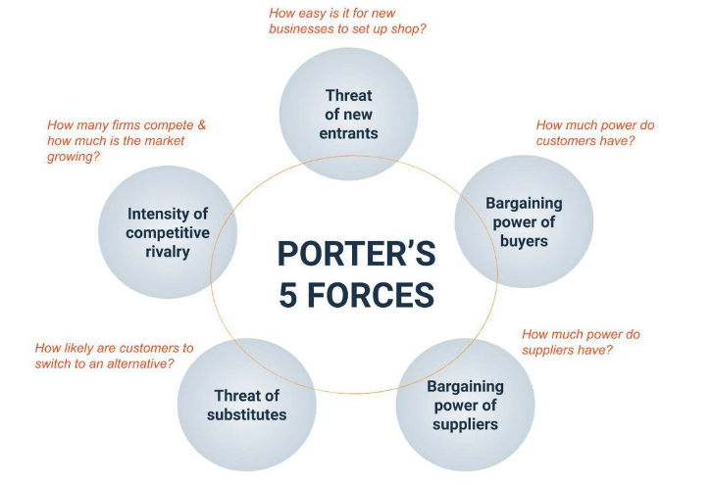

## **2.1 Threat of New Entrants (Moderate Risk)**

The social media industry faces a moderate threat from new entrants due to several factors. Technological advancements have lowered entry barriers, allowing the creation of new applications and websites with relative ease and low cost. For instance, according to an article by Exploding Topics (July 1, 2024), dozens of new social media networks emerged in 2024, adding creativity and diversity to the industry. A notable example is Airchat, a social media app launched in 2024 that focuses on push-to-talk, voice-first messaging, differing from traditional text-based platforms like Twitter or Instagram. Airchat's innovative approach, which includes transcribing voice messages into text using AI, has quickly gained popularity, amassing over 50,000 users within less than a year and achieving a 5-year search growth of 300%, indicating a strong annual compounded growth rate of revenues. Innovations like Airchat increase the threat level in the social media industry.

However, despite these low entry barriers, new entrants face significant challenges in gaining substantial market share due to high marketing costs and the entrenched position of established platforms. Gaining significant market share requires substantial marketing efforts and investment, which can be prohibitive for new entrants. Established companies like Instagram mitigate the threat by continuously innovating upon their existing platforms. On August 5, 2020, Instagram released Reels, a feature that allows users to create and share short, entertaining videos up to 15 seconds long, competing directly with TikTok. Reels has proven successful, consistently surpassing other content types in terms of reach and impressions (February 2024, Sprout Social). This ongoing enhancement in user experience by established companies further lowers the threat level, as new entrants must deliver significantly better innovations to attract users.

Additionally, established platforms benefit from strong brand loyalty and network effects, where the value of the platform increases with the number of users. Platforms like Facebook, Instagram, and Twitter have built substantial user bases, creating a significant challenge for new entrants to attract users away from these established networks.

In summary, while the ease of entry and innovation by new players like Airchat increases the threat of new entrants, high marketing costs, strong brand loyalty, and continuous innovation by established platforms lower this threat.

## **2.2 Buyer’s Power (High Risk)**

Consumers have numerous choices in the social media industry, there are many substitutes for platforms other than Instagram. Examples include Facebook, TikTok and Twitter. Only 0.2% of Instagram users are unique to the platform. A very large number of users use it alongside other social media platforms like Facebook (80.8%), YouTube (77.4%) and TikTok (52.8%) (February 2024, Sprout Social)​. That means that consumers have very low switching costs with minimal effort. Indicating that continuous innovations and solid marketing strategies is crucial for user retention. Hence, the high buyer power in the social media industry necessitates that companies remain responsive to user preferences to stay relevant.

Advertisers, who generate substantial revenue for social media companies, also hold significant leverage. They can choose among various platforms to place their ads, giving them considerable bargaining power. This is especially true if a platform increases its advertising rates or fails to deliver the desired engagement metrics. For example, advertisers may shift their budgets from Instagram to TikTok if TikTok offers better engagement and advertising outcomes at competitive prices. Hence, social media companies must balance user satisfaction with advertiser needs, ensuring effective advertisement performance while continuously innovating to keep their platforms attractive to both users and advertisers.

## **2.3 Supplier Power (Low-Moderate Risk)**

Social media companies rely on various suppliers for key resources such as data storage, software, and server infrastructure. Due to the exponential evolution of information technology, there are an abundance of suppliers for these resources which reduces the bargaining power of any single supplier. This dynamic creates a competitive environment among suppliers, leading to better pricing and terms for social media companies. For example, firstly cloud service providers. Major social media platforms like Instagram use cloud services from multiple providers such as Amazon Web Services (AWS), Google Cloud, and Microsoft Azure. The competition among these providers ensures that Instagram can negotiate favourable terms and switch providers if necessary, reducing dependency on any single supplier. Secondly, server infrastructure. The physical infrastructure for servers is another critical resource. Companies like Dell, HP, and Cisco compete to provide the hardware required by social media platforms. This competition ensures that companies like Instagram get the best possible deals on their server infrastructure needs.

Additionally, established companies have significant negotiating power due to their high demand for these resources, enabling them to secure favourable terms. Companies providing these services aim to retain them as repeat customers. For example, Instagram, being a large player, can negotiate better deals with cloud service providers like AWS or Google Cloud due to its substantial and consistent demand for data storage and computing power.

## **2.4 Threat of Substitutes (High Risk)**

The threat of substitutes for Instagram is high due to several factors. Firstly, the switching costs for users are very low since most social media services are free to access. This makes it easy for users to migrate to other apps without incurring any financial costs. Additionally, there is a high availability of substitutes, including major platforms like TikTok, Twitter (X), and Snapchat, as well as emerging players like Lemon8, Yubo and Airchat. These platforms offer diverse features and user experiences, contributing to a highly competitive social media landscape.

Users are attracted to these alternatives for various reasons, such as unique content formats on TikTok or the privacy features of Telegram. The ease of switching and the multitude of options mean that Instagram must continuously innovate to retain its user base. This high threat of substitutes compels Instagram to enhance its features and user experience to maintain its competitive edge.

Not only that, but there are also non-social media apps competing with social media apps. One example is YouTube Shorts, a feature on YouTube that performs similarly to TikTok and Instagram Reels, providing users with an alternative source of short-video content. This further increases the threat of substitutes as it could potentially divert users’ time away from social media platforms to entertainment platforms.

## **2.5 Competitive (High Risk)**

According to a report by Business Research Insights (April 2024), the global social media market has experienced significant growth, with its size estimated at USD 5,357 million in 2021 and projected to reach USD 34,380.12 million by 2031. This represents an increase of more than six times its original size in less than a decade.  As the market size experiences such growth, there will naturally be more emerging companies that want to get the slice of the pie. Hence, the degree of rivalry among existing competitors in the social media industry is high, with companies constantly trying to come up with innovative ideas to gain an edge over their competitors.

For example, in 2020, ByteDance5 released Lemon8, a social media app described as “a cross between Instagram and Pinterest.” Many new platforms are targeting younger audiences with similar strategies. Therefore, it is critical for companies to continually innovate their products to secure a competitive position. Even established companies with sizable user bases cannot take their dominance for granted, as customers can easily migrate to other platforms.

# **3. Industry Segmentation Analysis**

## **3.1 Demographics Segmentation**

### **3.1.1 Age Groups**

The social media industry serves a broad range of age groups, but it predominantly attracts young adults. For instance, TikTok is mainly used by individuals aged 18-24. In contrast, most Facebook users are in the 31-40 age group as of 2024. Snapchat, on the other hand, has most of its users in the 18-24 age group (Oberlo, n.d.). Based on the demographics as shown for established social media platforms, it is critical for players in the social media market to innovate their product that caters to the needs of young adults to gain a competitive position in the industry.

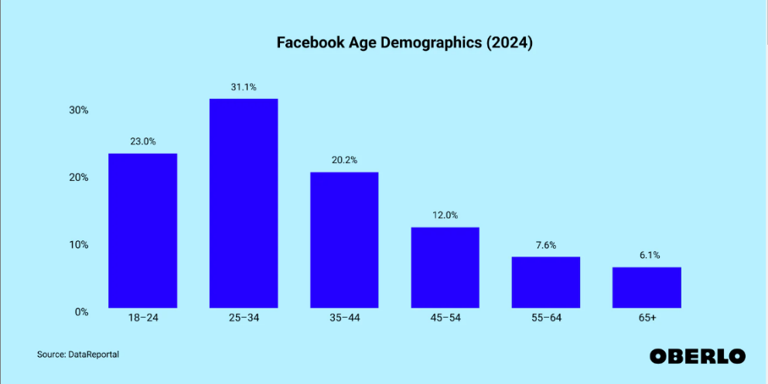

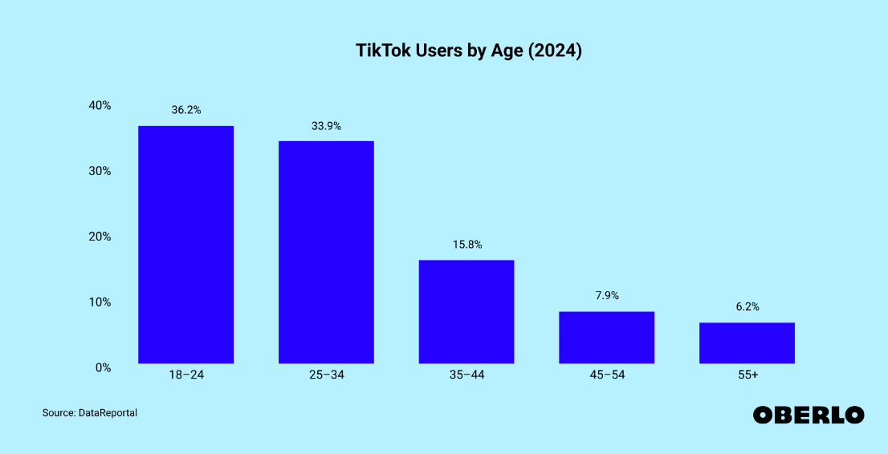

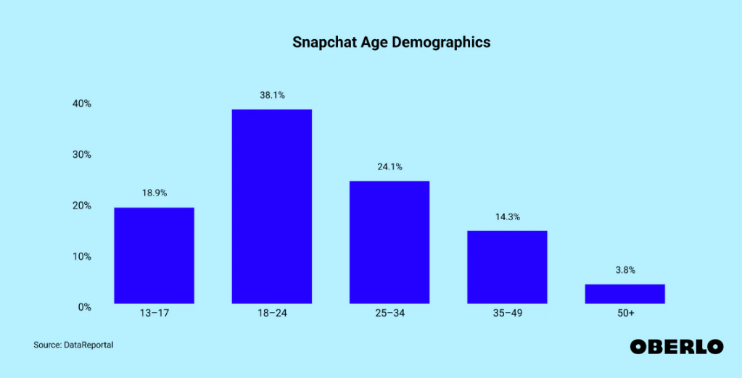

### **3.1.2 Gender**

The gender distribution on social media platforms varies significantly, influencing how brands plan and execute their targeted advertising campaigns. Understanding these demographics is crucial for marketers aiming to reach specific audiences effectively. Instagram has a nearly balanced user base with 50.8% male and 49.2% female users. This balanced gender distribution allows brands to target both male and female audiences equally, making it ideal for brands focusing on aesthetics and lifestyle content. Snapchat also maintains a relatively even gender split with 50% male and 49.1% female users, providing an equal opportunity for brands to engage with both male and female users, particularly appealing to millennials and Gen Z with its interactive features like stories and augmented reality filters.

On the other hand, Pinterest is heavily skewed towards female users, with 69.4% female, 22.6% male, and 8% unspecified. This significant female majority makes Pinterest an ideal platform for brands targeting women, particularly in industries like fashion, beauty, home decor, and food. Conversely, Reddit has a more male-dominated user base, with 62.1% male and 36.8% female users. This male skew is beneficial for brands targeting male audiences, such as those in technology, gaming, and automotive industries. Reddit’s community-based structure allows for deep engagement with niche audiences, where authenticity and relevance are highly valued. Understanding these gender distributions helps brands optimize their social media presence, ensuring their content reaches the right people on the right platforms.

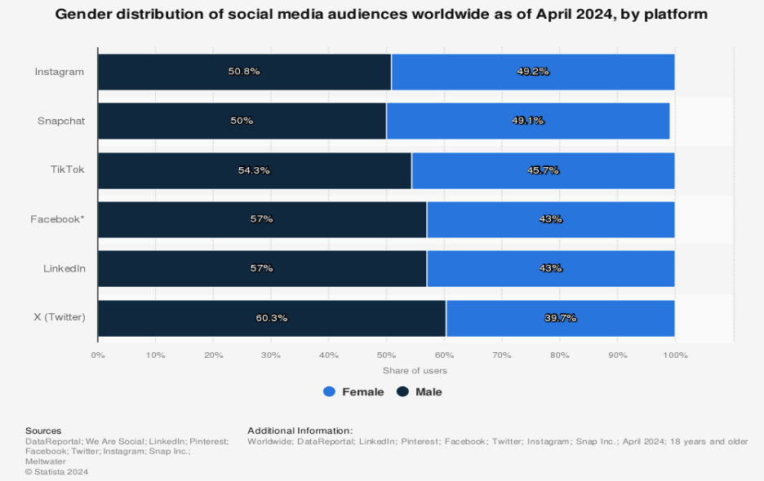

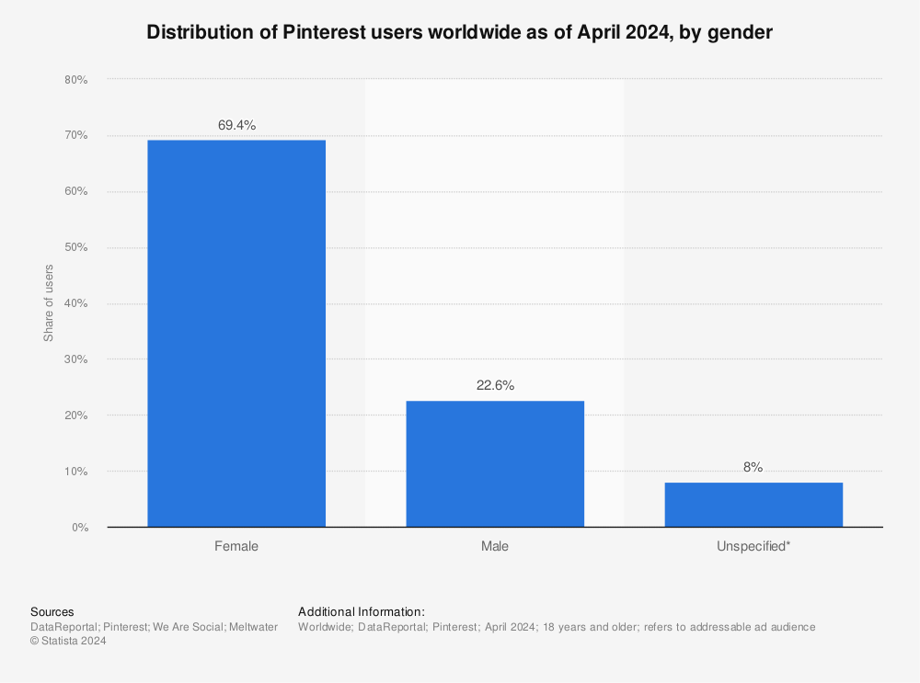

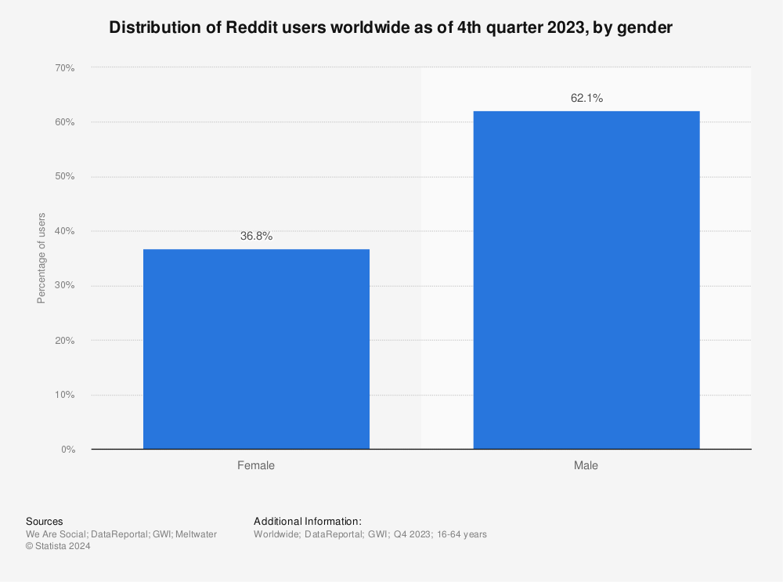

### **3.1.3 Income**

The income levels of social media users vary by platform. The bar chart shows that BeReal has the highest percentage of high-income users in the US. This is followed closely by LinkedIn, which is known for its professional user base. Platforms like Twitter (X) and Instagram have a substantial share of high-income users, while platforms such as Snapchat and TikTok have a more balanced distribution across different income levels. X (formerly Twitter) shows a significant representation of high-income users as well.

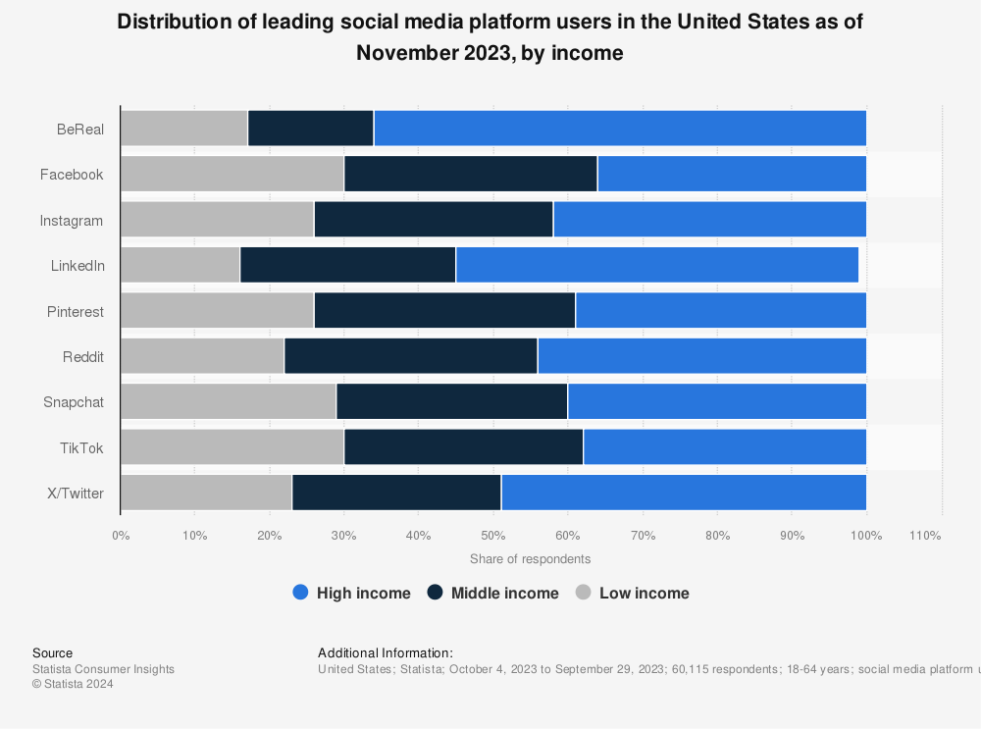

## **3.2 Geographic Segmentation**

### **3.2.1 Regional Use**

The regional use of social media reveals that its highest penetration rates are in areas with high internet accessibility. For instance, Eastern Asia, including countries like China, Japan, and South Korea, has a significant social media presence, accounting for 30.1% of global users and boasting a penetration rate of around 75%​​. Conversely, Middle, East, and West Africa have lower penetration rates at around 10% to 16%, but these regions are poised for rapid growth due to increasing internet access and smartphone adoption​​. This anticipated growth is crucial for social media platforms and marketers looking to tap into emerging markets with expanding digital footprints.

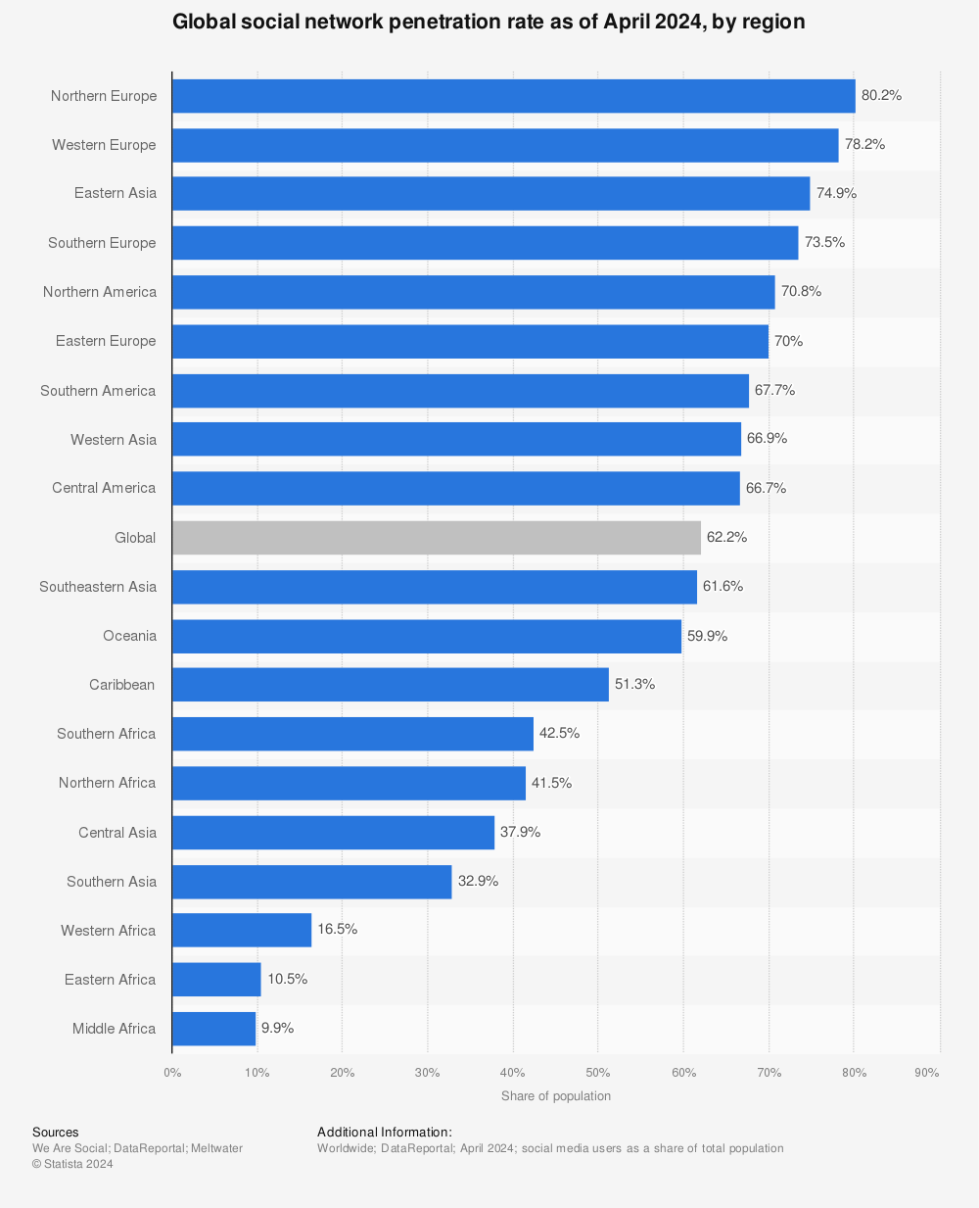

### **3.2.2 Country Specific Platforms**

Different countries have dominant social media platforms. In China, for instance, WeChat and Sina Weibo are more popular due to restrictions on Western platforms like Facebook and Twitter. In contrast, Facebook, Instagram, and YouTube dominate in countries like the USA, India, and many parts of Europe​.

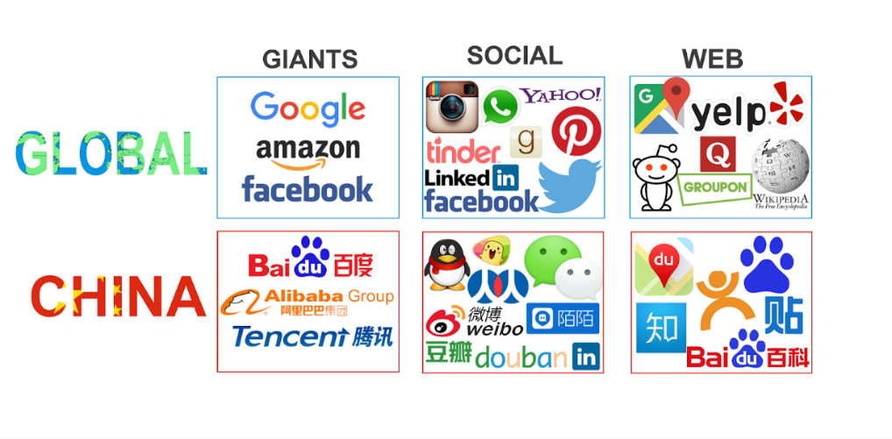

## **3.3 Behavioral Segmentation**

### **3.3.1 Usage Patterns**

Users' engagement with social media varies by platform and content type. For example, the average time a user spends on Instagram is 33 minutes, while for X (formerly known as Twitter), it is 34 minutes. However, platforms like TikTok and YouTube see higher engagement, with average times of 54 minutes and 49 minutes respectively (Sprout Social, February 14, 2024). Hence, it can be observed that the time a user spends on any social media platform should be between 30 minutes to an hour.

### **3.3.2 Content Interaction**

The type of content that users engage with also varies. Instagram users might engage more with stories and reels, while Twitter users focus on real-time news and updates. LinkedIn users are more likely to engage with professional content, such as industry news and job postings.

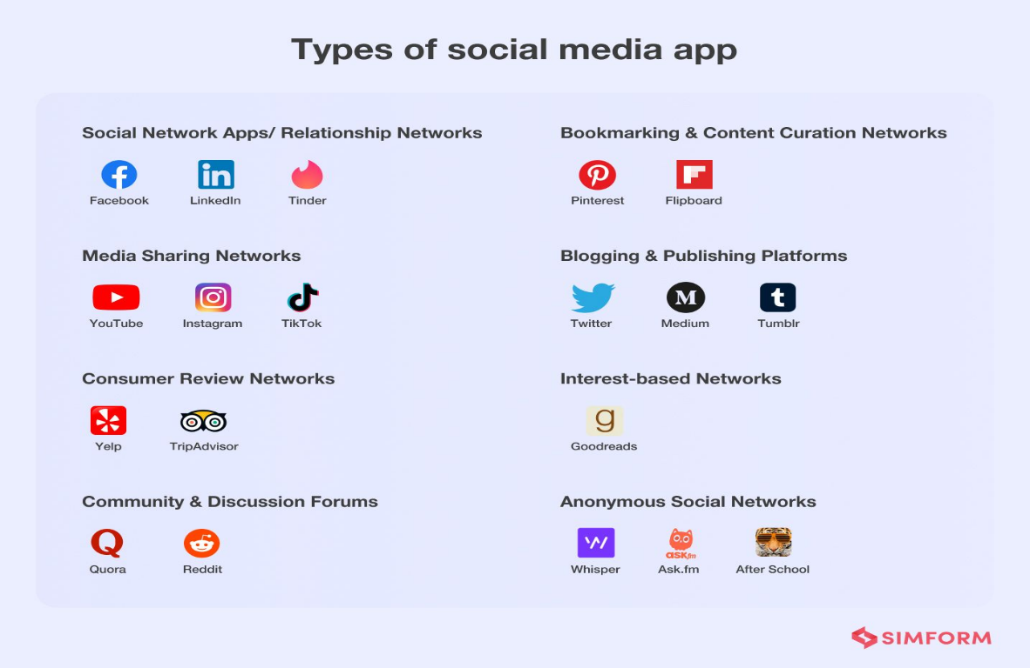

## **3.4 Psychographic Segmentation**

### **3.4.1 Interests & Lifestyles**

Different platforms cater to various interests and lifestyles. Pinterest audience is diverse, catering to different hobbies and passions. The platform is viral among moms, foodies and home decor enthusiasts who seek inspiration and ideas for multiple aspects of their lives. (April 16, 2024, SOCIALCHAMP). LinkedIn appeals to professionals looking to network and advance their careers. TikTok users often seek entertainment and trends, making it suitable for brands targeting lifestyle and entertainment sectors​.

# **4. Industry Life Cycle**

The Industry Life Cycle tool is a useful tool for analyzing the effects of industry evolution on competitive forces is the industry life cycle model, which involves five stages, including embryonic, growth, shakeout, maturity, and decline stages.

The social media industry is currently between the late growth and early maturity stages of its life cycle.

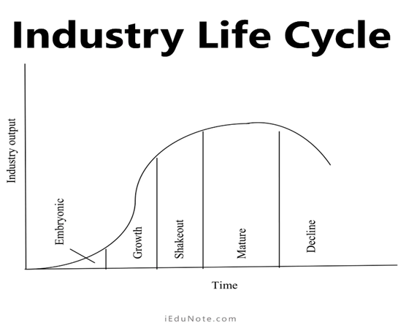

## **4.1 Demand**

The market is saturated with extensive user bases across major platforms, indicating that growth in new users has slowed. For example, Facebook’s user growth averaged 15% from 2013 to 2017 but slowed to 8% from 2018 to 2021, with just 4% growth in 2021. Instagram’s user growth rate is projected to decrease from 6.5% in 2024 to 4.7% in 2025. The focus is now on retaining and engaging existing users through features like Stories, Reels, and Shopping. Only growth will come from population expansion or an increase in replacement demand. For instance, Instagram’s introduction of reels provided a new way for users to consume content on their platform, replacing their old habits of watching static posts or stories with watching reels, thus helping to maintain high levels of engagement within their platform.

## **4.2 Costs**

Productions are cost-efficient as the platforms have optimized their operations over time. The mature stage allows for economies of scale, leading to lower production costs. As mentioned in Supplier’s Power, established social media platforms can negotiate better rates with suppliers for server hosting and data storage. Another example is due to the strong brand reputation established social media platforms possess, it helps to reduce marketing costs per user.

## **4.3 Revenue & Profits**

Despite the market reaching saturation in terms of new user growth, overall revenues in the social media industry continue to increase significantly. As mentioned in Competitive Rivalry, the global social media industry continues to increase rapidly. This growth is driven by the diversification of revenue sources beyond advertising; new monetary strategies adopted by social media companies include leveraging existing user bases for more intensive monetization. For example, Instagram Shopping generates revenue from transaction fees and increased ad spending, while Instagram Subscriptions offer exclusive content to subscribers for a monthly fee.

## **4.4 Distribution Channels**

The distribution channels are well-developed, with established networks and infrastructure supporting user access and engagement. Social media platforms have built robust systems for content distribution, advertising, and e-commerce integrations. One such example is the Instagram shopping platform that is available inside Instagram.

## **4.5 Products**

The products offered by social media platforms are mature, with an optimal number of features designed to serve the current market. Continuous innovations help keep the platforms relevant and engaging. For instance, Meta has integrated advanced AI technologies into Instagram to enhance their algorithm for content recommendations to users. Additionally, Instagram uses Meta’s Spark AR platform to offer interactive AR experiences, keeping the platform innovative and engaging for users who seek a digital experience. (September 17, 2023, PURE PIXEL DESIGNS)

# **5. Snap Inc. Management Orientation**

Marketing orientation is a business philosophy that prioritizes identifying and meeting the needs and wants of customers.

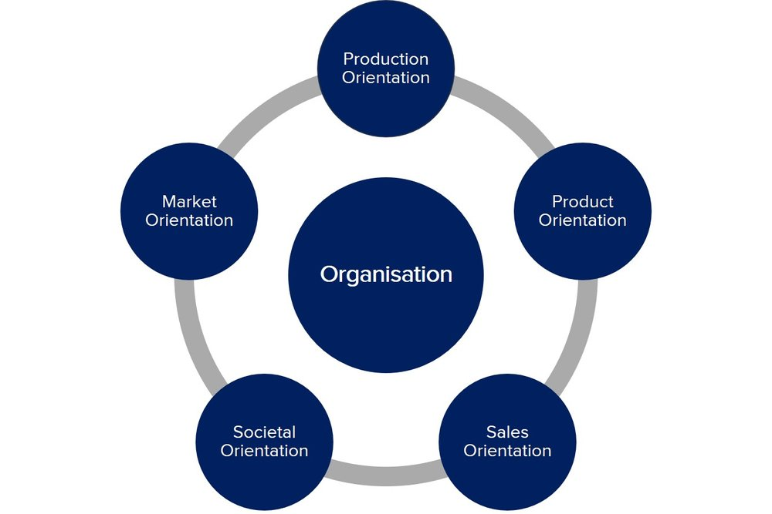

## **5.1 Marketing Concept**

Snap Inc. conducted an extensive market research to understand its user base, On May 13, 2021, Snapchat has made an article, where it stated that Snap commissioned a study from Deloitte Digital, a creative consultancy and talked to more than 15,000 customers from various countries like Japan, India and Germany etc. This has led Snap into understanding its users’ preferences and behaviours. This form of orientation lets Snap to ensure that its product remains relevant and engaging to its audience, thereby maintaining a competitive edge.

This market orientation has led to Snap tailoring its offerings, such as the development of Augmented Reality lenses to enhance user engagement. In 2017, Snap released Lens Studio, an application that empowers people to develop engaging AR experiences on the Snapchat platform.

## **5.2 Societal Marketing**

Snap Inc. has initiatives aimed at promoting social good and mental health awareness. On Snapchat, users can send supportive messages using stickers with texts like “I support you” and “Mental Health Matters” to spread positivity. Additionally, Bitmojis featuring the green ribbon, a symbol of mental health support, are available. Snap Inc. collaborates with industry experts and non-governmental organizations to provide further support. Snapchat’s “Here for You” search tool offers resources (n.d. Snapchat Support).

# **6. Snap Inc. Value Chain Analysis**

The value chain is a business model used to examine all company activities, consisting of Inbound Logistics, Operations, Outbound Logistics, Marketing and Sales and Service.

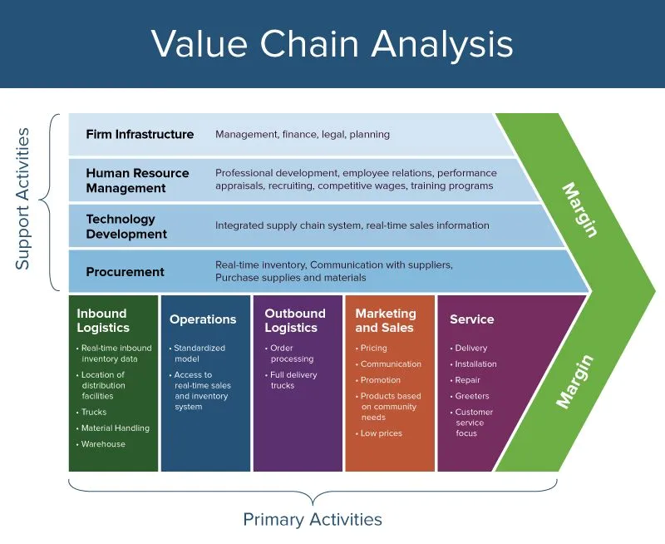

## **6.1 Inbound Logistics**

To develop and maintain the Snapchat application for both Android and iOS, Snap Inc. utilizes several key services and tools. Firstly, they rely on Amazon Web Services (AWS) for hosting, storage, compute power, and other cloud-based services, ensuring the reliability of their platform.

The company employs programmers proficient in various programming languages essential for building the app. For instance, Java, a versatile and widely used language, is integral to Snapchat's tech stack for server-side development. It facilitates efficient handling of complex backend processes such as user authentication, data storage and management, and real-time messaging. Python is also used for backend services.

Additionally, Snap Inc. leverages software development toolkits like the Android Software Development Kit (SDK), which provides the tools necessary for developing applications for the Android platform. For iOS, they use Cocoa Touch, a framework designed for building applications on Apple devices. These resources ensure that Snapchat delivers a seamless and enjoyable experience for users on both operating systems.

## **6.2 Operations**

### **6.2.1 User Experience & Interface Design**

Snap Inc. prioritizes user experience and interface design by having a dedicated team of UX/UX designers focused on enhancing the app usability and engagement. Continuous refinement of the user interface ensures that the app continues to remain intuitive and user-friendly. This process regularly involves regular updates and thorough usability testing to gather feedback from users, which are essential for driving design improvements. By leveraging user research and iterative testing, Snap Inc. effectively aligns its design decisions with user expectations and behaviour patterns. This strategic approach not only enhances the overall user experience but also supports Snapchat's goal of providing a seamless and enjoyable platform for digital interaction and content sharing.

### **6.2.2 Technical Infrastructure**

Snap Inc. relies on a robust technical infrastructure to support the app’s functionality and ensure a smooth user experience. It employs a team of professionals who manage the servers and cloud infrastructure. These experts are responsible for maintaining the scalability of Snapchat’s backend systems, ensuring that the app can handle millions of users simultaneously without the consequence of downtime or performance issues arising for users. This team also focuses on implementing necessary upgrades to keep up with the app’s increasing user base.

Snap Inc. also has a team of cybersecurity engineers that maintain the integrity and confidentiality of patient data, using advanced encryption methods and adhering to data protection laws like the General Data Protection Regulation (GDPR). Additionally, they make use of AI to build algorithms such as Natural Language Processing (NLP) to enhance user experience through personalized content and advertisements.

Additionally, Snap Inc. has a team of Machine Learning Engineers to develop algorithms such that they can filter out any explicit or harmful content. These algorithms work alongside human moderators to detect and review potentially inappropriate content, ensuring users have a safe and comfortable experience on the platform. For example, on Spotlight, a feature in Snapchat where creators can share videos to share with the community, all content is first reviewed automatically by AI before gaining any distribution. Once the content gains more viewership, it is then reviewed by human moderators before it is given the opportunity to reach a larger audience. This approach has reduced the risk of spreading misinformation, hate speech and other potentially harmful content.

Due to all these measures taking place, its product, Snapchat, was ranked as one of the friendliest social environments when compared to other platforms.

### **6.2.3 Product Development & Maintenance**

Snap Inc.’s product development boasts a dedicated team of software engineers who work on the continuous innovation of the Snapchat app. Regular updates are deployed to introduce new features and functionalities, such as Snap Map and Spotlight, ensuring that its app remains engaging and relevant in the social media industry.

## **6.3 Outbound Logistics**

### **6.3.1 Content Distribution**

Snapchat distributes content through different sections of its app, including Stories, Discover, and Spotlight. The Discover section, which showcases high-quality, curated content, benefits quite a lot from partnerships with media organizations. This distribution ensures that content reaches the right audience well.

### **6.3.2 App Store Distribution**

The snapchat app can be found on major app stores like Apple App Store and Google Play Store. These stores act as intermediaries, ensuring the app reaches users and is available for download on various devices. Snapchat was launched on the Apple App store in September 2011, while its android counterpart later became available on the Google Play Store in October 2012. By 2013, Snapchat had become a significant player and has been downloaded over 1 billion times from the Google Play Store alone. Therefore, Snap inc. releasing the app into a major digital app market platform allowed it to reach a wider user base both on the IOS and Android operating system.

## **6.4 Marketing & Sales**

### **6.4.1 Advertising Solutions**

Snapchat has countlessly introduced innovative features and tech where it allows their partners to have access and continue experiencing Snapchat’s digital ad campaigns. Furthermore, the launch of Creator Collab Campaigns facilitates partnerships between brands and influencers, enhancing its advertising appeal. The platform's revenue earned from advertising fees continues to grow, driven by its youthful user base and engaging ad formats.

### **6.4.2 Brand Collaborations**

Snapchat’s partners with agencies and influencers are key to delivering exceptional results for clients and unlocking the utmost potential of Snapchat’s vibrant ecosystem. Many collaborators are thrilled to partner up with Snapchat and Billion Dollar Boy is one example. With greater authenticity, it delivers effective results and hence, collaborators can't wait to work together to create more engaging ads and foster closer brand-power relationships.

### **6.4.3 Pricing Models**

Snap Inc. launched a subscription model on Snapchat called Snapchat+. It offers a premium service on the platform costing $3.99 USD per month or $39.99 USD per year. Subscribers can get exclusive access to features like enhanced story views, and insights about who rewatched their stories. This flexible pricing strategy allows people from diverse economic backgrounds to enjoy premium features without a significant financial burden, broadening accessibility of Snapchat’s premium services.

## **6.5 Services**

### **6.5.1 Snapchat App**

Users can send photos, video and messages to friends via privately or publicly. Their story is visible to their friends for 24 hours. There’s a feature called ‘Discover’, which allows users to view content from publishers, creators, including news and other forms of media. It also has a function known as Snap Map, where it allows users to share their location with friends and see where their friends are on an interactive map. Furthermore, there is a feature called Spotlight, where users can submit short-form videos to share with the community and potentially earn money based on views.

### **6.5.2 Customer Support**

For clients to have a seamless experience with Snapchat, they must provide a ‘Snapchat Support’ that addresses problems such as technical issues, managing content guidelines, and offering guidance on ad placements.

# **7. Snap Inc. Generic Strategy**

A generic strategy refers to the broad approach a company uses to achieve a competitive advantage in its industry. Snap Inc. uses **differentiation** as their generic strategy.

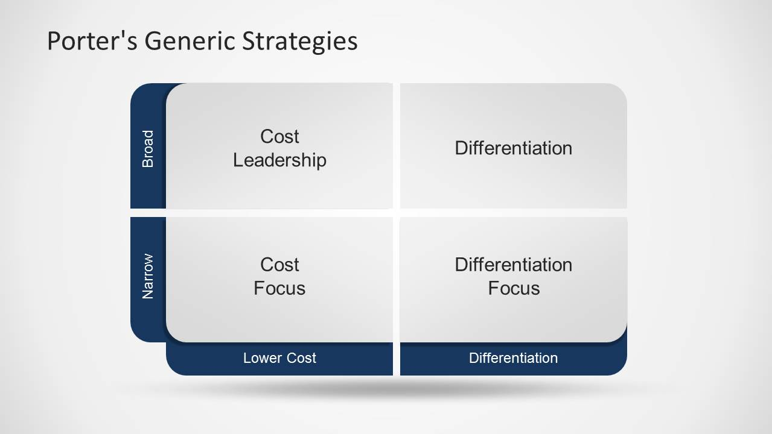

## **7.1 Snap Inc’s Cost Structure**

Snapchat excels in differentiation. It offers unique features like the View-Once function. Users can only view the photo once, once user exits out of viewing, the photo can’t be accessed anymore. Other features such as AR lenses, and Bitmoji integration distinguishes it from other platforms like Facebook and Instagram. Snapchat's continuous innovation in AR technology and creative tools, such as Lenses and Filters, attracts a broad user base looking for engaging and innovative ways to communicate and express themselves​.

## **7.2 Snap Inc’s Market Scope**

Snapchat is accessible to everyone regardless of income levels as the app is free to download and use. This inclusive approach broadens its market reach, ensuring that it appeals to a wide demographic. The availability of Snapchat+ as a premium subscription service adds an optional layer for users who seek enhanced features, thereby catering to diverse user preferences without excluding those who prefer the free version. Not only that, but people of all ages are also welcomed into the platform, there is a myriad of content suitable for both the young and old.

# **8. Snap Inc. SWOT Analysis**

SWOT analysis is a technique for assessing the performance, competition, risk, and potential of a business, as well as part of a business such as a product line or division, an industry, or other entity.

* SWOT analysis is a strategic planning technique that provides assessment tools.
* Identifying core strengths, weaknesses, opportunities, and threats lead to fact-based analysis, fresh perspectives and new ideas.
* Using internal and external data, a SWOT analysis can tell a company where it needs to improve internally, as well as help develop strategic plans.

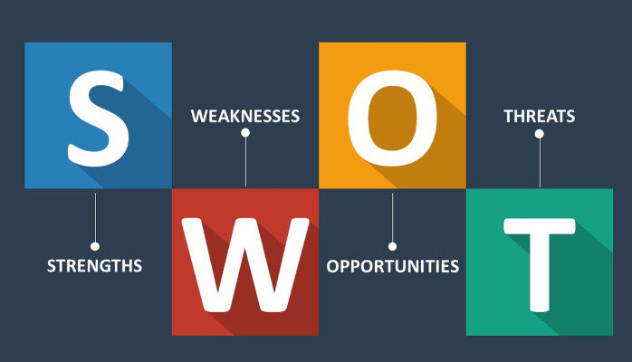

## **8.1 Strength**

### **8.1.1 Strong Brand Recognition**

With over 265 million daily users active, this solidifies their position in the social media world. Due to Snapchat’s unique features such as firstly, their ephemeral messaging, a view-once function and secondly, AR, had played a huge role in highly differentiating themselves from competitors and managed to foster a loyal user base. These innovative features serve as a base for attracting new advertisers.

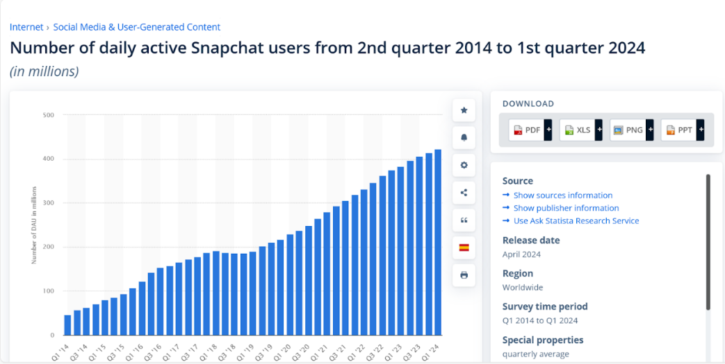

The graph provided is evidence of the strong brand recognition as there is a steady increase over the years in terms of user activity.

### **8.1.2 Innovative Products**

Snapchat’s AR provided an immersive and interactive experience for users where advertisers are then provided with creative ways to engage with their potential customers. The company has a sole objective on advertising technology which is for ad targeting and first-party measurement and solutions. This positions them as a leader in innovative digital advertising.

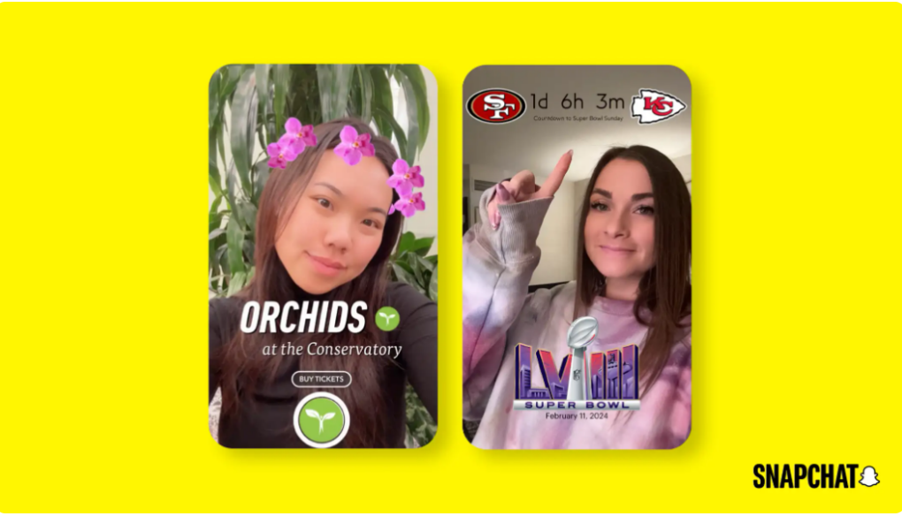

The image provided is an example of Snapchat’s augmented reality filters which was one of their innovative products to appeal to their users and to differentiate themselves from competitors.

### **8.1.3 Expansive Partner Ecosystem**

Snapchat’s ecosystem enhances experience and drives growth in the platform, which includes developers, creators and advertisers. With Snapchat integrating tools such as Creative Kit into third-party apps, while creator marketplace connects creators with advertising partners, this fosters an environment where all stakeholders can benefit.

## **8.2 Weaknesses**

### **8.2.1 Heavy Reliance on Advertising Revenue**

Snap Inc’s revenue is heavily reliant on advertising, making it susceptible to market volatility and changes in advertiser spending. The company’s financial stability is directly tied to its ability to attract and retain advertisers, which is challenged by the privacy and data protection laws, mobile operating system changes, and increasing user resistance to targeted advertising.

### **8.2.2 Privacy concerns & data security issues**

Snap has faced occasional privacy concerns and data security issues that have the potential to tarnish its brand reputation. In the past few years, reports show that there have been multiple instances of data breaches and privacy violations. For example, back in January 2014. Data Hack exposes details from 4.6 million accounts. The vulnerability allowed the hackers to acquire the usernames and phone numbers of millions of users. The stolen information was reportedly downloaded by a site using the name SnapchatDB.info and was made publicly accessible. Further down the years, other instances of data breaches and privacy violations like photos being leaked, cyberattack, phishing attack and insider threat could erode user trust and lead to a decline in user engagement.

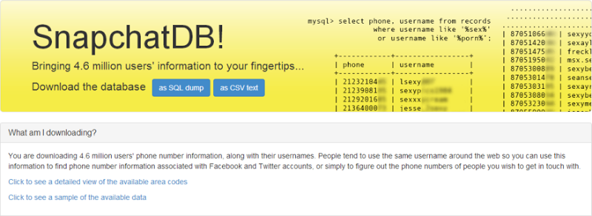

### **8.2.3 Historical Operating Losses**

Despite its strong brand and innovative products, Snap Inc has a history of operating losses. The company's strategic focus on long-term growth over short-term profitability has resulted in periods of financial instability. This approach, while potentially beneficial in the long run, poses risks to the company's financial health and may impact its ability to secure additional financing on favourable terms.

## **8.3 Opportunities**

### **8.3.1 Increasing Adoption of Social Media Apps**

As mentioned in the industry life cycle, the social media market is experiencing rapid growth, driven by increasing demand. This presents a great opportunity for Snap Inc to capitalize on this trend, with an increasing demand for social media tools, Snap Inc can position itself as one of the leading companies in the social media market, leveraging features imbued with AI such as its AR lenses to meet the growing wants of consumers.

### **8.3.2 Expansion into established markets**

It presents a significant growth opportunity for Snap Inc as it can tap into markets where smartphone and internet usage are on the rise. According to recent data from Statista, global smartphone users are expected to reach 5 billion users, providing a vast potential user base for Snap Inc to target.

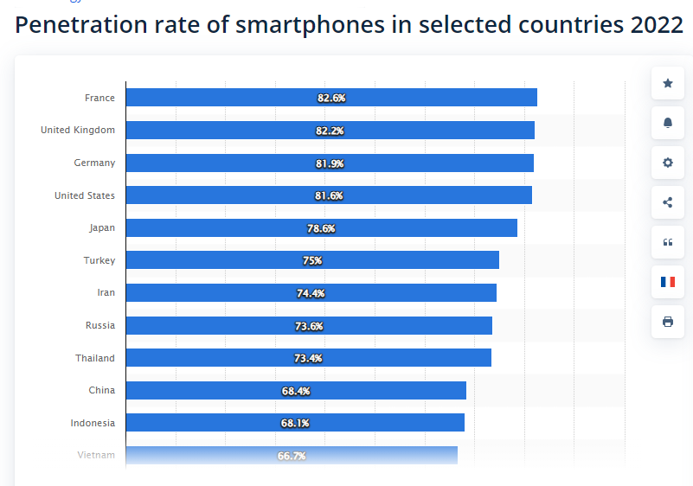

### **8.3.3 Partnerships with brands & content creators**

Partnerships can also enhance Snap’s offerings and attract different user segments. For example, Snap Inc, collaborated with local content creators in India, leading to the creation of localized content and features. Moreover, they also collaborated with local firms, partnering with Android phone manufacturers like Oppo and Samsung to pre-install the Snapchat app on their devices which have significantly boosted user adoption. These efforts contributed to Snapchat’s growth in India, reaching over a 100 million active users by October 2021.

### **8.3.4 Rise of e-commerce**

Snap Inc. can leverage its technology to solve business challenges or diversify into new digital products beyond social media. With the rise of e-commerce and digital services, there is a growing demand for innovative solutions, presenting a lucrative opportunity for Snap Inc. For example, TikTok and Instagram have implemented in-app functions where users can sell goods, known as TikTok Shop and Instagram Shopping, respectively. By exploring similar avenues, Snap Inc. can tap into the e-commerce market, providing users with seamless shopping experiences and generating additional revenue streams.

## **8.4 Threat**

### **8.4.1 Intense Competition**

One of the key threats Snap Inc. is facing currently is intense competition from other major social media platforms such as TikTok, Facebook and Instagram. These platforms are continuously launching similar features, such as short-video content and e-commerce, making it challenging for Snap Inc to differentiate itself and attract new users. In addition, Snap Inc is at risk of losing relevance if it fails to continually innovate and retain user interest with fresh content and features. With user preferences constantly changing, Snap Inc must stay ahead of the curve to avoid becoming obsolete in the rapidly changing social media landscape.

### **8.4.2 Regulatory Changes**

Changes in privacy policies and regulations pose a significant threat to Snap Inc’s data collection processes and advertising models. With increasing concerns from users about data privacy, Snap Inc could face restrictions on how to collect and use user data, affecting its ability to target advertisements effectively.

### **8.4.3 Economic Downturns**

Economic downturns are a threat to companies across all sectors, including social media companies like Snap Inc. In times of economic uncertainty, companies often reduce their advertising budgets, which could lead to a drop in revenue for Snap Inc.

### **8.4.4 Potential Future Cyberattacks**

Snap Inc must continually upgrade its database such that its cybersecurity is impenetrable. Any mistakes, such as data breaches, can significantly impact its operations and profitability. The social media industry is particularly vulnerable to cyberattacks, with data breaches increasing in both impact and frequency over the years. The number of social media accounts that were hijacked from 2021 to 2022 increased by 1000%. (STATIONX, February 7, 2024) As Snap Inc has already suffered multiple data breaches in its operations, additional compliance failures in securing users’ information could potentially lead to the suspension of their operations, either by the government, or cause a significant loss of public trust. If people lose confidence in Snap Inc’s ability to protect their private information, they may stop using its app and resort to competitors, leading to financial losses.

# **9. Snap Inc. BCG Matrix**

The BCG Matrix, also known as Boston Consulting Group Matrix, categorizes a company’s products or business units based on market growth and relative market share. Given the rapid growth in the Social Media Industry, Snap Inc. but slow growth it likely fits into the **“Question Mark”** category.

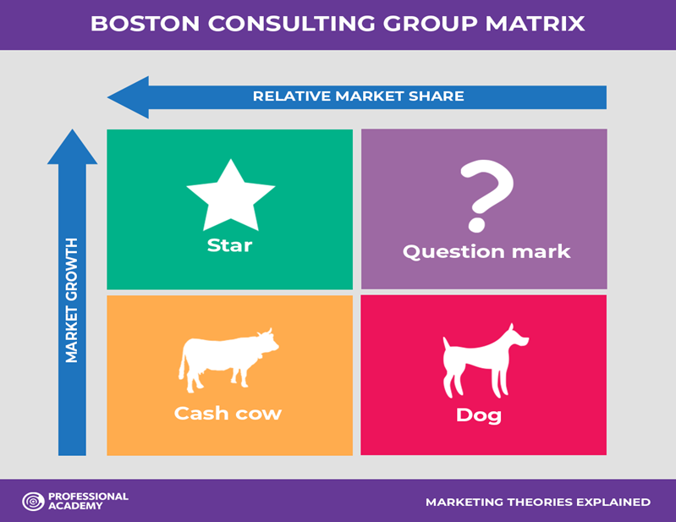

## **9.1 Low Market Share**

Despite being a well-known platform, Snapchat is relatively smaller compared to giants like Facebook, Instagram, and TikTok. Based on a source from CSIMarket, in Q1 2024, Snap Inc’ has a market share at 0.95% (CSIMarket, May 29, 2024). In comparison to bigger competitors like Meta with considerably higher market shares with 28.47%, this shows that Snap Inc has a low market share in the social media industry, therefore falling under the ‘question mark’ category.

## **9.2 High Industry Growth**

The social media sector still records high growth, with increasing numbers of user-bases and expanding advertising revenues. The global opportunity in social media today is tremendous, with significant growth expected in the coming years​​​. Based on a report by Business Research Insights (April 2024), the global social media market has experienced significant growth, with its size estimated at USD 5,357 million in 2021 and projected to reach USD 34,380 million by 2031. This represents an increase of more than six times its original size in less than a decade. Since the growth of the social media industry is rapid, it still gives Snapchat Inc with opportunities to grab more market share and grow, thus falling under the ‘question mark’ category. Therefore, Snapchat Inc is a question mark in the social media industry in terms of the BCG Matrix.

# **10. Snap Inc. Product Life Cycle**

Based on the Product Life Cycle, Snap Inc. Snapchat is likely to be between the “Maturity & Decline” stage.

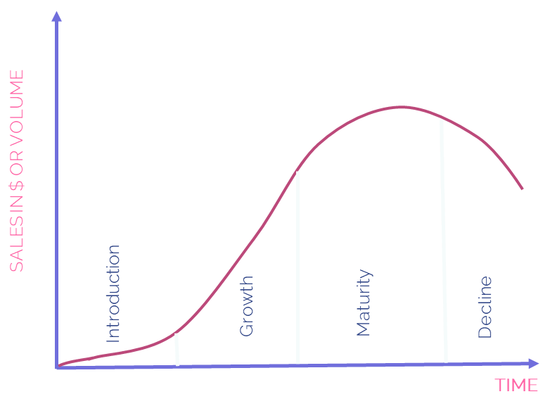

As of the first quarter of 2024, Snapchat had 422 million daily active users (DAU) worldwide, up from 414 million global DAU in the fourth quarter of 2023. The app has seen steady increases in daily active users since the beginning of 2019. (Statista, May 22,2024). Moving to the financial aspect, Snapchat’s annual revenue in 2022 and 2023 was $4.602 and $4.606 billion dollars respectively, compared to the revenue growth from 2021 and 2022 which was an 11.78% increase, the revenue growth from 2022 to 2023 was a mere 0.09%. (macrotrends, n.d.), and it suffered a net loss of $328.67 million USD in 2023. This suggests that the app has moved into the maturity to decline stage, as it is operating at a loss. It has more competition for the attention of its primary target audience than ever, thanks to TikTok. However, it’s not too late for Snapchat, as it is still a popular platform for advertisers and consumers, but it needs to diversify its revenue streams and ensure more than 1% of its revenue comes from other sources apart from advertisement. (TechReport, May 27, 2024)

# **11. Snap Inc. Marketing Segmentation & Mix**

A marketing mix includes multiple areas of focus as part of a comprehensive marketing plan. The term often refers to a common classification that began as the four Ps: product, price, placement, and promotion.



## **11.1 Product**

### **11.1.1 Core Products**

Core products refer to the essential benefits or values that a product provides to consumers. For Snapchat, the core product is its primary function as a multimedia messaging app, enabling users to communicate through photos, videos, and text messages. A distinctive feature of Snapchat is its ephemeral messaging, where content disappears after being viewed, offering a unique element of privacy compared to other social media platforms like Facebook, Instagram, and TikTok. Additionally, Snapchat enhances the user experience with features like Stories and Filters, which allow users to share their daily moments in a creative and engaging way.

**Snaps**

Snaps are the basic form of communication on Snapchat, allowing users to send photos or videos with captions, drawings or filters. These messages are designed to disappear after being viewed, placing a focus on real-time sharing.

**Stories**

Stories are compilations of Snaps, which are viewable for a maximum duration of 24 hours, allowing users to share experience in chronological order. For instance, a user attending a music festival can post a series of Snaps throughout the day, capturing different performances and moments. This feature encourages continuous engagement and content sharing among users.

**Filters**

Filters are graphical overlays that users can apply to their photos or videos. For example, users can use colour filters to change the overall tone of a photo or video, like features found in photo editing apps like PicsArt.

**Lenses**

Lenses are augmented reality features that allow users to add interactive elements to their photos, altering the appearance of users’ faces or the surrounding environment in real time. The difference between lenses and filters on Snapchat is that lenses work spontaneously, responding to the user’s actions. For example, a popular lens called 'Puking Rainbow' activates when users open their mouths, causing a rainbow to appear as if it’s coming out, and deactivates when they close their mouths.

All in all, Snapchat's core customer value provides private, creative, and real-time communication through ephemeral messaging, Filters, and Lenses. It addresses users' needs for privacy, personalization, and engaging social interaction, offering a unique platform for self-expression and real-time experience sharing.

### **11.1.2 Actual Products**

The actual product is the physical product that the users see when they use Snapchat. The products listed below empower users to express themselves.

**User Interface**

Snapchat allows quick and fun user interaction through its snappy user interface that builds expressions and communication in real-time.

**Discover**

Users can find content through this feature, which has content from major media partners, publishers, news sources, and other information/entertainment-based elements.

**Snap Map**

This is a map feature that enables users to see where their friends are and what they are up to, thus adding an element of social discovery to the application.

**Spotlight**

Allows user-generated content and allows people to share small, fun videos like competitors like TikTok.

**Bitmoji**

Personal avatars that could be created by users and utilized in their Snaps and chats, thus enhancing personalization and engagement.

**Snapchat+**

A premium subscription service offering additional features such as custom app icons and themes, priority Story replies, exclusive lenses and filters, advanced analytics, and early access to new features.

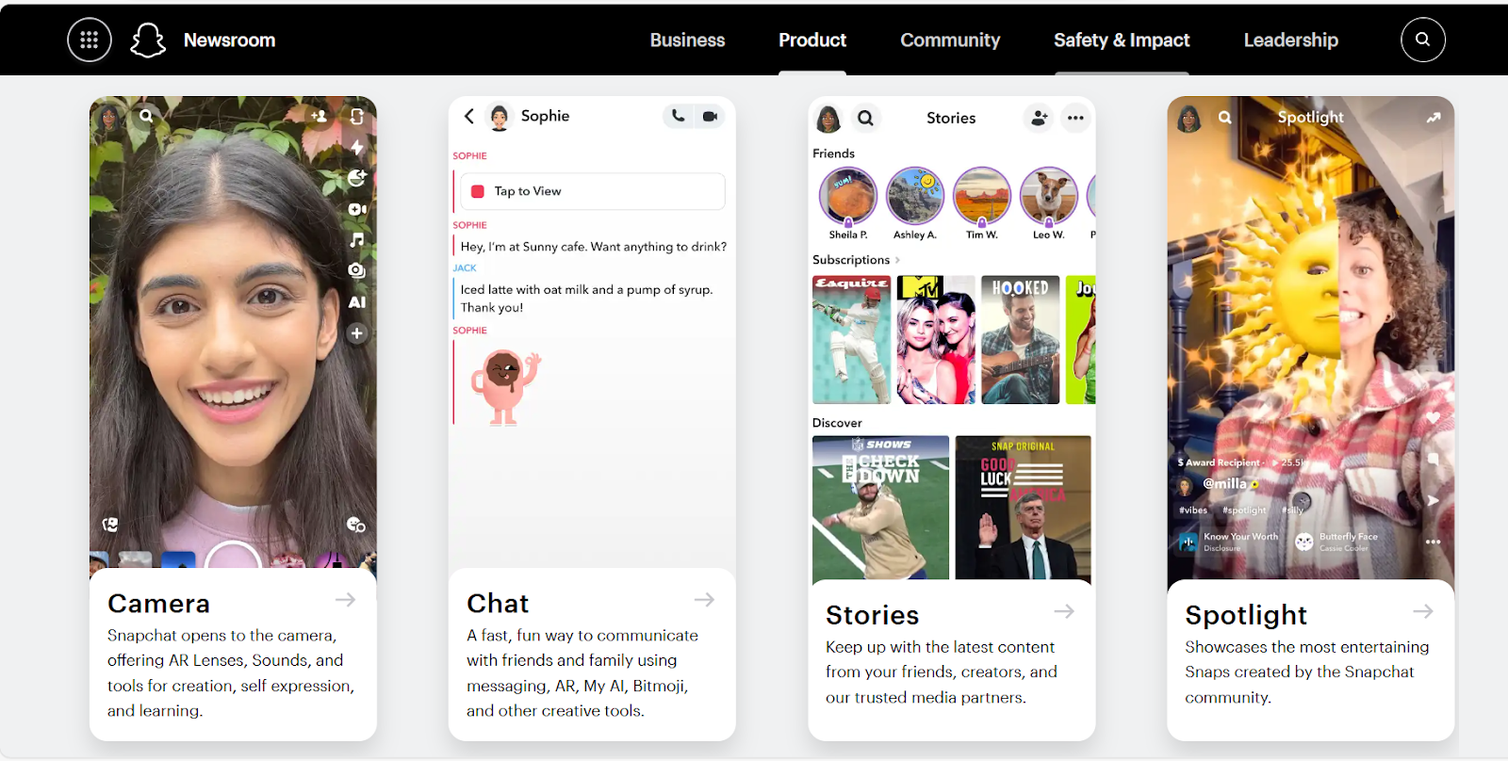

**Augmented Product**

An augmented product has been enhanced by its seller with added features or services to distinguish it from the same product offered by its competitors. Augmenting a product involves including intangible benefits or add-ons that go beyond the product itself.

**Privacy and Security**

Snapchat focuses on privacy through features such as disappearing messages and the ability to control who views your content.

**Continuous Updates**

There are always fresh features, filters, lenses, and overall improvements because updates are regular in this application, making the app engaging.

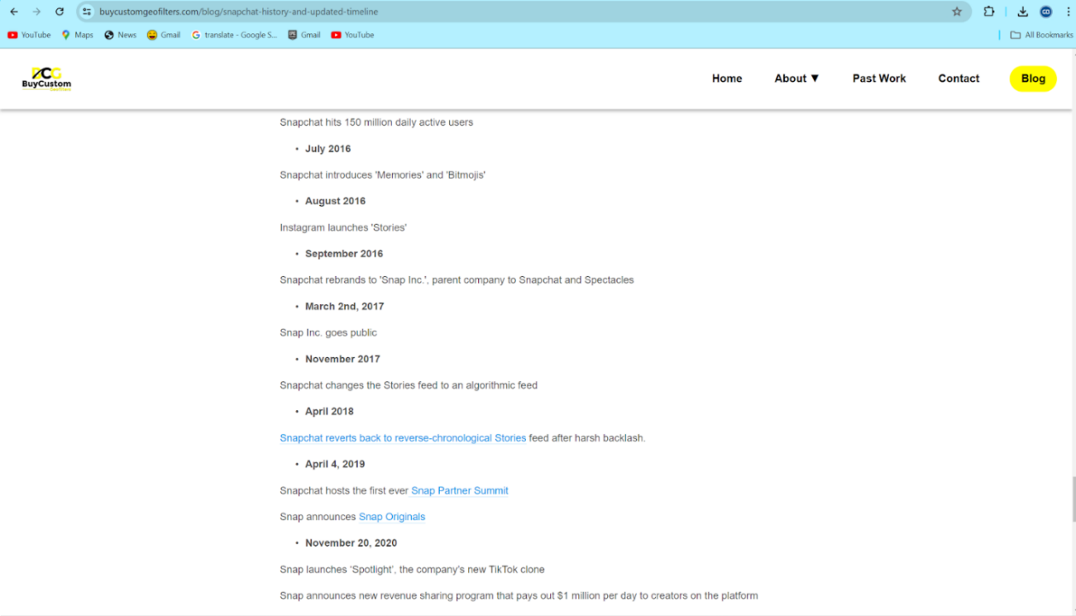

From the website, it is evident that Snapchat releases app updates once every few months. These updates aim to introduce new filters and lenses, modify existing features, and more. Such efforts are made to maintain user engagement and ensure the app remains appealing to its user base.

**Snapchat+**

Subscribers get enhanced support options and early access to experimental features, adding value to the premium experience.

### **11.1.3 Differentiation**

**Ephemeral Content**

It has a unique selling point of being ephemeral in nature, meaning content will disappear after viewing, hence making the user communicate more spontaneously and authentic.

**AR Technology**

The first one to have created an impact with augmented reality on social media is arguably Snapchat, through its innovative filters and lenses which they released in January 2015.

**Appeal to Youth**

Its appeal remains solid in the hearts of younger individuals, especially those from Generation Z.

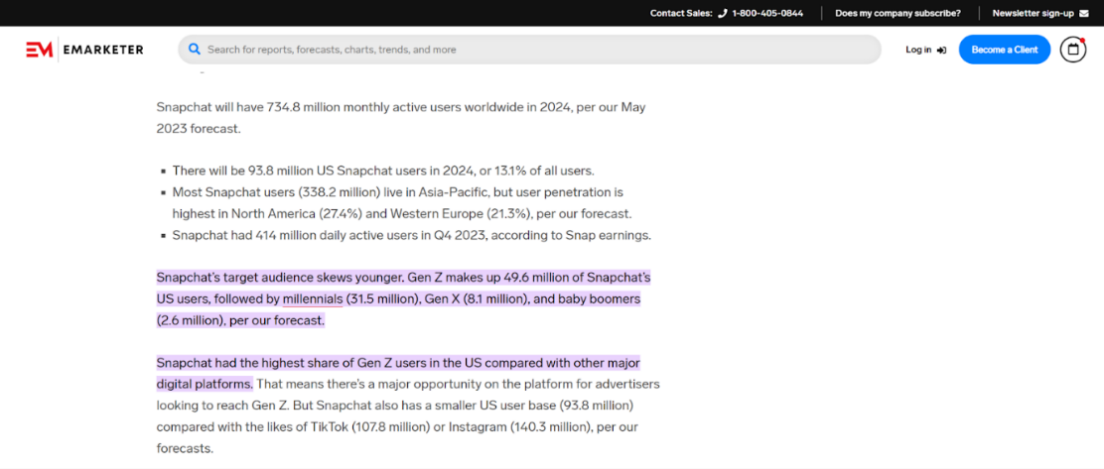

According to sources from EMarketer, most Snapchat's target audience consists of Gen Z users, with over 49 million users in the US. In comparison, Millennials, Gen X, and Baby Boomers collectively account for around 43 million users. This indicates that Snapchat has a stronger appeal to the younger generation. Gen X refers to individuals born between 1965 and 1980, while Baby Boomers are those born between 1946 and 1964.

**Snapchat+**

Provides a more personalized and enriched experience for users willing to pay for premium features, setting it apart from the standard version and other social media platforms.

Unlike other social media platforms, Snapchat+ offers early access to many new experimental features such as Snapchat Badge and more, which allows users to make use of the features before they are officially released. This type of early access perk is normally not available in competitor applications such as TikTok and Facebook.

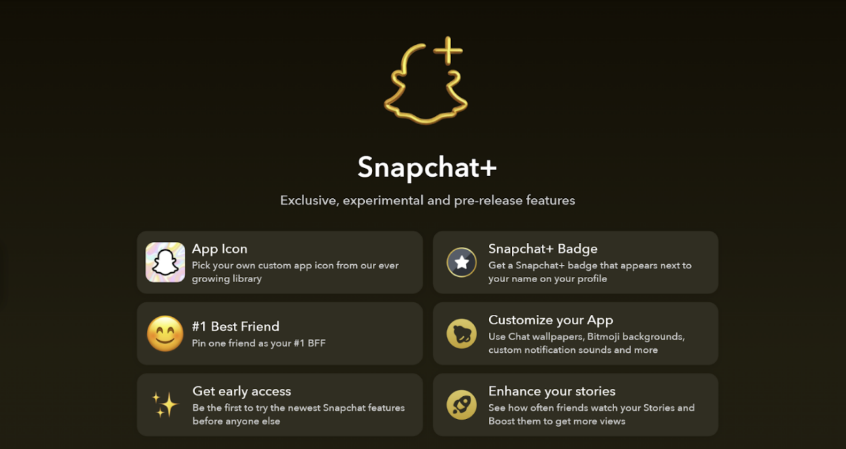

Snapchat's product strategy is unique, engaging, and constantly growing the platform for social interaction and creative expression. Launching Snapchat+ adds a premium layer to its suite that is dedicated to all the power users looking for elite features and personalization. This two-tiered approach allows Snapchat to continue its competitive edge while appealing to a larger spectrum of audiences, both casual and devoted.

## **11.2 Pricing**

### **11.2.1 Freemium Model**

Snapchat follows a freemium pricing model, meaning the app’s core features are free to use, making it accessible to the wide range of the user base. This strategy allows them to attract and retain a large user community, which in turn drives engagement and content creation on the platform.

### **11.2.2 Premium Features**

Premium Features: Snapchat offers premium features and content through its subscription service, Snapchat Premium. The service adopts an odd-even pricing technique, setting prices just below a rounded number, such as $5.98 per month and $44.98 per year. These premium features include access to exclusive content, such as special filters, lenses, and an ad-free experience. The psychological effect of odd-even pricing further encourages consumers to purchase the subscription.

## **11.3 Place**

### **11.3.1 Indirect Distribution**

Snapchat uses an indirect distribution strategy to deliver its application by collaborating with online distribution channels such as the Google Play Store and Apple App Store. For Android devices, the Google Play Store acts as an intermediary, allowing Snapchat to reach millions of Android users worldwide. For iOS devices like the iPhone and iPad, the Apple App Store serves as the main distribution channel, ensuring broad accessibility and easy installation for these users.

These app stores act as digital distribution intermediaries, providing a platform for Snapchat to efficiently and effectively distribute its app to a global audience. Additionally, they help manage app updates and offer a user review system, enabling Snap Inc. to evaluate the app's performance on each digital channel.

## **11.4 Promotions**

Snapchat has an interactive and detailed website where users can access comprehensive information about all its products, features, and policies. The platform continuously introduces innovative and appealing features, such as the recent expansion of its Snapchat+ subscription service. Subscribers can now personalize and design a house on Snap Map, which is visible to friends with whom they share their location. Additionally, Snapchat has rolled out new tools like the Mirror feature in the Bitmoji Builder, allowing users to see themselves in real-time and select features that closely resemble their appearance (Nasdaq, July 3, 2024).

Snapchat's advertising strategy includes Snap Ads, which are video ads appearing between user stories. These ads feature interactive elements, such as web page links and catalogues, encouraging users to act. This approach is enhanced by an algorithm developed by Snap Inc., which helps reach targeted audience segments effectively.

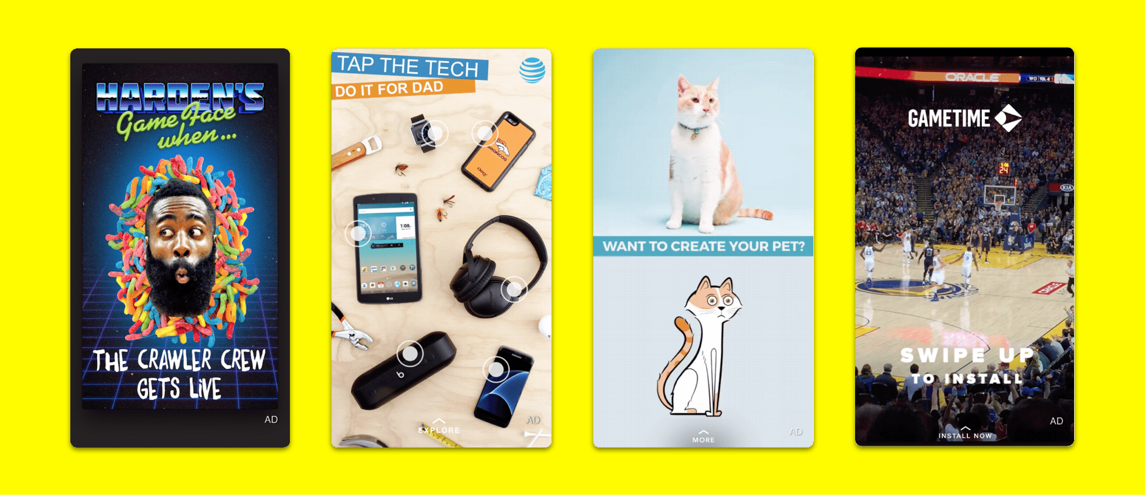

In conjunction with the guest sharing by AWS on the use of Gen AI tools including PartyRock for development of apps, we have built our own individual apps using PartyRock as part of the marketing strategy for the company Snap Inc.

### **11.4.1 Aleem’s Individual Report**

#### **11.4.1.1 Introduction**

Previously, there had been a guest sharing in Ngee Ann Polytechnic which I attended, and AWS presented one of their AI tools which was PartyRock AI. This assignment required me to make use of PartyRock AI to develop an application that helps promote my target company, SnapChat, as part of ‘Promotion’, which is one of the 4 Ps. I have created my own application using PartyRock AI, which I will be showing you in the next few sections. So, sit back and enjoy!

#### **11.4.1.2 Getting to know the app**

The application I developed with PartyRock AI is called ‘Snap Boost: Interactive Snapchat Companion’, where it is an interactive app designed to enhance your Snapchat experience. Users get to explore tutorials, take on daily challenges, showcase their creativity, and earn exciting rewards which they can claim in Snapchat. The goal of this app is to promote users to make use of this app to earn rewards such as premium Snapchat lenses and filters, which they would be able to import them to their Snapchat account. This makes more people want to download back Snapchat for this reason, which is a good form of marketing and promotion for Snapchat.

#### **11.4.1.3 Link to Application**

Here is the link to my application that I have developed:

<https://partyrock.aws/u/al33m/OAib-8CBz/SnapBoost%3A-Interactive-SnapChat-Companion>

#### **11.4.1.4 Design Mocks of the Application**

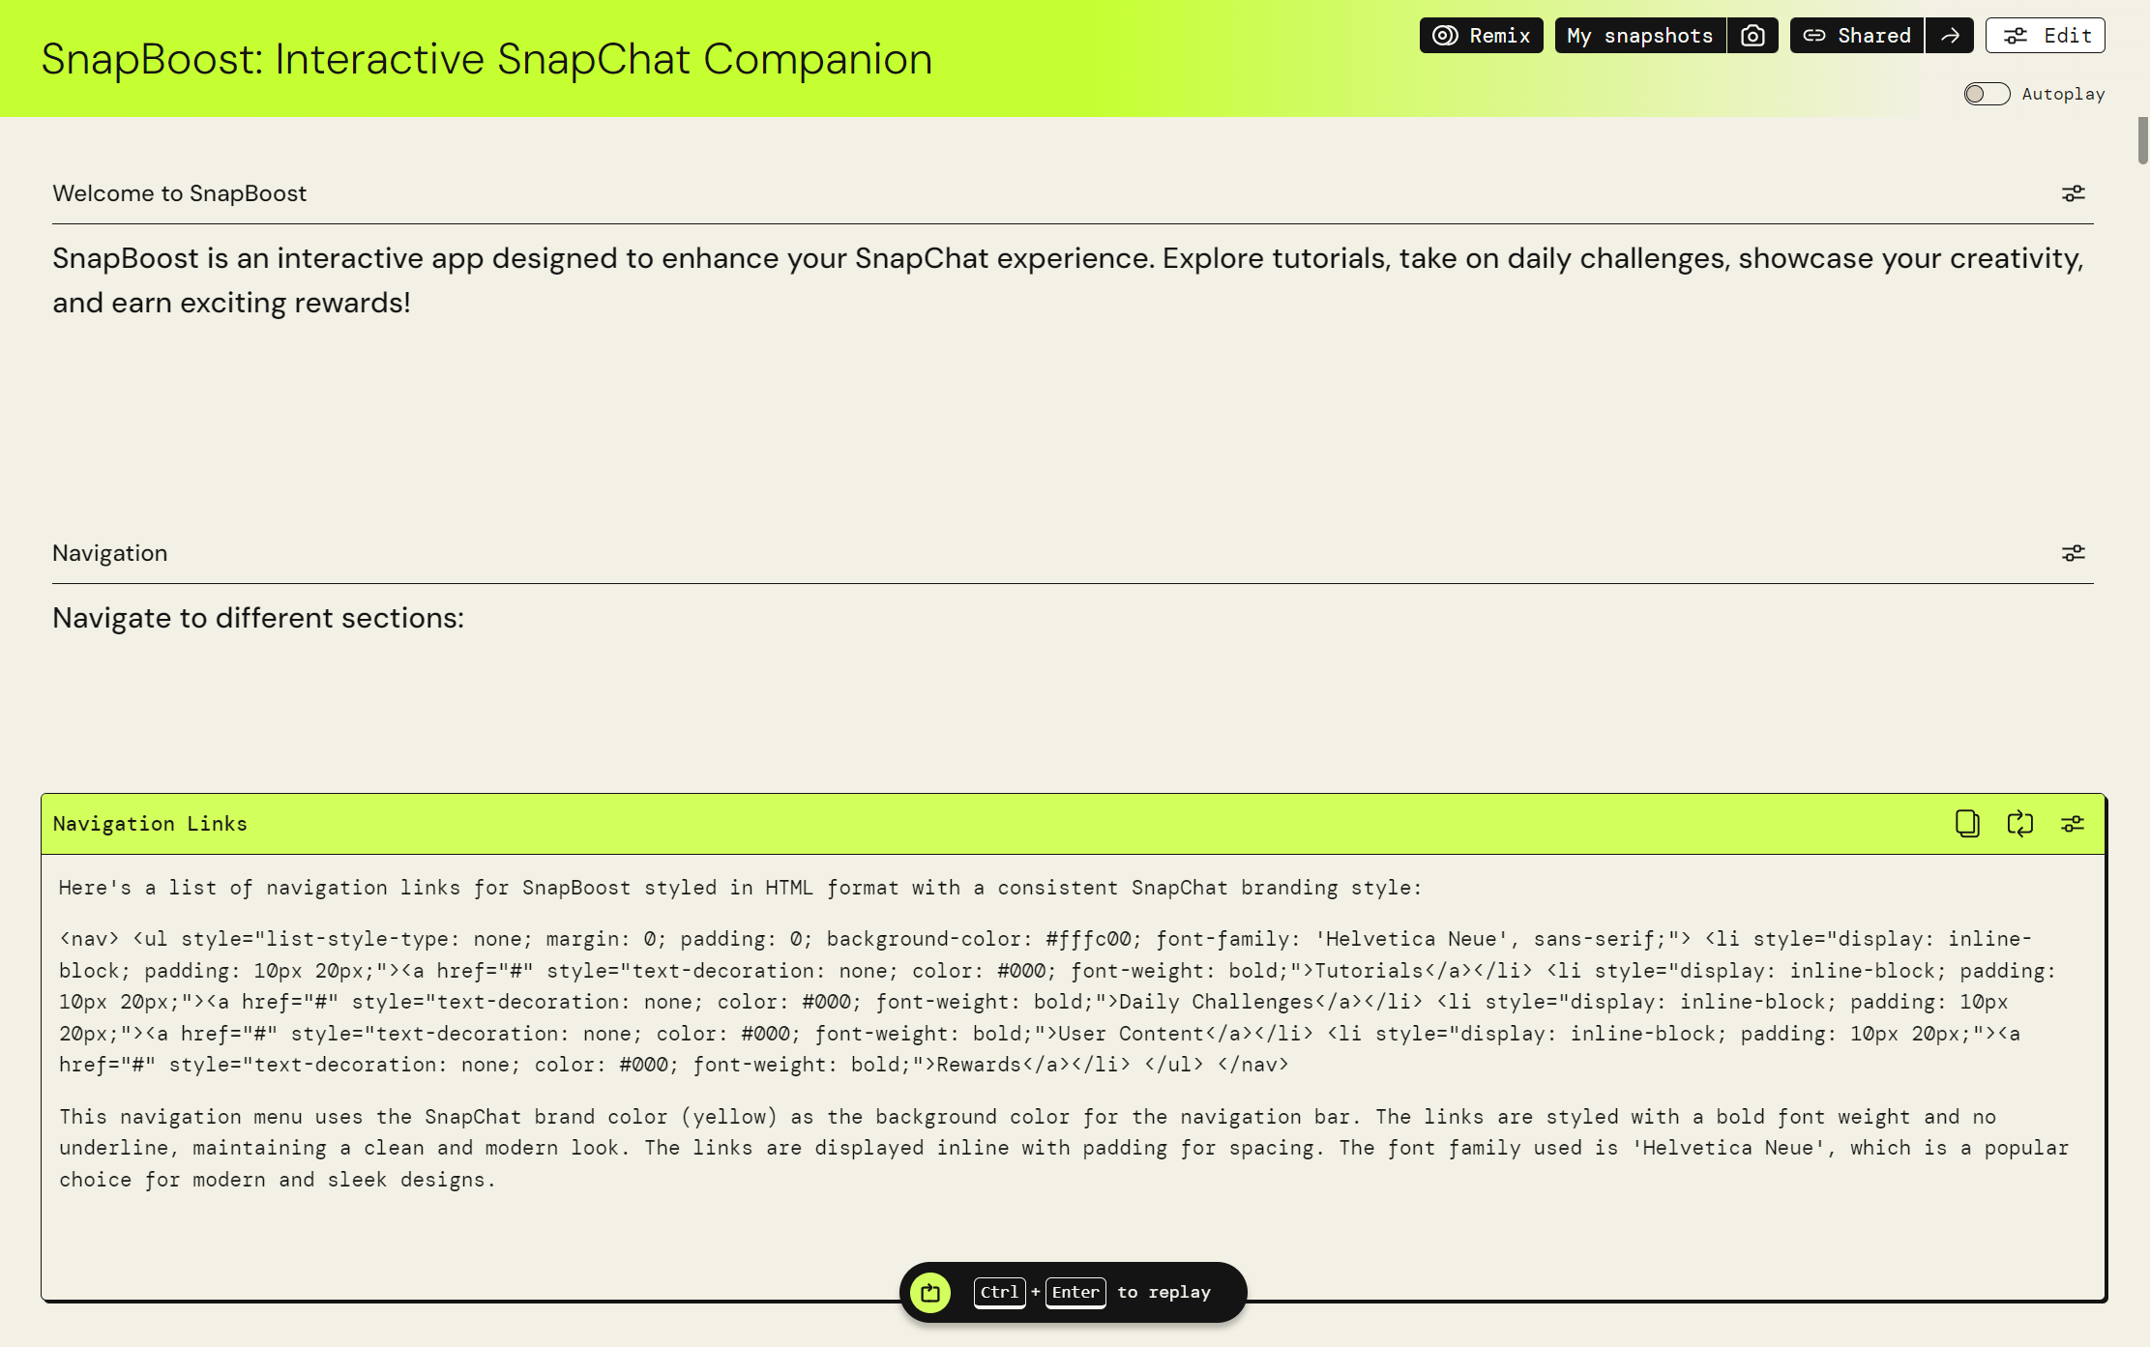

Firstly, this page welcomes users and explains that SnapBoost offers tutorials, daily challenges, user content showcasing, and rewards. The section displayed is "Navigation," providing HTML code for navigation links styled to match Snapchat’s branding, with a yellow background and Helvetica Neue font. The navigation links include sections like Tutorials, Daily Challenges, User Content, and Rewards, formatted to look sleek and modern.

4o

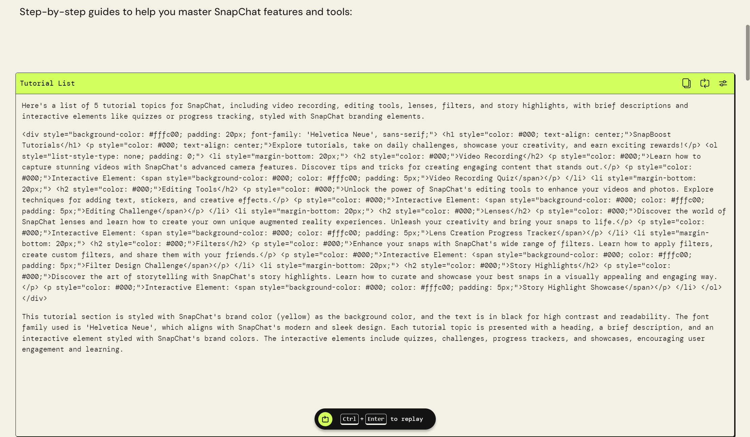

This shows a section of SnapBoost: Interactive SnapChat Companion focused on tutorials. It lists five key tutorial topics: Video Recording, Editing Tools, Lenses, Filters, and Story Highlights. Each topic includes brief descriptions and interactive elements like quizzes and progress tracking, all styled with Snapchat's branding for a cohesive look. The text is presented in Helvetica Neue font for the text recommendation, which ensures high readability and a modern appearance.

4o

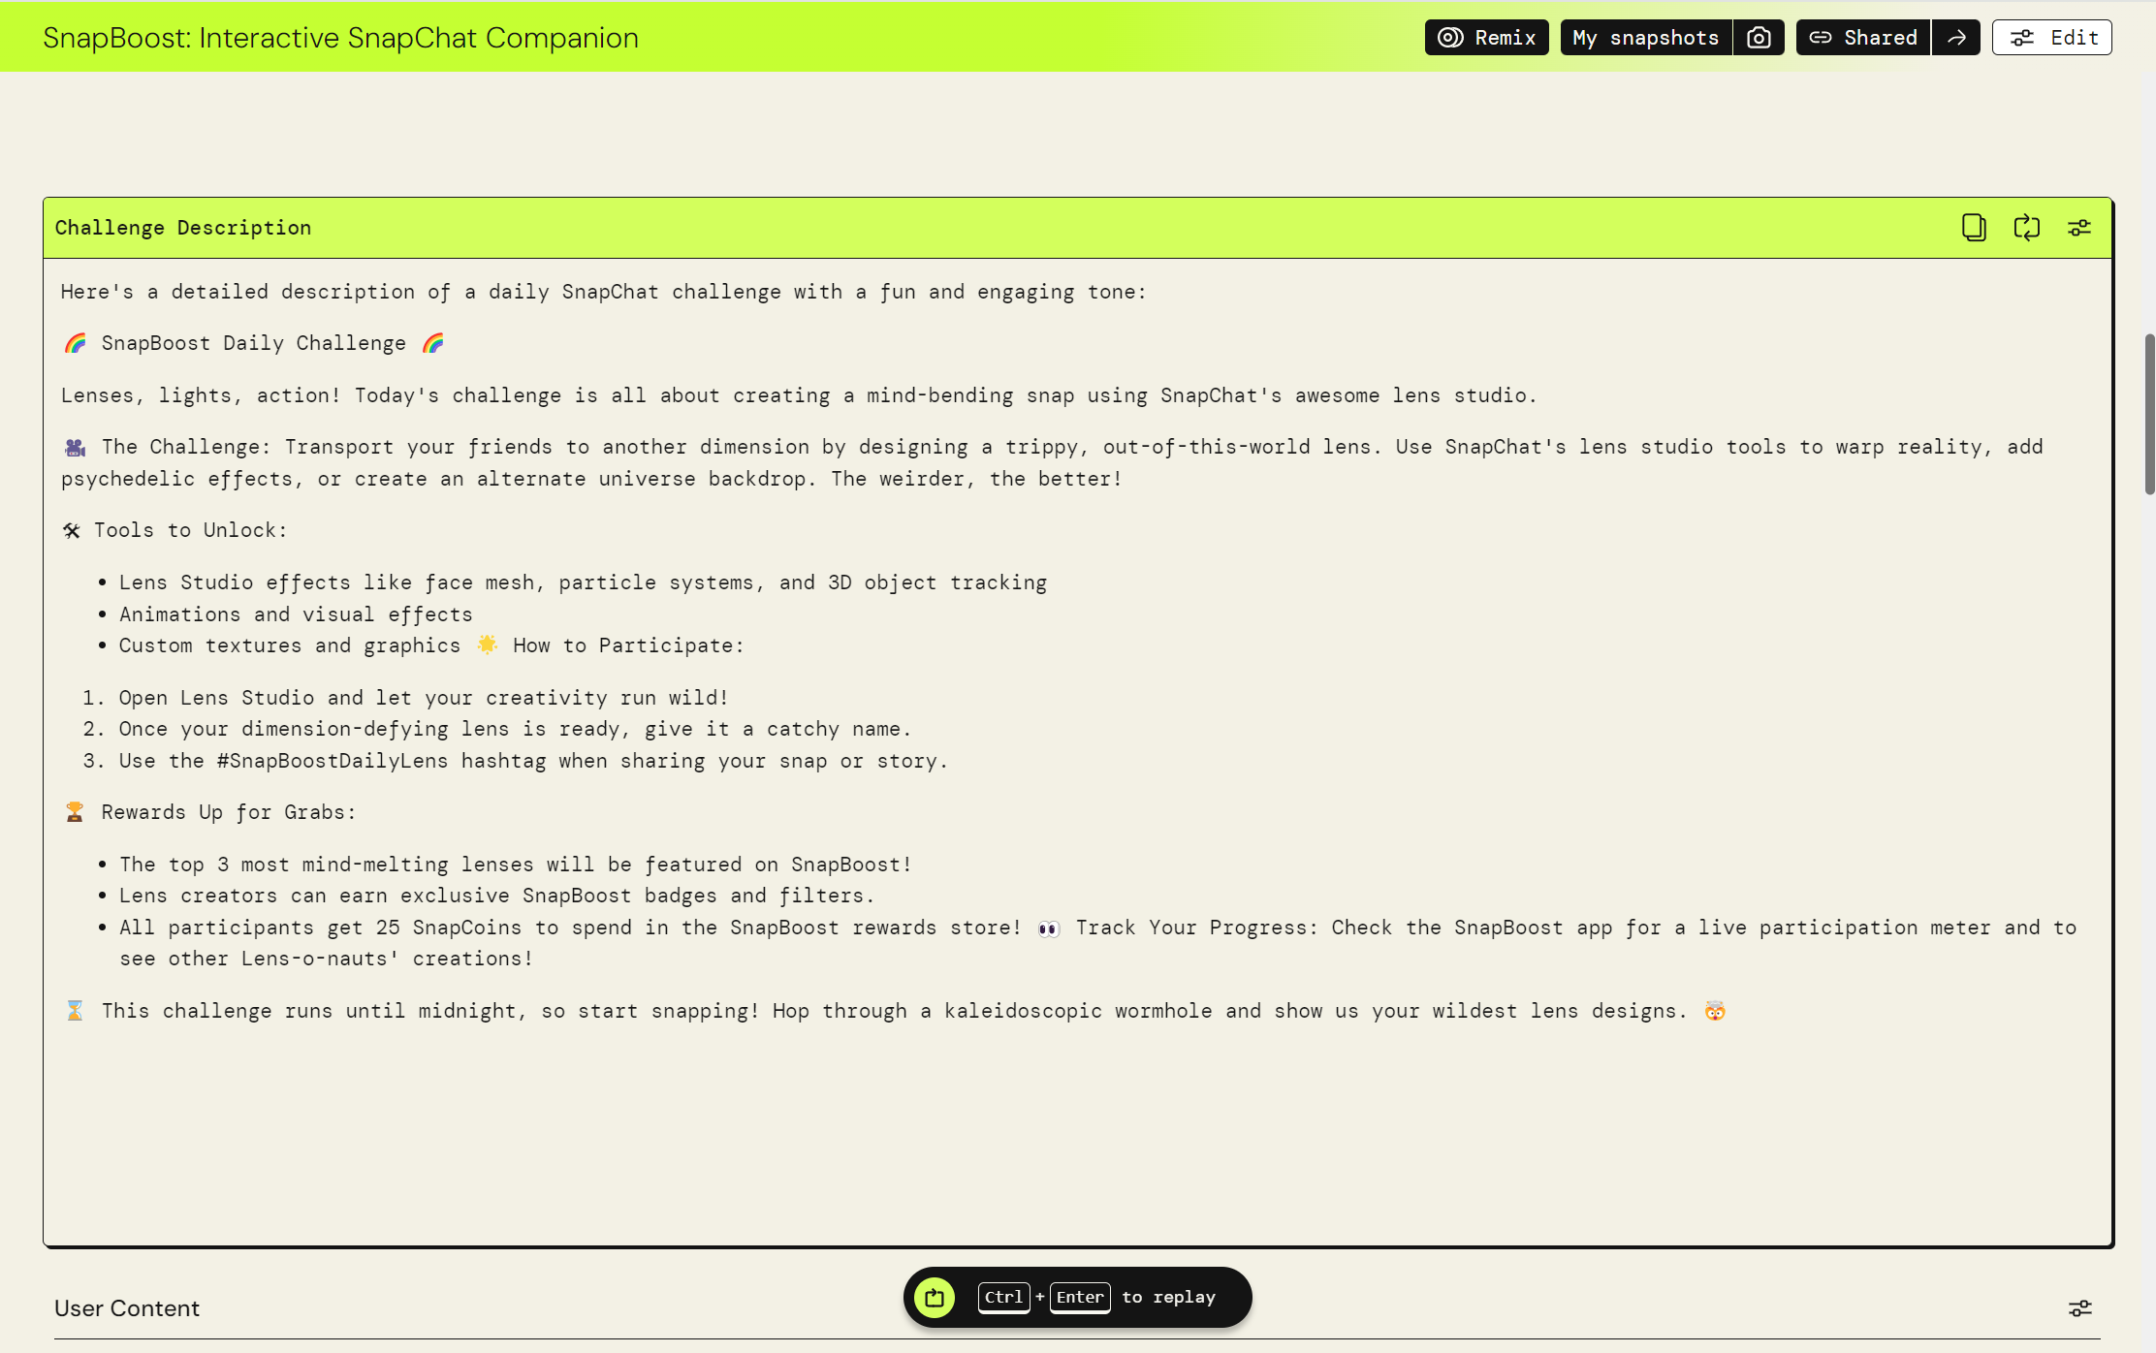

This shows the "Challenge Description" section of SnapBoost: Interactive SnapChat Companion, detailing a daily challenge for creating mind-bending snaps using Snapchat's lens studio. It explains the challenge to transport friends to another dimension with trippy effects, tools to unlock like face mesh and 3D object tracking, and instructions on how to participate. Rewards include featuring the top lenses and earning SnapBoost badges and filters. The challenge encourages creativity and runs until midnight.

4o

The application will thus be able to generate suitable, creative challenges available to complete in the application for people to work on.

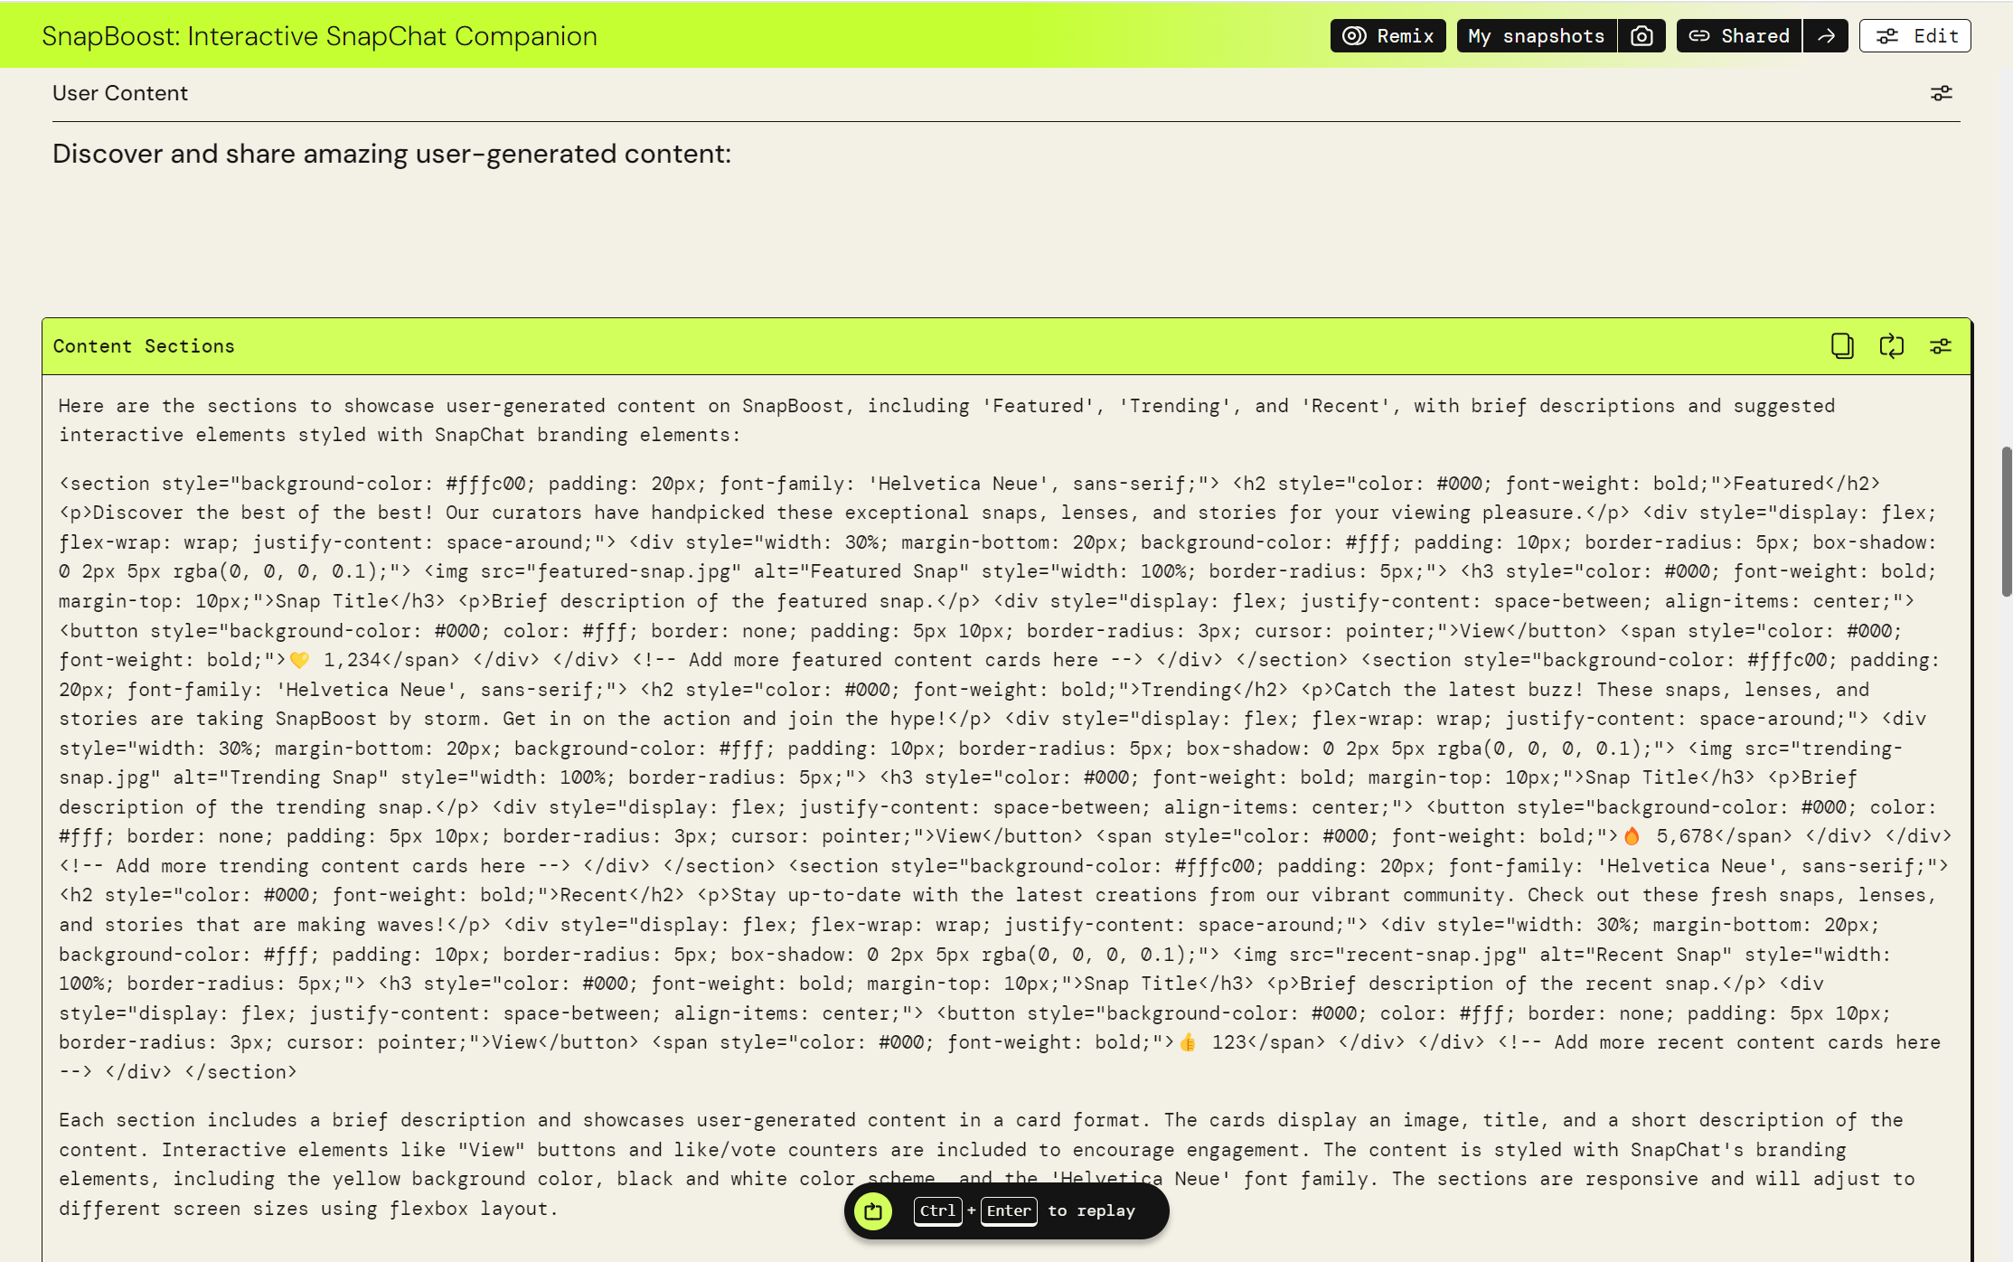The image showcases the "User Content" section of SnapBoost: Interactive SnapChat Companion. It highlights user-generated content under categories like "Featured," "Trending," and "Recent." Each section includes a description, images, and interactive elements like "View" buttons, styled in Snapchat's branding. This design encourages users to explore top snaps, lenses, and stories selected by curators, promoting engagement and community interaction.

4o

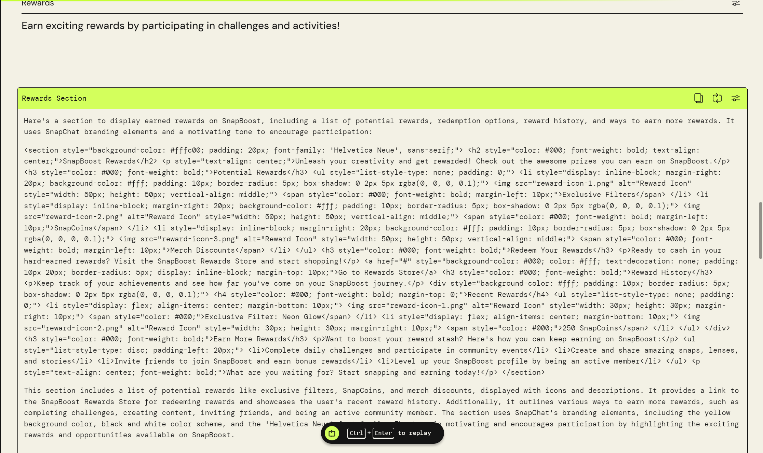

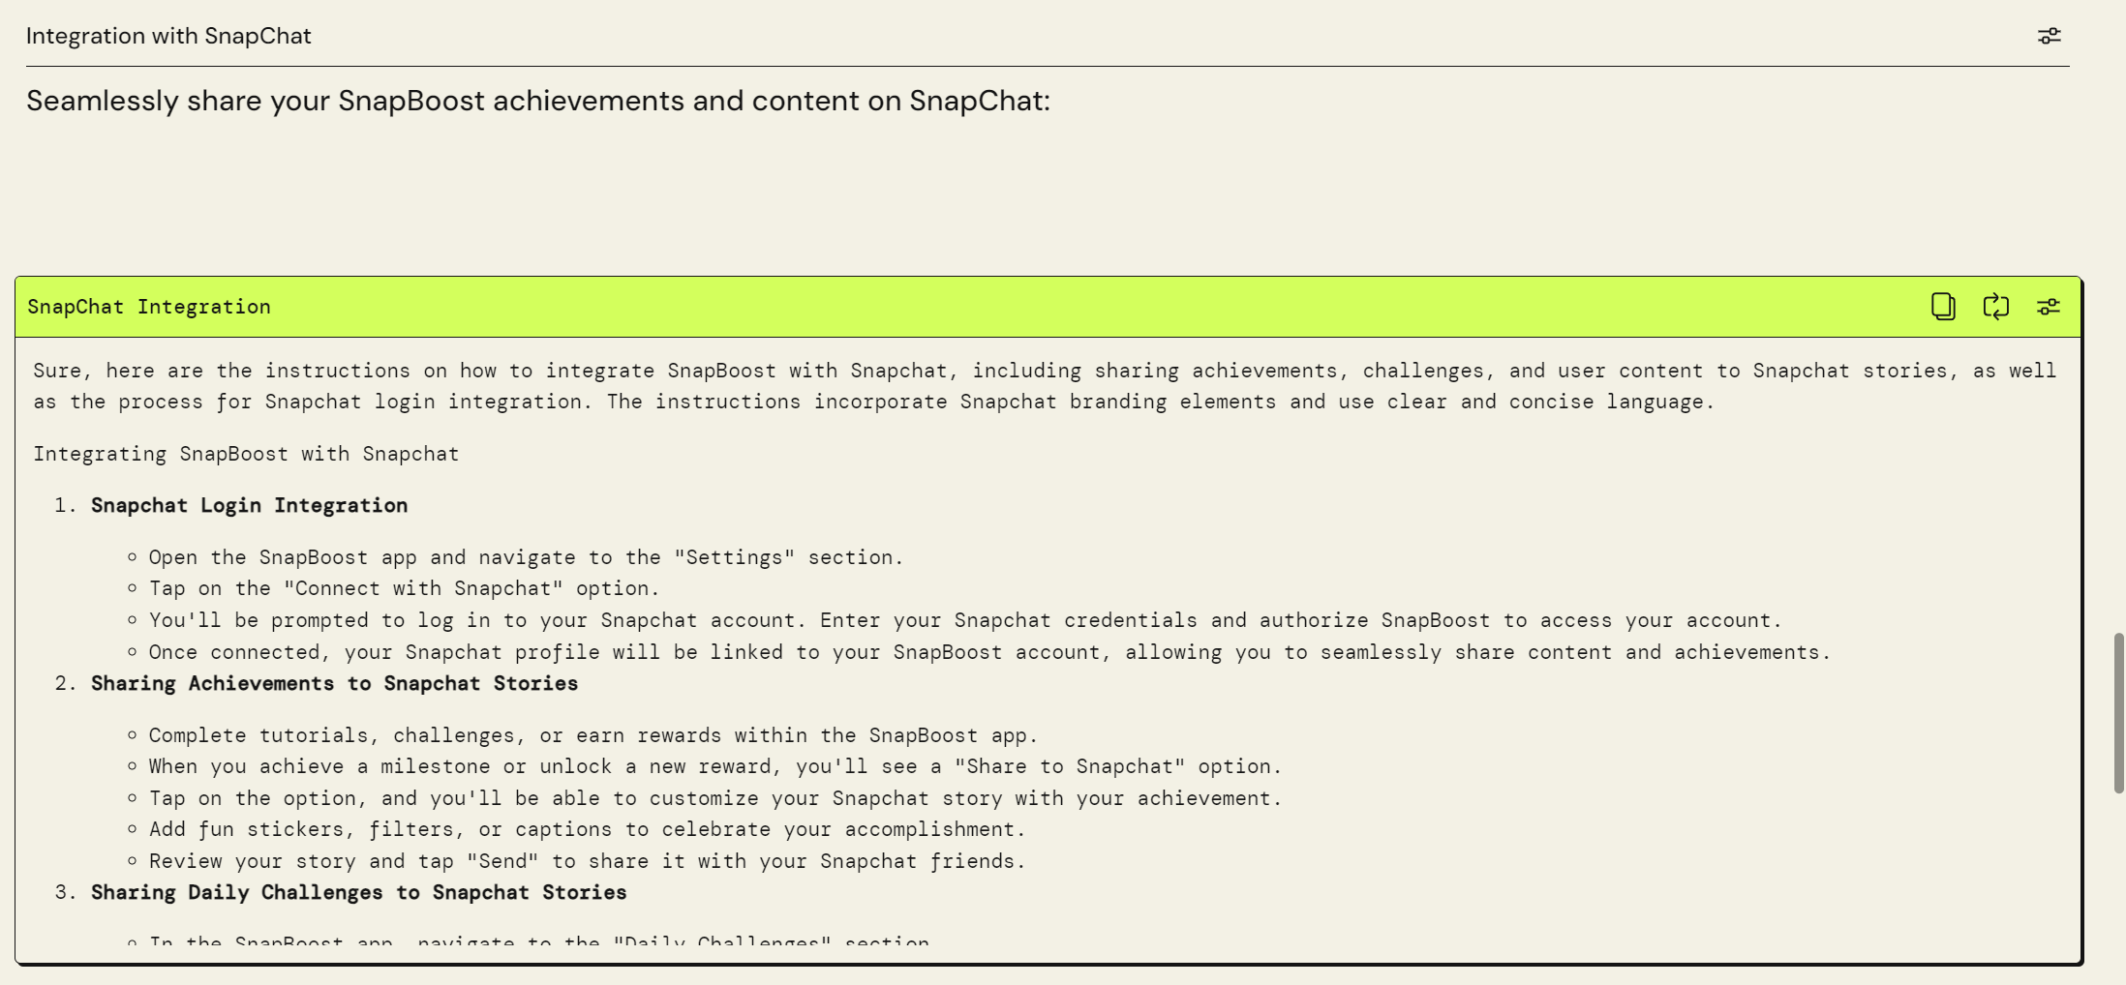

**Continuation of the Snapchat Integration instructions:**

Sure, here are the instructions on how to integrate SnapBoost with Snapchat, including sharing achievements, challenges, and user content to Snapchat stories, as well as the process for Snapchat login integration. The instructions incorporate Snapchat branding elements and use clear and concise language.

**Integrating SnapBoost with Snapchat**

1. **Snapchat Login Integration**

- Open the SnapBoost app and navigate to the "Settings" section.

- Tap on the "Connect with Snapchat" option.

- You'll be prompted to log in to your Snapchat account. Enter your Snapchat credentials and authorize SnapBoost to access your account.

- Once connected, your Snapchat profile will be linked to your SnapBoost account, allowing you to seamlessly share content and achievements.

2. **Sharing Achievements to Snapchat Stories**

- Complete tutorials, challenges, or earn rewards within the SnapBoost app.

- When you achieve a milestone or unlock a new reward, you'll see a "Share to Snapchat" option.

- Tap on the option, and you'll be able to customize your Snapchat story with your achievement.

- Add fun stickers, filters, or captions to celebrate your accomplishment.

- Review your story and tap "Send" to share it with your Snapchat friends.

3. **Sharing Daily Challenges to Snapchat Stories**

- In the SnapBoost app, navigate to the "Daily Challenges" section.

- Tap on a challenge you want to participate in and complete the required tasks.

- Once you've finished the challenge, you'll see a "Share to Snapchat" option.

- Customize your Snapchat story with the challenge details, your submission, and any additional creative elements.

- Review your story and tap "Send" to share your challenge participation with your Snapchat friends.

4. **Sharing User Content to Snapchat Stories**

- Create amazing snaps, lenses, or stories within the SnapBoost app using the various tools and features.

- After creating your content, you'll see a "Share to Snapchat" option.

- Tap on the option, and you'll be able to share your creation directly to your Snapchat story.

- Add any additional captions, stickers, or filters to enhance your story.

- Review your story and tap "Send" to share your creativity with your Snapchat friends.

Remember, by integrating SnapBoost with Snapchat, you'll be able to seamlessly share your achievements, challenges, and user content, making it easier to showcase your SnapBoost journey and engage with your Snapchat friends.

Enjoy the enhanced Snapchat experience with SnapBoost!

This section provides instructions on integrating SnapBoost with Snapchat, allowing users to seamlessly share their achievements, challenges, and user-generated content directly to Snapchat stories. The steps include:

1. **Login Integration**: Connect SnapBoost to Snapchat via the app settings.
2. **Sharing Achievements**: Share milestones and rewards from SnapBoost to Snapchat stories.
3. **Daily Challenges**: Participate in challenges and share them on Snapchat.
4. **User Content**: Create and share snaps, lenses, or stories from SnapBoost to Snapchat.

Each step emphasizes customization with stickers, filters, and captions to enhance user engagement.

4o

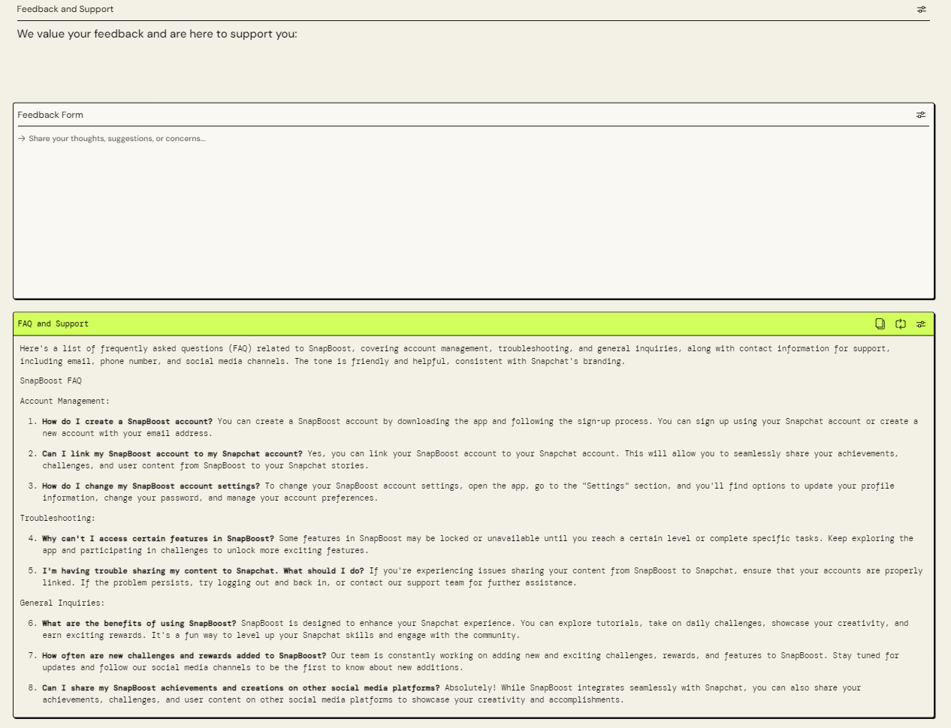

This is a feedback form as well as a FAQ and support section. The feedback form allows for users who want to give reviews or improvements about the application to do so in this form. This will allow the application team to work on these feedback in order to provide a better experience of the SnapBoost application.

The FAQ and Support section provides users with answers to frequently asked questions, helping them resolve common issues independently. It serves as a helpful resource for troubleshooting and understanding the features of SnapBoost. Users can refer to this section to quickly find solutions without needing to contact support. This self-service approach enhances user experience by offering immediate assistance for common queries.

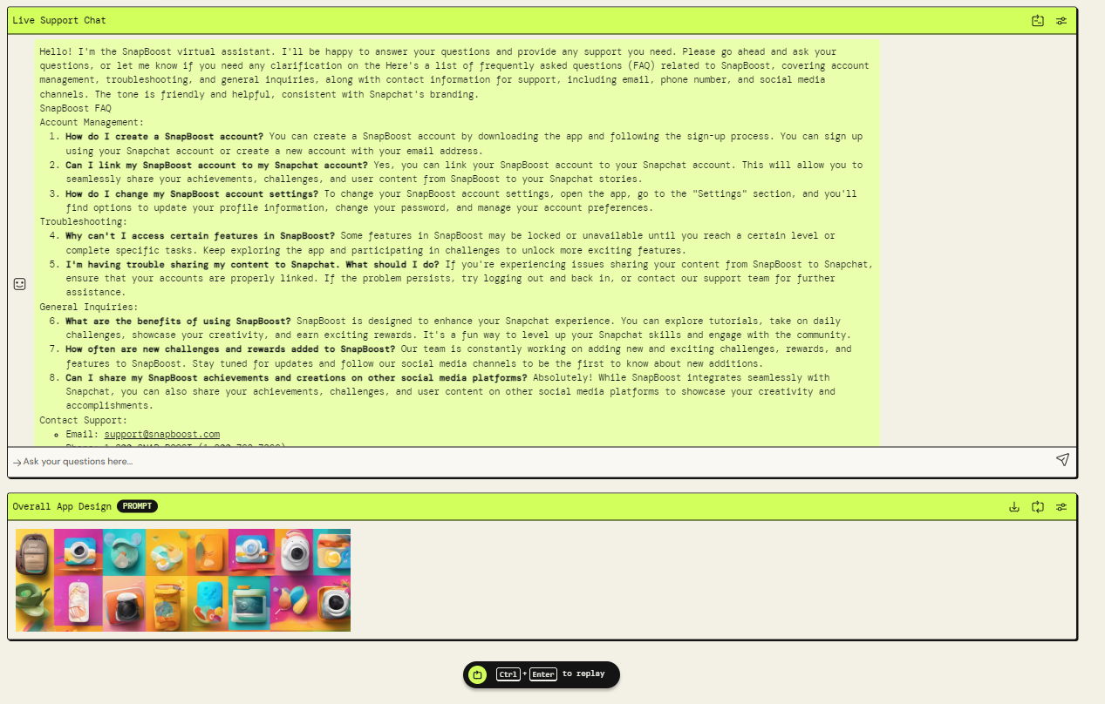

This shows the "Live Support Chat" and "FAQ" section of SnapBoost: Interactive SnapChat Companion. This section offers answers to common questions about account management, troubleshooting, and general inquiries, including creating a SnapBoost account, linking it to Snapchat, changing settings, and resolving feature access or sharing issues. It also highlights the benefits of using SnapBoost, updates on new challenges and rewards, and information on sharing content on other social media platforms. Contact details for support are also provided, including email and phone number.

4o

The Overall App Design prompt below was added by me as a small extra feature to attempt and make a cool looking design or theme for the application to make it look nice. This prompt generates a suitable design for the application developers to follow/implement.

#### **11.4.1.5 Application Feedback**

I was also required to share this application with several people to see whether they liked it or not. I posted about my app on my social media platforms since they increase the chances of me getting responses, but this was the best I could find:

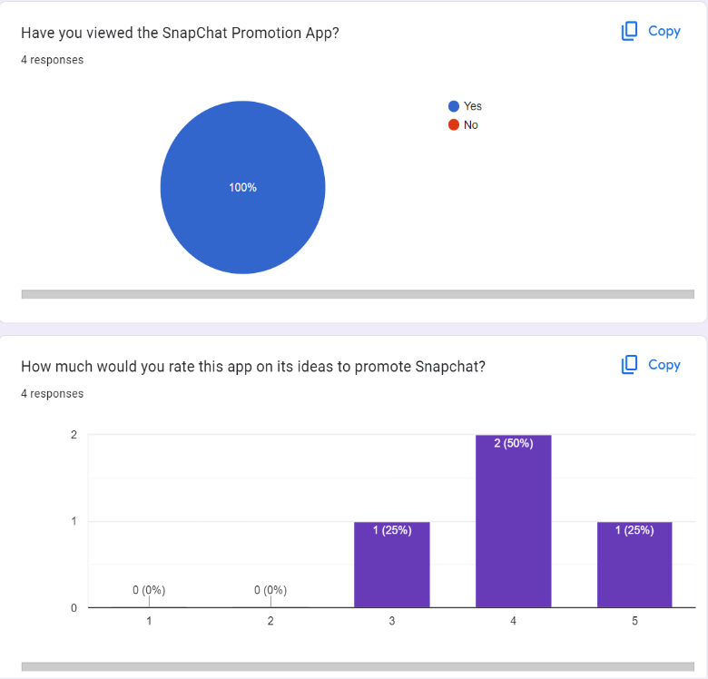

All of the responsers have made use of my application and from all of the app ratings, it seems though that I had an average of 4 rated out of 5 for my app in terms of its ideology (SnapBoost) to boost SnapChat. This shows that my application has produced good ideas for a way to promote SnapChat.

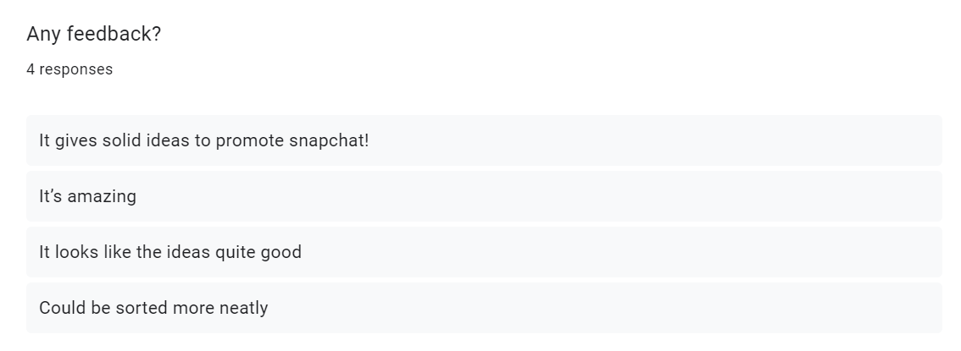

Looking at the feedback, it seems that my application has some improvements to also make, such as sorting the app to make it look neater and more pristine.

#### **11.4.1.6 Concept and Rationale**

The application that I have developed reflects on certain key concepts of promotion marketing such as **Engagement and Interaction**, **Customization and Personalization, Social Sharing** and **Rewards and Incentives.**

· **Engagement and Interaction**: The app makes use of Snapchat features like lenses, filters, and stories to engage users in daily challenges and tutorials, promoting active participation and making more users be inclined to use Snapchat more as a result of these daily challenges.

· **Customization and Personalization**: Users can customize their content with stickers, filters, and captions, enhancing personal expression and connection to the app, which allows for them to have more options to express themselves and be more creative.

· **Social Sharing**: The integration with Snapchat allows seamless sharing of achievements and user-generated content, encouraging viral marketing and expanding reach through social networks.

· **Rewards and Incentives**: Offering rewards for participation in challenges and featuring top content motivates users to engage more deeply with the app, fostering loyalty and repeated use.

As a plus point, I could theoretically advertise my application on social media applications such as Instagram or Tiktok (where majority of the target audiences Gen Zs are) to promote SnapChat and potentially get new users of the app.

#### **11.4.1.7 Reflection**

Personally, for me, PartyRockAI is quite a useful tool for me to develop an application that can perform multiple functions such as Image Generation, idea generation and much more.

I only found out about PartyRockAI during the guest sharing session by AWS on the 26th of June 2024, which was led by one of their team members John Fan. He talked a lot about the future of the industry, which was going to be dominated by multiple different Artificial Intelligence platforms, including ChatGPT, Claude and many more. He also gave us a tutorial on how to create an application using one of AWS’s very own AI Partyrock. The steps to make your own application was quite simple, as you just had to describe in detail how you wanted to customize your application well. One key takeaway was that you had to be quite specific on how you wanted to prompt the AI to create your application

For example:

To prompt PartyRock AI to create an app that plans your next holiday ->

Instead of prompting this: “Create an app for me that can plan my next holiday”

Prompt like this:

"Create an app to plan my next holiday with the following features:

1. **Destination Choice**: Allow users to pick a destination from a list or enter their own.
2. **Budget Planning**: Include a budget tool to help users plan their spending on travel, accommodation, and activities.
3. **Itinerary Builder**: Provide a simple day-by-day planner for activities and sightseeing. Suggest popular attractions for the chosen destination.
4. **Travel Logistics**: Help users book flights, accommodations, and local transport with real-time pricing.
5. **Packing List**: Generate a basic packing list based on the destination and planned activities.
6. **Weather Forecast**: Show the weather forecast for the destination during the travel dates.
7. **Travel Documents**: Remind users about necessary travel documents like passports and visas.
8. **Local Tips**: Offer basic local tips, such as language phrases and recommended foods.
9. **Notifications**: Send reminders for bookings, packing, and other preparations.”

Honestly after making use of PartyRock AI, I found it to be quite user friendly as it required no coding skills to create the app, unlike other application builders. It also gave me a hand on experience to learn more about generative AI and prompt engineering. I got to also express my creativity by customizing my own application and planting my own ideas here and there.

#### **11.4.1.8 Comparison with other AI Tools**

Gemini

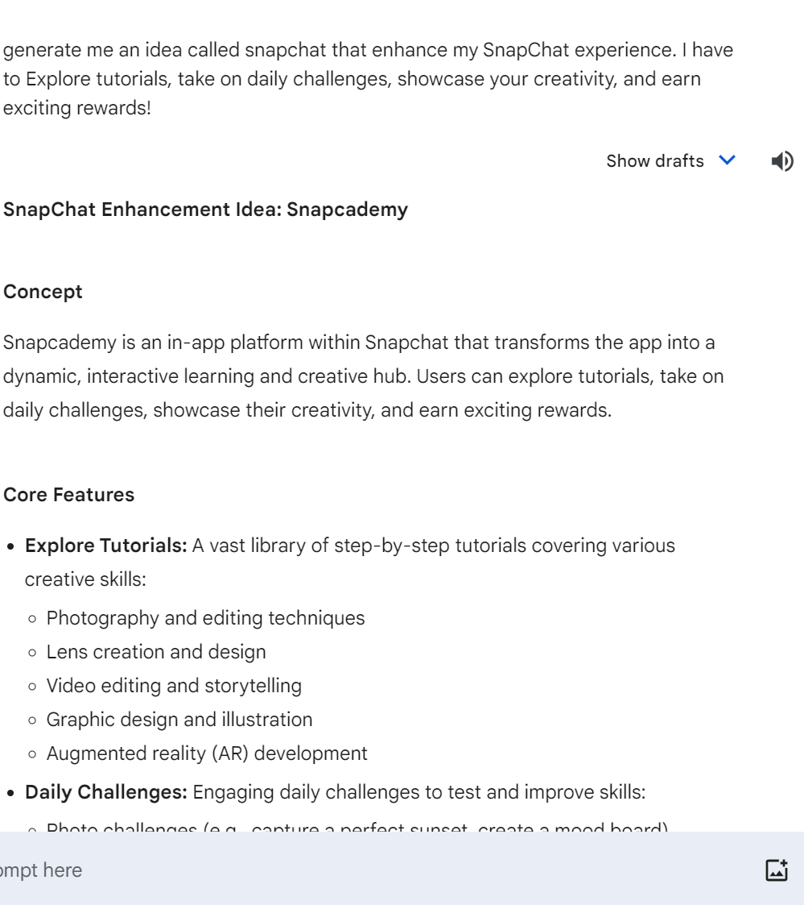

ChatGPT

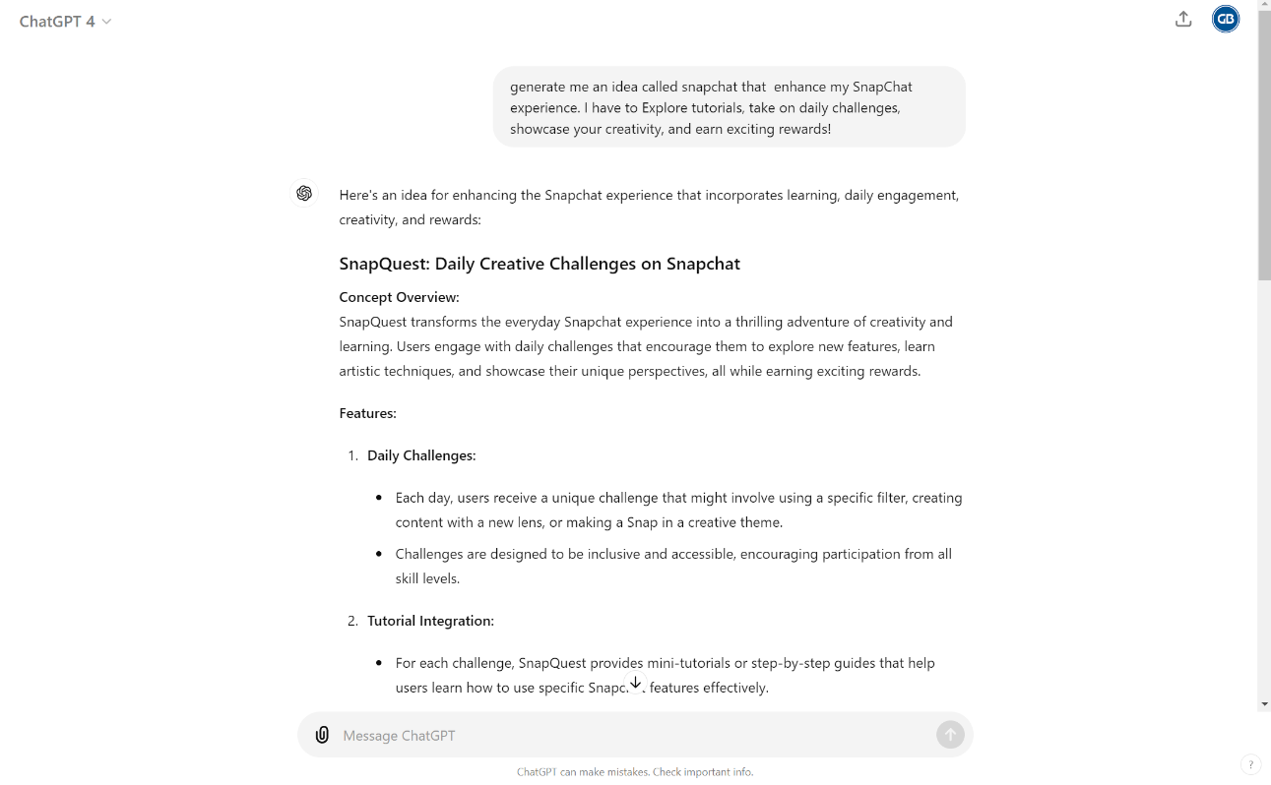

These responses were like the one generated by Partyrock AI, however there are some differences.

One difference is that there isnt’t any HTML code generated that would have been used to create the different layouts of different features such as the navigation links, tutorial lists,

contents section and much more. However, the PartyRock AI application has gone the extra mile to generate the code suitable for making the respective layouts.

Another main difference is the responses for sections such as the Challenge Description.

Gemini:

**Daily Challenges:** Engaging daily challenges to test and improve skills:

* Photo challenges (e.g., capture a perfect sunset, create a mood board)
* Video challenges (e.g., create a short film with a specific theme, lip-sync challenge)
* Lens creation challenges (e.g., design a lens for a specific occasion, create a game lens)
* Editing challenges

ChatGPT:

**Daily Challenges:**

* Each day, users receive a unique challenge that might involve using a specific filter, creating content with a new lens, or making a Snap in a creative theme.
* Challenges are designed to be inclusive and accessible, encouraging participation from all skill levels.

PartyRock:

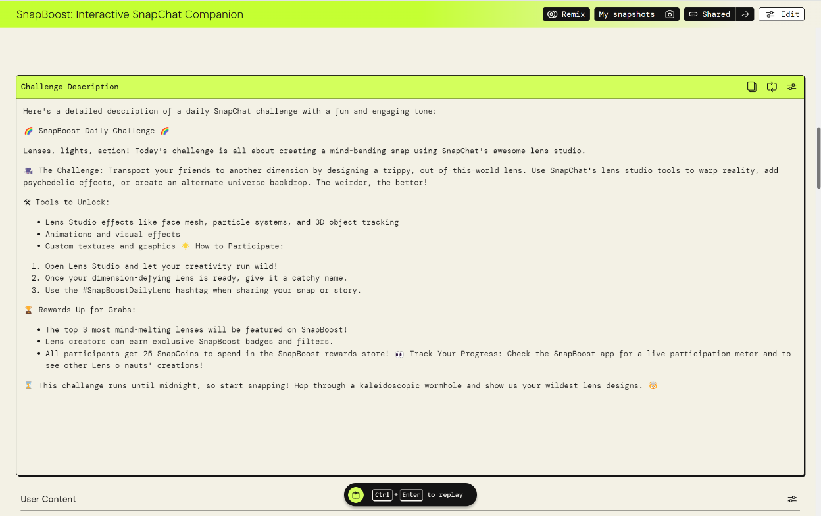

PartyRock in this case, its response is more detailed and makes the response look more friendly and informal by making use of emojis to decorate the response. I’d say I would pick my app over using ChatGPT or Gemini for generating a response like this.

#### **11.4.1.9 Cross Referencing Info and Having Critical Thinking Skills**

In this case just now, all the AIs generated a similar response when I asked them a prompt. This makes it likely that whatever information they gave us, is relevant and accurate.

However, we cannot assume that to be the case. There will be sometimes where the Generative AI provides us with incorrect answers, and we must thus be very vigilant about it.

In this assignment, me and my groupmates made extensive use of ChatGPT to get our sources from the internet. There is nothing wrong with this, since we cross referred BACK to the source websites ChatGPT had provided us with, and the data/statistics provided were accurate. It is thus good practice to double check your answers from Generative AI every time we make us of it. You never know when Generative AI may provide you with incorrect answers.

#### **11.4.1.10 Sign off**

Overall, Generative AI has helped us in our assignments, but we made sure to double check our sources to make sure that everything is factual and correct. As for the PartyRock AI app builder, it is an easy-to-use application that allows me to express my creativity by allowing for extensive customization based on prompts. I would really love to make good use of this application for future projects.

#### **11.4.1.11 References**

4o* suggests that I made use of ChatGPT 4o to help me with part of my response

### **11.4.2 Afiq’s Individual Report**

#### **11.4.2.1 Overview**

After the guest sharing by AWS on the use of a GenAI tool, PartyRock, I am now aware of how PartyRock provides users with a code-free-app building playground while learning the fundamentals of prompt engineering and generative. With that, I have developed an app using PartyRock as part of SnapChat’s Marketing strategy for the company.

#### **11.4.2.2 Concept & Design of App**

**Main Concept**

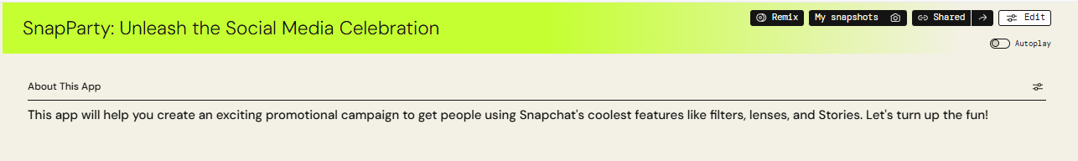

The main concept of this app is to assists creators and influencers in starting campaign by using Snapchat’s features that will ultimately attract people to join in and participate in the trend.

**App Design**

**Campaign Hashtag**

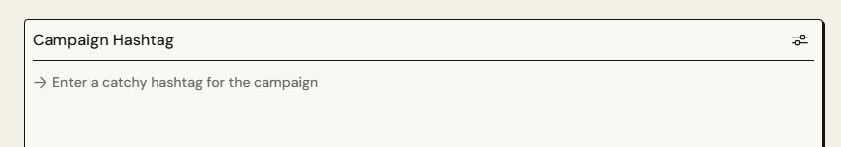

Firstly, Users are prompted to enter their hashtag that will resemble their campaign. Based on the user’s input, the app will find keywords and will potentially generate challenges, filters and story ideas that matches the user’s input.

**Fun Challenges**

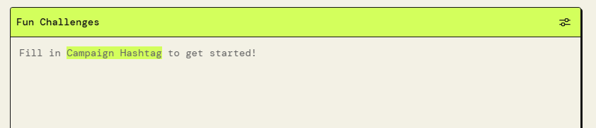

As for the challenges, firstly, the app will generate a new hashtag specifically for challenges that links to campaign hashtag. Next, different challenge ideas will be generated where it provides a general idea of how the challenge should go about and explains the rationale behind the given challenge as well as explaining how the challenge hashtag could be linked back to the campaign hashtag. Finally, Users will be able to create a snap based on the challenge where it could potentially be showcased across the snapchat community for being the most entertaining snap, which is a feature in snapchat called ‘Spotlight’.

**Creative Filter Ideas**

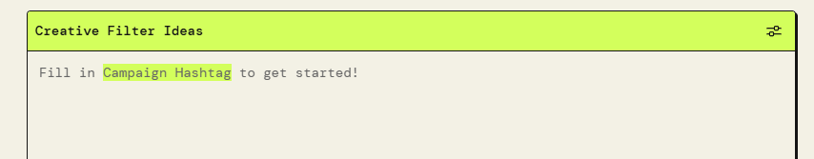

One of Snapchat’s unique and core idea is where it opens the camera and offers tools for creation such as filters, where it is a design overlay that transforms the users face for their snap. With the help of Partyrock, the app will generate a list of different filters ideas that could be made where it matches the idea of the campaign hashtag. These ideas could potentially go viral where many users will use them. As for the output of this feature, like challenges, the app will provide a detailed overview on how the filter should be developed.

**Story Ideas**

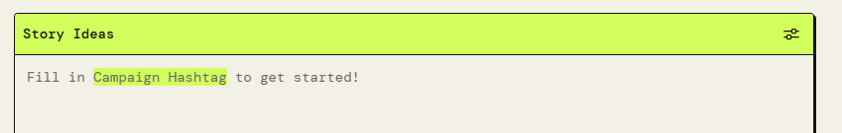

Stories are what Snapchat users use to keep up with latest content from people they wish to keep up with. With the story idea from the Partyrock app, users will be provided with ideas on what to post when creating their stories to share to the public. The app will generate some combination of snapchats features such filters and lenses in order to come up wit the best idea that links back to the campaign hashtag.

**Example Use of App**

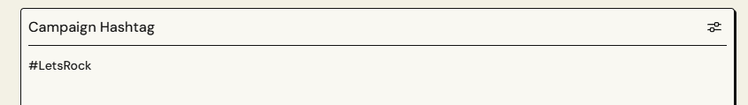

From this example, imaging that this user loves rock music. The user wishes to start a trend where everyone could show their love to anything that is related to rock music. Thus, the user inputs ‘LetsRock as their hashtag.

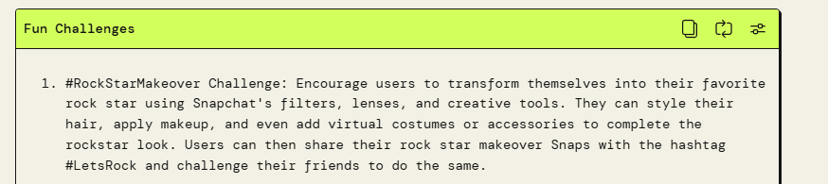

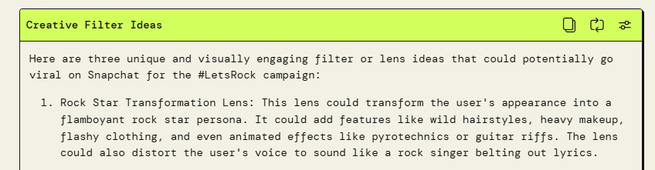

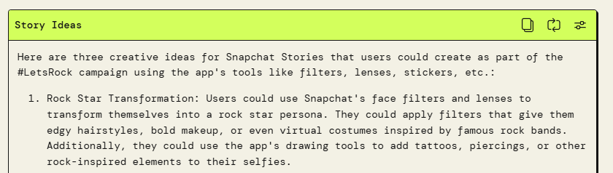

After the campaign Hashtag has been filled in with ‘LetsRock’, the app automatically generates challenges, filters and story ideas that links to the ‘LetsRock’. Firstly, All of the ideas have a direct link to the campaign hashtag. This helps to provide a push to the creators to get on the Snapchat and start creating the campaign hashtag as users will now know what to publish and develop. This ultimately increases the user viewer and may possibly attract newer users to get on the app and start following the campaign.

#### **11.4.2.3 Rationale**

Snapchat offers multiple features to their users. These features may be used to create and combine features to create the ultimate snap. However, some creators and influencers may not know what to publish, have doubts on what they publish makes sense or even views. With these concerns in mind, I have created this app not only for creators, but everyone can use in general. This apps provides a push to those who wants to publish and develop a snap by providing with ideas and how it could attract others to join in.

#### **11.4.2.4 App Feedback**

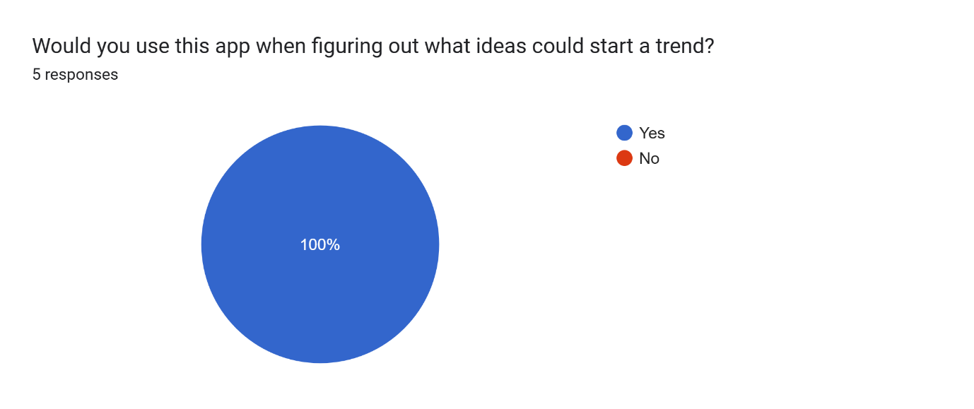

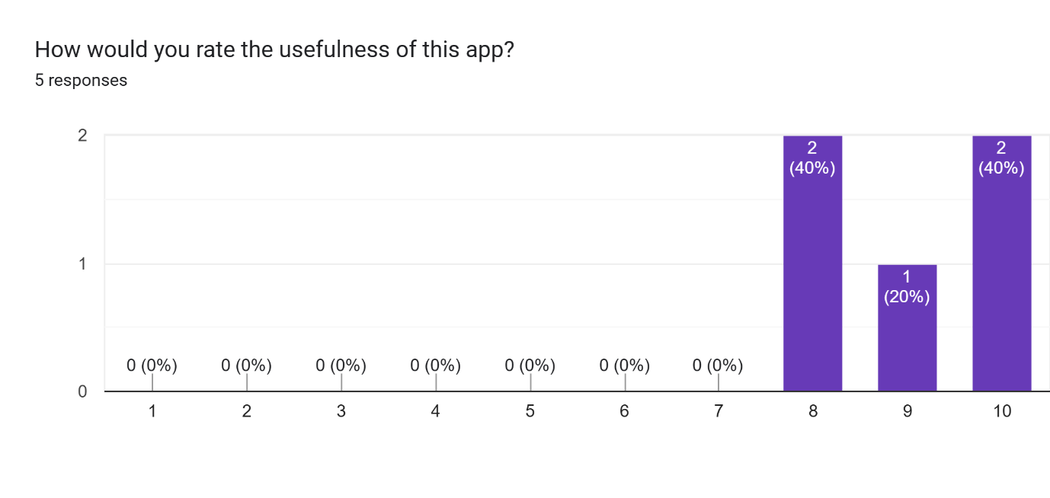

Based on these statistics that I have received social media; I can tell that most of the users that voted definitely thinks that the app that I have developed will be useful in helping creators in idea development that will start a trend. The score from the second graph is all in the high range which supports my app being useful.

#### **11.4.2.5 Reflection**

**PartyRockAI**

During the guest sharing by AWE and during the app development for the assignment 2, I have realised the importance of prompt as it will have a drastic impact on the output. With a detailed prompt where it includes a well-thought-out feature with enough context, PartyrockAI will be able to generate an app that is up to the users standards.

Example of bad prompt: “Make a playlist”

Example of good prompt: "Hey PartyRockAI, can you create a high-energy playlist for a summer pool party? I want a mix of pop, electronic dance music, and some throwback hits from the 2000s. It should last about 2 hours and keep everyone dancing and having a great time!”

From this example a good prompt is clearer and much more specific where it sets the mood, duration, setting and the desired output. With sufficient details PartyrockAI is able to generate an output that links perfectly to the prompt given.

**ChatGPT**

**Evaluating Sources:** When I used ChatGPT for information and prompt them for sources as well, I have to cross check with the actual site to verify that the information is indeed valid before inputting them into my report. By checking the authority, accuracy, coverage and currency, I can easily verify if the sources ChatGPT has provided is valid.

**Refining Critical Skills:** When refining my critical skills when attempting the assignment, I focused on assessing the validity, credibility, and reliability of findings. By evaluating credentials and transparency of authors and journals, and seeking consistency across multiple studies, I enhanced my ability to critically evaluate research. This process highlighted the importance of well-defined research questions, credible sources, and reliable, generalizable findings, ultimately deepening my understanding of rigorous research assessment.

**Cross Verification Method:** Together with my groupmates, everyone has different sources when finding a certain information. When we use ChatGPT for a certain information, we used everyone’s sources to cross verify and see whether the information is similar. This is how we verify if ChatGPT’s information is valid

**Mitigating Flaws of GenAI:** ChatGPT is not always perfect with their information. Firstly, GenAI may be bias as they inherit their information from training data which leads to unfair outputs. Secondly, misinformation and fake content where GenAI generates realistic but fake content. Lastly, resource intensity where GenAI requires substantial computational resource where it could be pricey and environmentally impactful.

As for mitigating these issues, firstly, by having diverse and representation of different demographics to train models, this helps reduce biasedness as there are different train models. Secondly, by having verification systems to verify authenticity of AI generated content, this will reduce misinformation as evidence is there is evidence of authenticity. Lastly, having efficient algorithms helps to use lesser computational power which reduces resources needed. Overall, there are many flaws regarding GenAI but there is always a way to mitigate these issues.

#### **11.4.2.6 Conclusion**

Both PartyrockAI and ChatGPT have been a wonderful resource in terms of my learning. Through this assignment, I have learnt more about the use of generative AI as well as prompt engineering.

### **11.4.3 Senderos’s Individual Report**

#### **11.4.3.1 SnapContent Creator: Personalized Social Media Content Designer**

Link to App: <https://partyrock.aws/u/Senderos/gDyiQlldH/SnapCraft%3A-Personalized-Social-Media-Content-Designer>

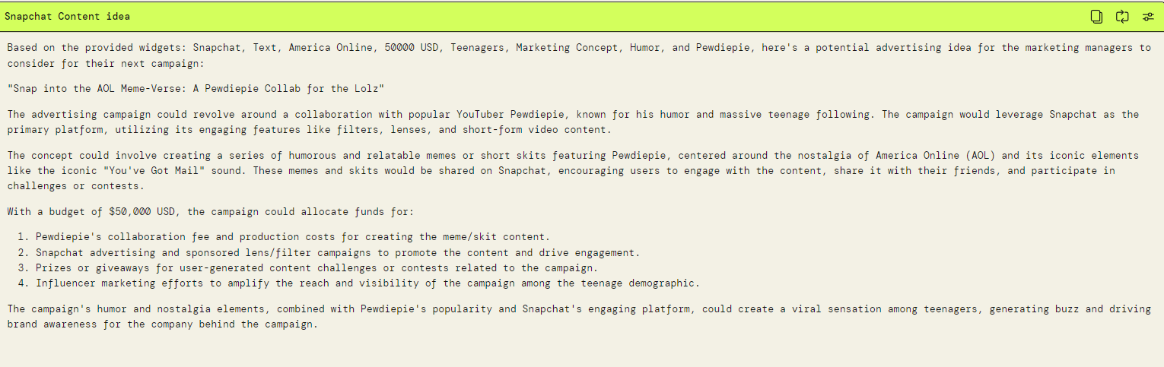

Preview of the app’s functionality: It gives an advertising idea based on the inputs, and generates images based on the advertising widget ‘Snapchat Content idea’

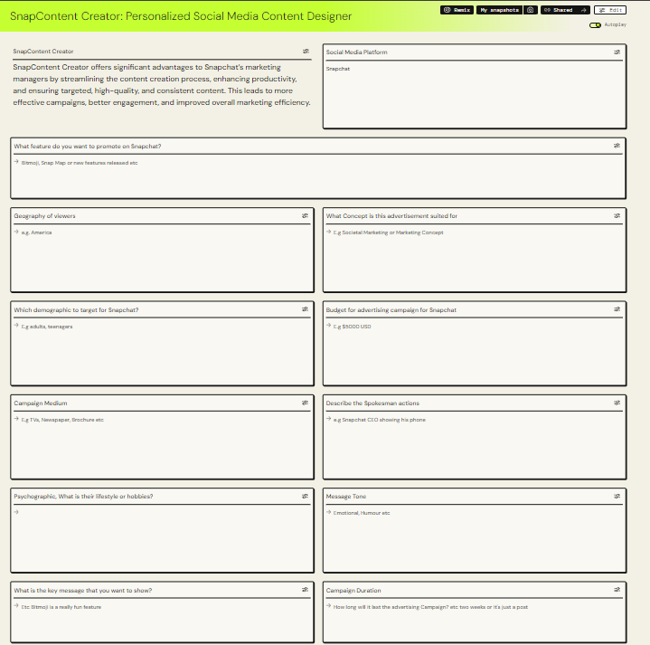

Examples of images generated in SnapContent Creator app developed on PartyRock:

  

#### **11.4.3.2 Reflection on Using PartyRock as a GenAI Tool for SnapContent Creator**

In the initial experience of using PartyRock to create an app during the AWS Guest sharing session led by John Fan on June 26th, 2024, the intuitive interface immediately stood out, even for a first-time user. The process began with a straightforward prompt to ‘Create an App,’ which facilitated the generation of a foundational app with ease as PartyRock allowed for the input of app ideas directly. Although it took some time to become accustomed to the widgets and to understand how to connect the widgets to the draft generator, the learning curve was manageable.

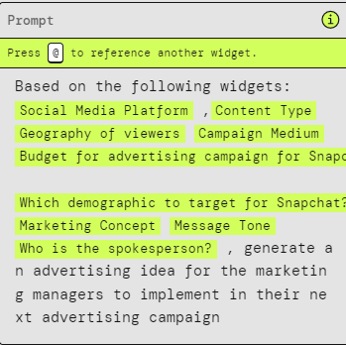

The basics of using PartyRock were well understood. What sets PartyRock apart from other GenAI tools is its ability to function effectively with minimal input. Unlike OpenAI and Claude, which require detailed context and numerous sentences to generate the desired content, PartyRock only needs a few inputs on various widgets. This efficiency significantly reduces the time needed to produce content, making the tool exceptionally user-friendly and timesaving.

The simplicity and efficiency of PartyRock lie in its streamlined input process. Users are prompted to fill out concise and straightforward fields, such as the social media platform, brand voice, content type, and specific campaign details. This approach contrasts sharply with other GenAI tools that often necessitate elaborate instructions and extensive context to generate appropriate content. By minimizing the need for verbose inputs, PartyRock enhances productivity, enabling users to swiftly move from the conceptual stage to content generation

#### **11.4.3.3 Rationale & Concept for SnapContent Creator**

In the fast world of social media advertising, it is even more important today to make custom, quality content in a fast way. The idea for SnapContent Creator was conceived specifically to assist Snapchat marketing managers in this regard. The goal was to offer them an advanced AI-based tool that would help simplify their content development process. This inspiration was drawn from SnapContent Creator being increasingly difficult to have one voice about the brand while capturing a wide variety of audience and making its contents adaptive for various platforms at short notice.

Usually, it takes a lot of manual effort to create all such content, which can be tedious and inconsistent. Furthermore, platform-specific content contributes another level of complexity. SnapContent Creator was designed to address these pain areas by automating initial steps in content creation so that marketing managers could put more emphasis on strategy and fine-tuning the final product.

When SnapContent Creator was built, several key considerations for Snapchat's marketing team were kept in mind. The most important aspect was efficiency. SnapContent Creator cuts down the time to make draft content by automating it. This helps marketing teams move and keep up with what's hot in the market and how users act. Consistency was also a critical factor. It's important for a brand to sound the same in all its posts and campaigns. SnapContent Creator excels at this by making content that follows the brand's rules, ensuring everything sounds like the brand, no matter who's making it. Customization was another focus. Snapchat has all kinds of users, so content needs to cater to different groups, places, and interests. SnapContent Creator allows this by letting users choose parameters like social media platform, content type, length, and campaign medium. This means marketing managers can create content that speaks directly to their target audience.

As Snapchat keeps growing, the ability to handle more users becomes crucial. SnapContent Creator supports this by enabling marketing managers to generate large volumes of content without sacrificing quality. This is essential to keep up with the platform's demands and ensure the content remains fresh and engaging. Overall, SnapContent Creator was developed to make it easier and better for Snapchat's marketing team to create content. It helps them produce high-quality, consistent, and customized content quickly and efficiently, allowing them to spend more time on creativity and strategy.

#### **11.4.3.4 Marketing Concepts Implemented from ISM**

Most of the widgets created in SnapContent Creator utilize concepts learned from the 4Ps, specifically Promotion. When developing SnapContent Creator, it was essential to identify the target audience for the advertising campaign. Therefore, there are widgets that prompt marketing managers to input geographic information, demographics, and psychographics.

One widget, named ‘What is the key message’, implements concepts from Integrated Marketing Communications (IMC) learned in ISM Promotions, focusing on the primary objectives of IMC. It asks for the goal of the campaign, key message, or Call-to-Action. Designing the message required several inputs, such as the key message, the campaign medium, and the individuals involved in the campaign.

During the week focused on Promotions, we also learned that advertising campaigns could be planned in different ways, such as month-to-month, rather than solely goal-oriented. Consequently, a widget was created to gather input on the budget, ensuring realistic advertising campaigns within financial constraints. Lastly, SnapContent Creator incorporates feedback gathered from various users to showcase engagement. This approach is similar to how organizations conduct marketing research to test preliminary app concepts with members of a target segment.

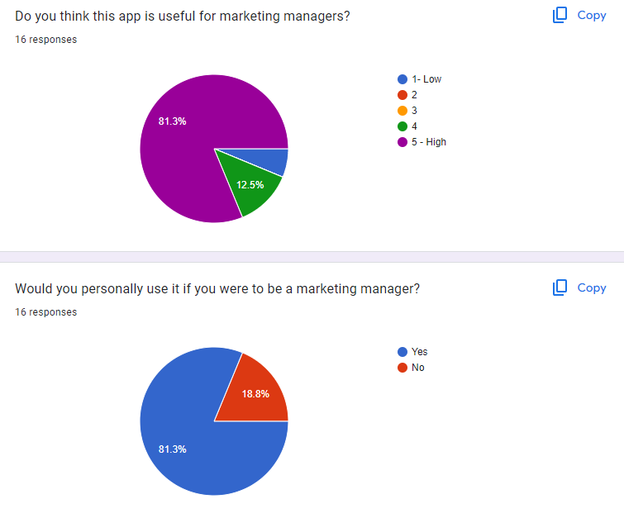

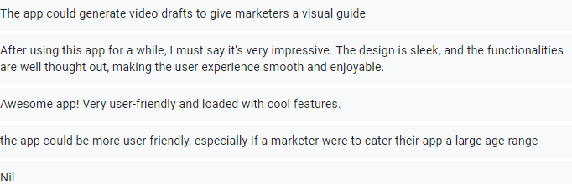

The feedback on SnapContent Creator indicates strong positive reception, with 81.3% of respondents finding the app highly useful for marketing managers and expressing a willingness to use it personally. This reflects that the app's features align well with user needs for efficient content creation. There was feedback that stated if the app could generate video drafts for advertisement, it would be better for marketers. There was an idea to implement that, but due to PartyRock’s limitations, the app was unable to do that.

#### **11.4.3.5 Comparison with other GenAI Tools**

Google Gemini Output:

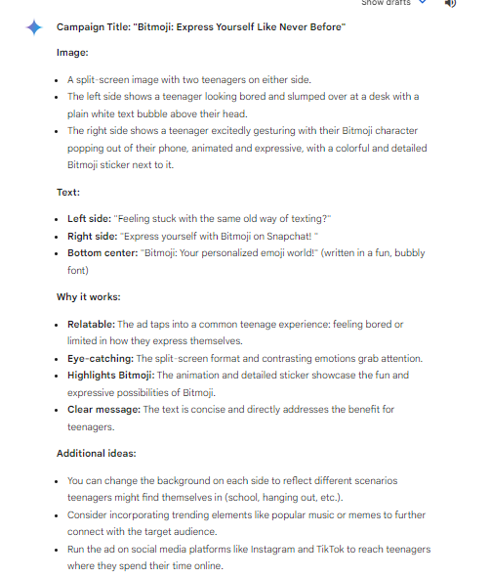

Snapchat Content Idea Output:

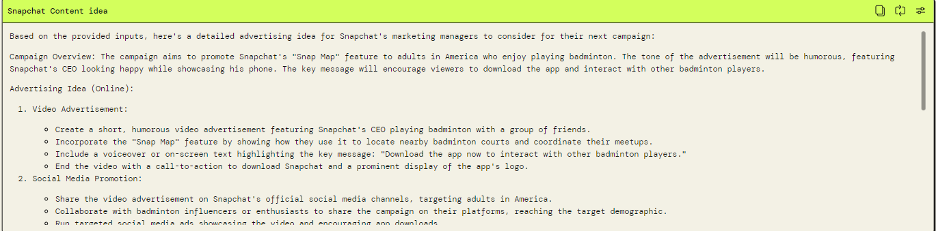

OpenAI Output:

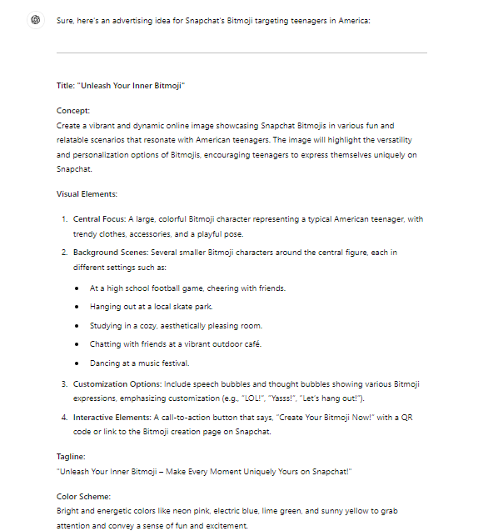

It can be observed that for the Snapchat Content Idea created on PartyRock app, its idea is much more granular in the fact that it tells us what actions should be taken. For example, ‘Share the video advertisement on Snapchat’s official social media channels, targeting adults in America’. And other imperatives like collaborating with influencers. On the other hand, Google Gemini merely stated how the poster should be written, without any recommendations for the marketing managers to take. For OpenAI, it gave more specific ideas compared to Google Gemini, it recommended having the advertisement include Call-to-actions, providing examples. Additionally, it has recommended a colour scheme with bright colours to attract Snapchat’s users.

However, the difference that makes PartyRock different compared to these two is that it can generate both text and image at the same time, while other GenAI tools like OpenAI and Google Gemini can only do one or the other once per time.



One of the images generated by SnapContent Creator

This image is generated from this widget:

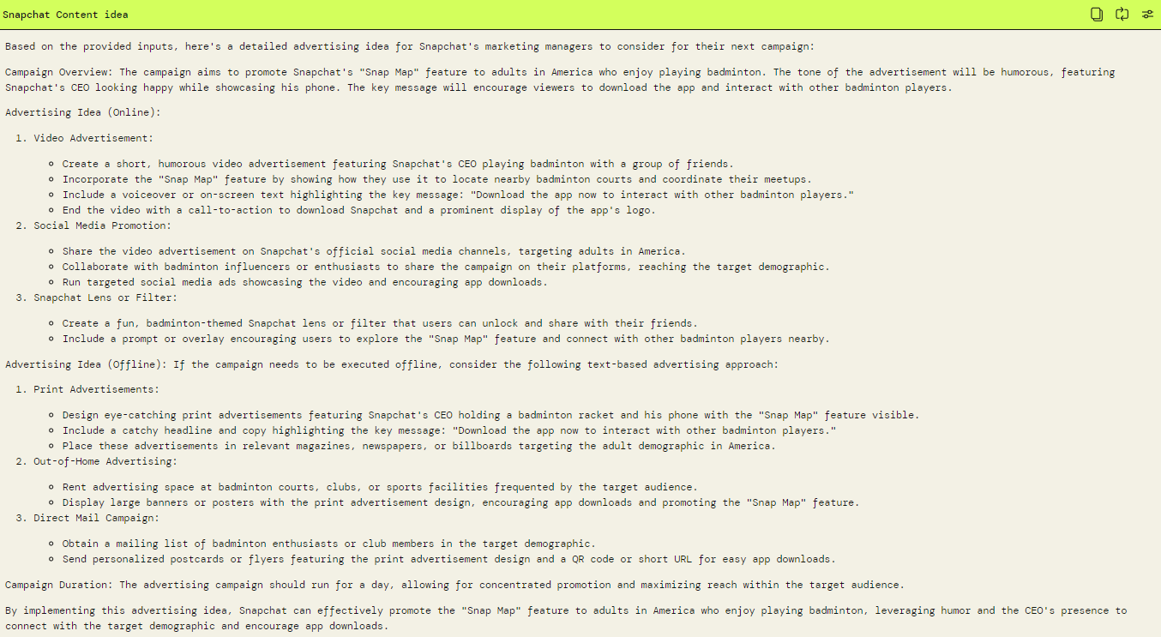

Hence, what sets PartyRock apart is that it can do both outputs simultaneously.

#### **11.4.3.6 Reflection on using GenAI for Group Report**

When creating the group report, I used various GenAI tools to further enhance my research and analysis to refine my paragraphs. For each section such as Industry, company and portfolio analysis, I was able to refine my critical thinking skills by using a combination of both GenAI tools as well as the internet to decipher reliable information.

A Problem Identification that I had solved with the help of GenAI tools:

**Where is Snapchat placed in the Product Life Cycle?**

AI Tools Chosen for cross-validation

1. OpenAI’s ChatGPT 4.0

2. Google Gemini

3. Microsoft Copilot

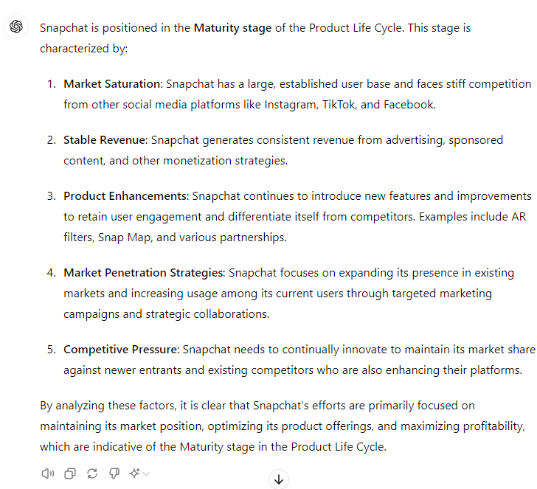

Output from OpenAI ChatGPT

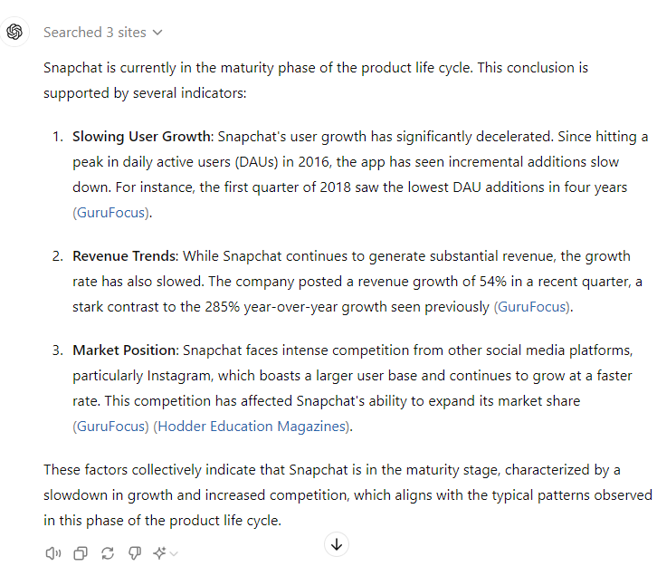

Further prompting on OpenAI with ‘Give evidence to websites that support your argument’.

It is noted that while ChatGPT provides valuable points to answer the question, it lacks recent data, such as Snapchat’s Daily Active User (DAU) growth for the years 2022 and 2023, relying instead on information from 2018. Consequently, the evidence presented is insufficient. However, the response effectively establishes a foundation for assessing Snapchat’s current position in the product life cycle. For example, if Snapchat was in the maturity stage in 2018, it could be inferred that it is now in either the maturity or decline stage in 2024. Thus, ChatGPT offers a good starting point for further analysis.

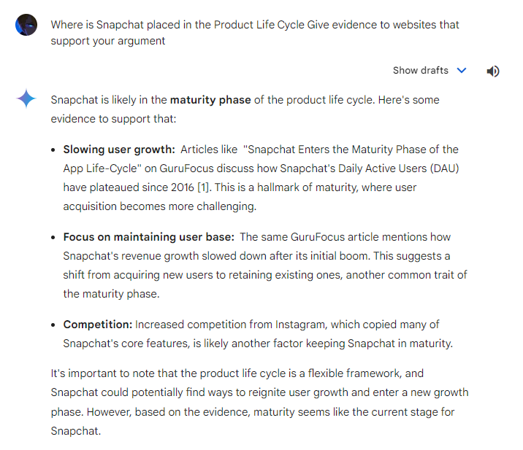

Output from Google Gemini

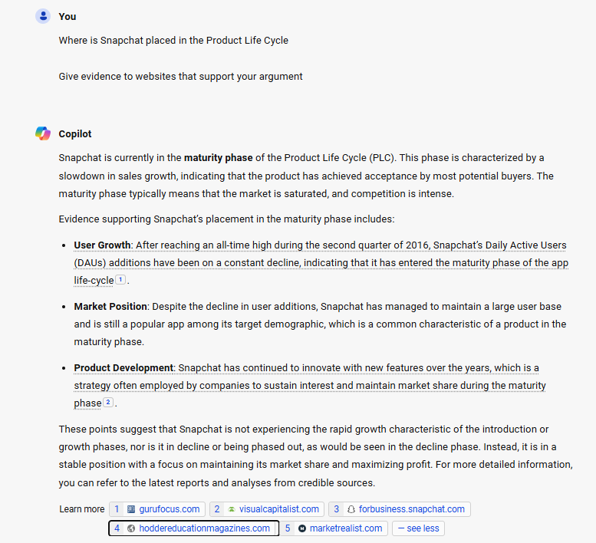

Output from Microsoft Copilot

**Review of Outputs from different GenAI tools**

**ChatGPT:** It is noted that while ChatGPT provides valuable points to answer the question, it lacks recent data, such as Snapchat’s Daily Active User (DAU) growth for the years 2022 and 2023, relying instead on information from 2018. Consequently, the evidence presented is insufficient. However, the response effectively establishes a foundation for assessing Snapchat’s current position in the product life cycle. For example, if Snapchat was in the maturity stage in 2018, it could be inferred that it is now in either the maturity or decline stage in 2024. Thus, ChatGPT offers a good starting point for further analysis.

**Google Gemini:** Like ChatGPT, but it only briefly talked about the reasons why Snapchat is in this phase. It did not provide any stats or figures compared to ChatGPT. Additionally, it did not give the link for users to go and check out the article themselves, which is a limitation for Gemini.

**Microsoft Copilot:** Like the above 2, but Copilot is better than Gemini in that it was able to provide the specific links.

#### **11.4.3.7 Conclusion**

All in all, the main challenge was the lack of comprehensive evidence from the AI tools. To address this, manual research is done on the internet to find the most relevant evidence, and not those spanning from 5 years ago. These flaws by GenAI such as providing outdated evidence and not supporting figures shows that the tools are still not capable to an advanced level of portfolio analysis. Critical thinking skillsets are still imperative to be able to differentiate whether firstly, the source is relevant, followed by whether this source can still be used in the current date and if other articles / web pages share the same notion on the same topic as the product life cycle of Snapchat.

Additional cross verification was also done between articles and not just GenAI. For example, when searching evidence for the product life cycle of snapchat, it is necessary to check whether the content shared by different articles show the same result. Cross verification is important when conducting the analysis of Snapchat and other companies as providing wrong information to the senior management of the company will cause devastating results. When I see different content shared by different articles. I will do an analysis of the speaker or publisher, whether there is any vested interest.

#### **11.4.3.8 Citation & References**

OpenAI. (2023). GPT-3.5: Generative Pre-trained Transformer.

Microsoft. (2023). Microsoft Copilot: AI-powered Productivity Tool.

Google. (2023). Google Gemini: AI-driven Insights for Businesses.

### **11.4.4 Zavier’s Individual Report**

#### **11.4.4.1 Introduction**

As part of my assignment and in conjunction with the guest sharing by AWS on the use of Gen AI tools including PartyRock for development of apps, I have been tasked to build an app using PartyRock as part of the marketing strategy for the company I chose Snap Inc. on Snapchat, under one the 4 Ps, ‘Promotions’.

So, I have created an app to help promote the array of features Snapchat has to offer by educating business on how to leverage it: Snap4Biz Consultation App

#### **11.4.4.2 Preview**

The Snap4Biz app is to promote Snapchat as a powerful marketing platform for businesses, especially startups and small to medium-sized enterprises (SMEs). By demonstrating the various features and tools Snapchat offers, Snap4Biz aims to showcase how businesses can effectively utilize these resources to enhance their marketing and promotional activities.

#### **11.4.4.3 Objective**

* **Promote Snapchat’s Capabilities:** To highlight the diverse tools and features available on Snapchat, such as Stories, Geofilters, Lenses, and Snap Ads, and demonstrate how these can be used to drive brand visibility and engagement.
* **Educational Resource:** To educate businesses on the best practices for using Snapchat in their marketing strategies, providing them with the knowledge and confidence to leverage the platform effectively.
* **Strategic Guidance:** To offer strategic advice on integrating Snapchat into broader marketing campaigns, including tips on content creation, audience targeting, and performance measurement.

#### **11.4.4.4 App Development using PartyRock**

Snap4Biz App Link: <https://partyrock.aws/u/Zavier/nZyxCUlSK/Snap4Biz-Consulting-App>

**Design Mocks of the App**

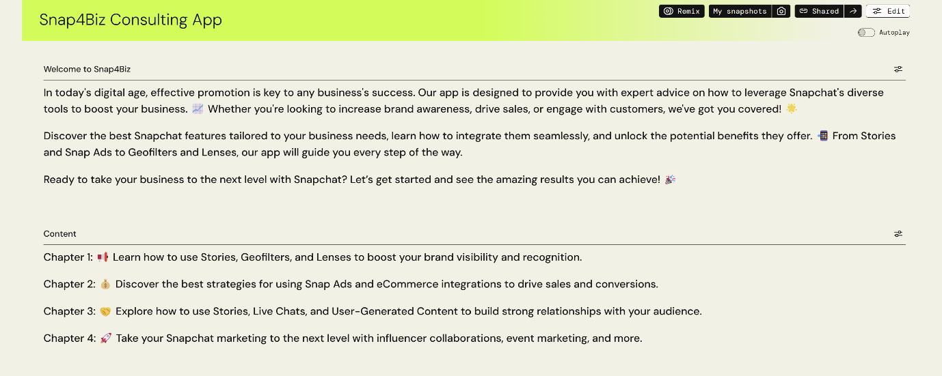

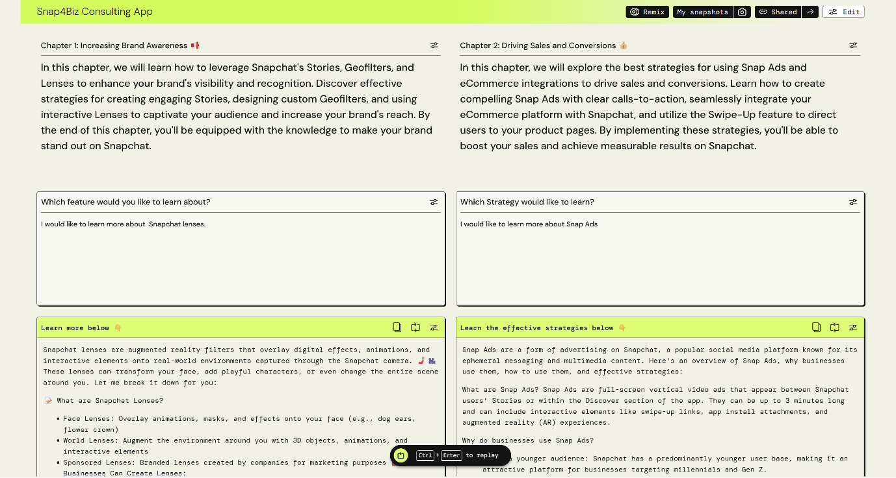

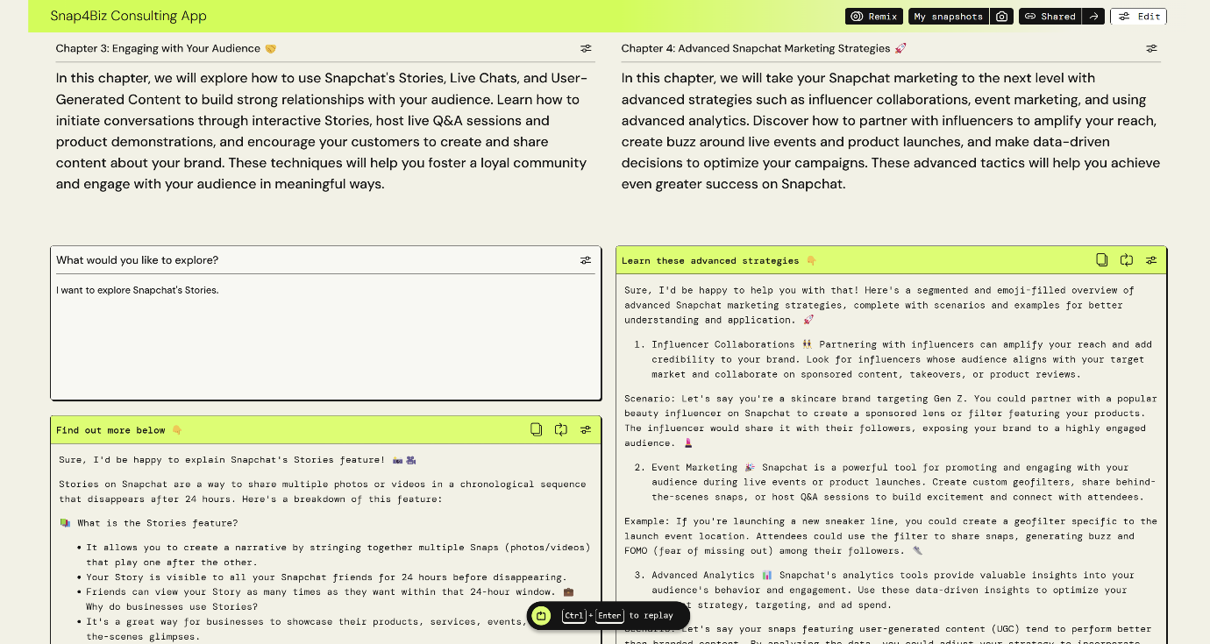

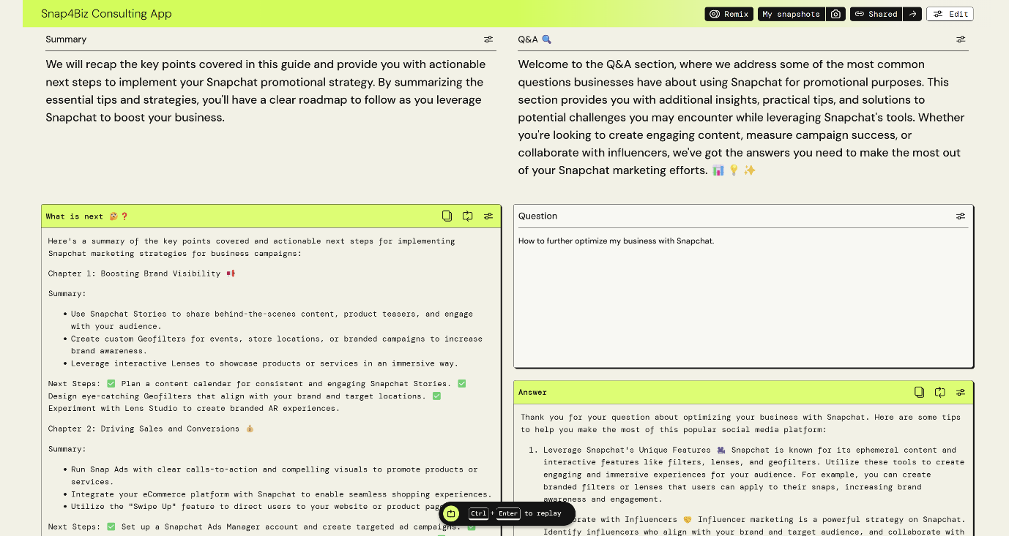

#### **11.4.4.5 Promotional Technique**

Based on the promotion tool table, I used the sales promotion tool when creating the app.

**Reach**

The specific segment I had in my when building the app was targeted towards startups and small to medium-sized enterprises (SMEs). The app is meant to provide businesses comprehensive educational resources about using Snapchat for business. This includes detailed guides, best practices, and strategic advice. The educational approach is rooted in content marketing, aimed at providing value to users and positioning Snapchat as an essential tool for their marketing needs.

**Main Costs**

Creating the Snap4Biz app was relatively cost-effective due to it being preloaded with many useful resources for app creation. This approach minimized development costs while maximizing the value provided to the target audience.

**Strengths**

One of the main strengths of the Snap4Biz app is its flexibility. The app can be easily adjusted and updated to include new features as Snapchat evolves. This adaptability ensures that the app remains relevant and valuable to its users over time.

**Weaknesses**

However, the free nature of the platform means that many others have access to the same resources, making it easy for competitors to recreate or even improve upon the app. Additionally, the use of AI poses a risk, as individuals with malicious intent could provide false or misleading information under the guise of a trustworthy guide. The ease of app creation also means there will always be constant competition, which can dilute the app's unique value proposition.

#### **11.4.4.6 Rationale & Purpose for Snap4Biz**

In the fast-paced VUCA world, it is increasingly important to provide businesses with comprehensive tools that can streamline their promotional efforts and maximize engagement. The idea for Snap4Biz was conceived specifically to assist startups and small to medium-sized enterprises (SMEs) in effectively leveraging Snapchat for their marketing needs. The goal was to offer an educational and strategic resource that simplifies the process of using Snapchat’s diverse tools for business promotion.

Snap4Biz was inspired by the challenge many businesses face in understanding and utilizing social media platforms efficiently. Creating impactful content and campaigns often requires significant manual effort and expertise, which can be daunting and inconsistent, especially for smaller businesses. Moreover, each platform has its unique set of features and user behaviour, adding another layer of complexity. Snap4Biz was designed to address these challenges by providing detailed guides, best practices, and strategic advice tailored to Snapchat, allowing marketing managers to focus more on creative strategy and execution.

When developing Snap4Biz, several key considerations were kept in mind to meet the needs of Snapchat's business users. The primary focus was on **educational value**. Snap4Biz provides comprehensive resources that educate users on the various features of Snapchat, such as Stories, Geofilters, Lenses, and Snap Ads, and how to use them effectively for marketing purposes. This helps businesses quickly learn and implement these tools, keeping pace with market trends and user behaviour.

**Consistency** was another critical factor. Maintaining a unified brand voice across all marketing efforts is crucial for building brand identity and trust. Snap4Biz offers step-by-step instructions and best practices to ensure that businesses create content that aligns with their brand guidelines, ensuring a cohesive and professional presence on Snapchat.

**Efficiency** was a final key consideration. Snap4Biz aims to reduce the time and effort required to develop effective Snapchat campaigns by offering ready-to-use templates and detailed tutorials. This enables businesses to produce high-quality content quickly, ensuring they remain agile and responsive to market demands.

As Snapchat continues to evolve and grow, the ability to scale content creation becomes increasingly important. Snap4Biz supports this by equipping businesses with the knowledge and tools to generate large volumes of engaging content without compromising on quality. This is essential for keeping up with the platform's dynamic nature and ensuring that promotional efforts are always fresh and compelling.

Overall, Snap4Biz was developed to enhance the capabilities of Snapchat's business users by providing an all-encompassing, educational, and strategic tool. It helps businesses produce consistent, customized, and high-quality content efficiently, allowing them to focus more on creativity and strategic planning.

#### **11.4.4.7 Reflection on Using PartyRock as a GenAI Tool**

When I first came across PartyRock, it was during the AWS Guest sharing session led by John Fan on June 26th, 2024. My initial thought when using PartyRock to create an app was smooth and intuitive, even as a user who never used it before. The user interface stood out as simple and straightforward. This allows generating a base app easy, as PartyRock allows for direct input of app ideas. Although some time was needed to familiarize myself with the widgets and how to integrate them, the learning curve was fairly manageable.

The fundamental functionalities of PartyRock were quickly grasped. One of the standout features of PartyRock compared to other GenAI tools is its efficiency with minimal input. Unlike tools like OpenAI and Claude, which require detailed context and numerous sentences to generate the desired content, PartyRock operates effectively with just a few inputs on various widgets. This efficiency significantly reduces the time needed to produce content, making the tool exceptionally user-friendly and timesaving.

Overall, my experience with PartyRock highlighted its strengths in simplicity and efficiency. The tool's design allows for quick learning and application, making it an ideal choice for businesses looking to streamline their content creation process. By reducing the complexity typically associated with GenAI tools, PartyRock enables users to focus more on strategic planning and creativity, ultimately enhancing their marketing efforts.

#### **11.4.4.8 Comparison with other GenAI Tool**

Here I will be showing some comparison by using the same prompt to compare the output between selected AI tools and Snap4Biz Consultation App.

# Prompt: I would like to learn more about the features of Snapchat Lenses.

**ChatGPT Response**

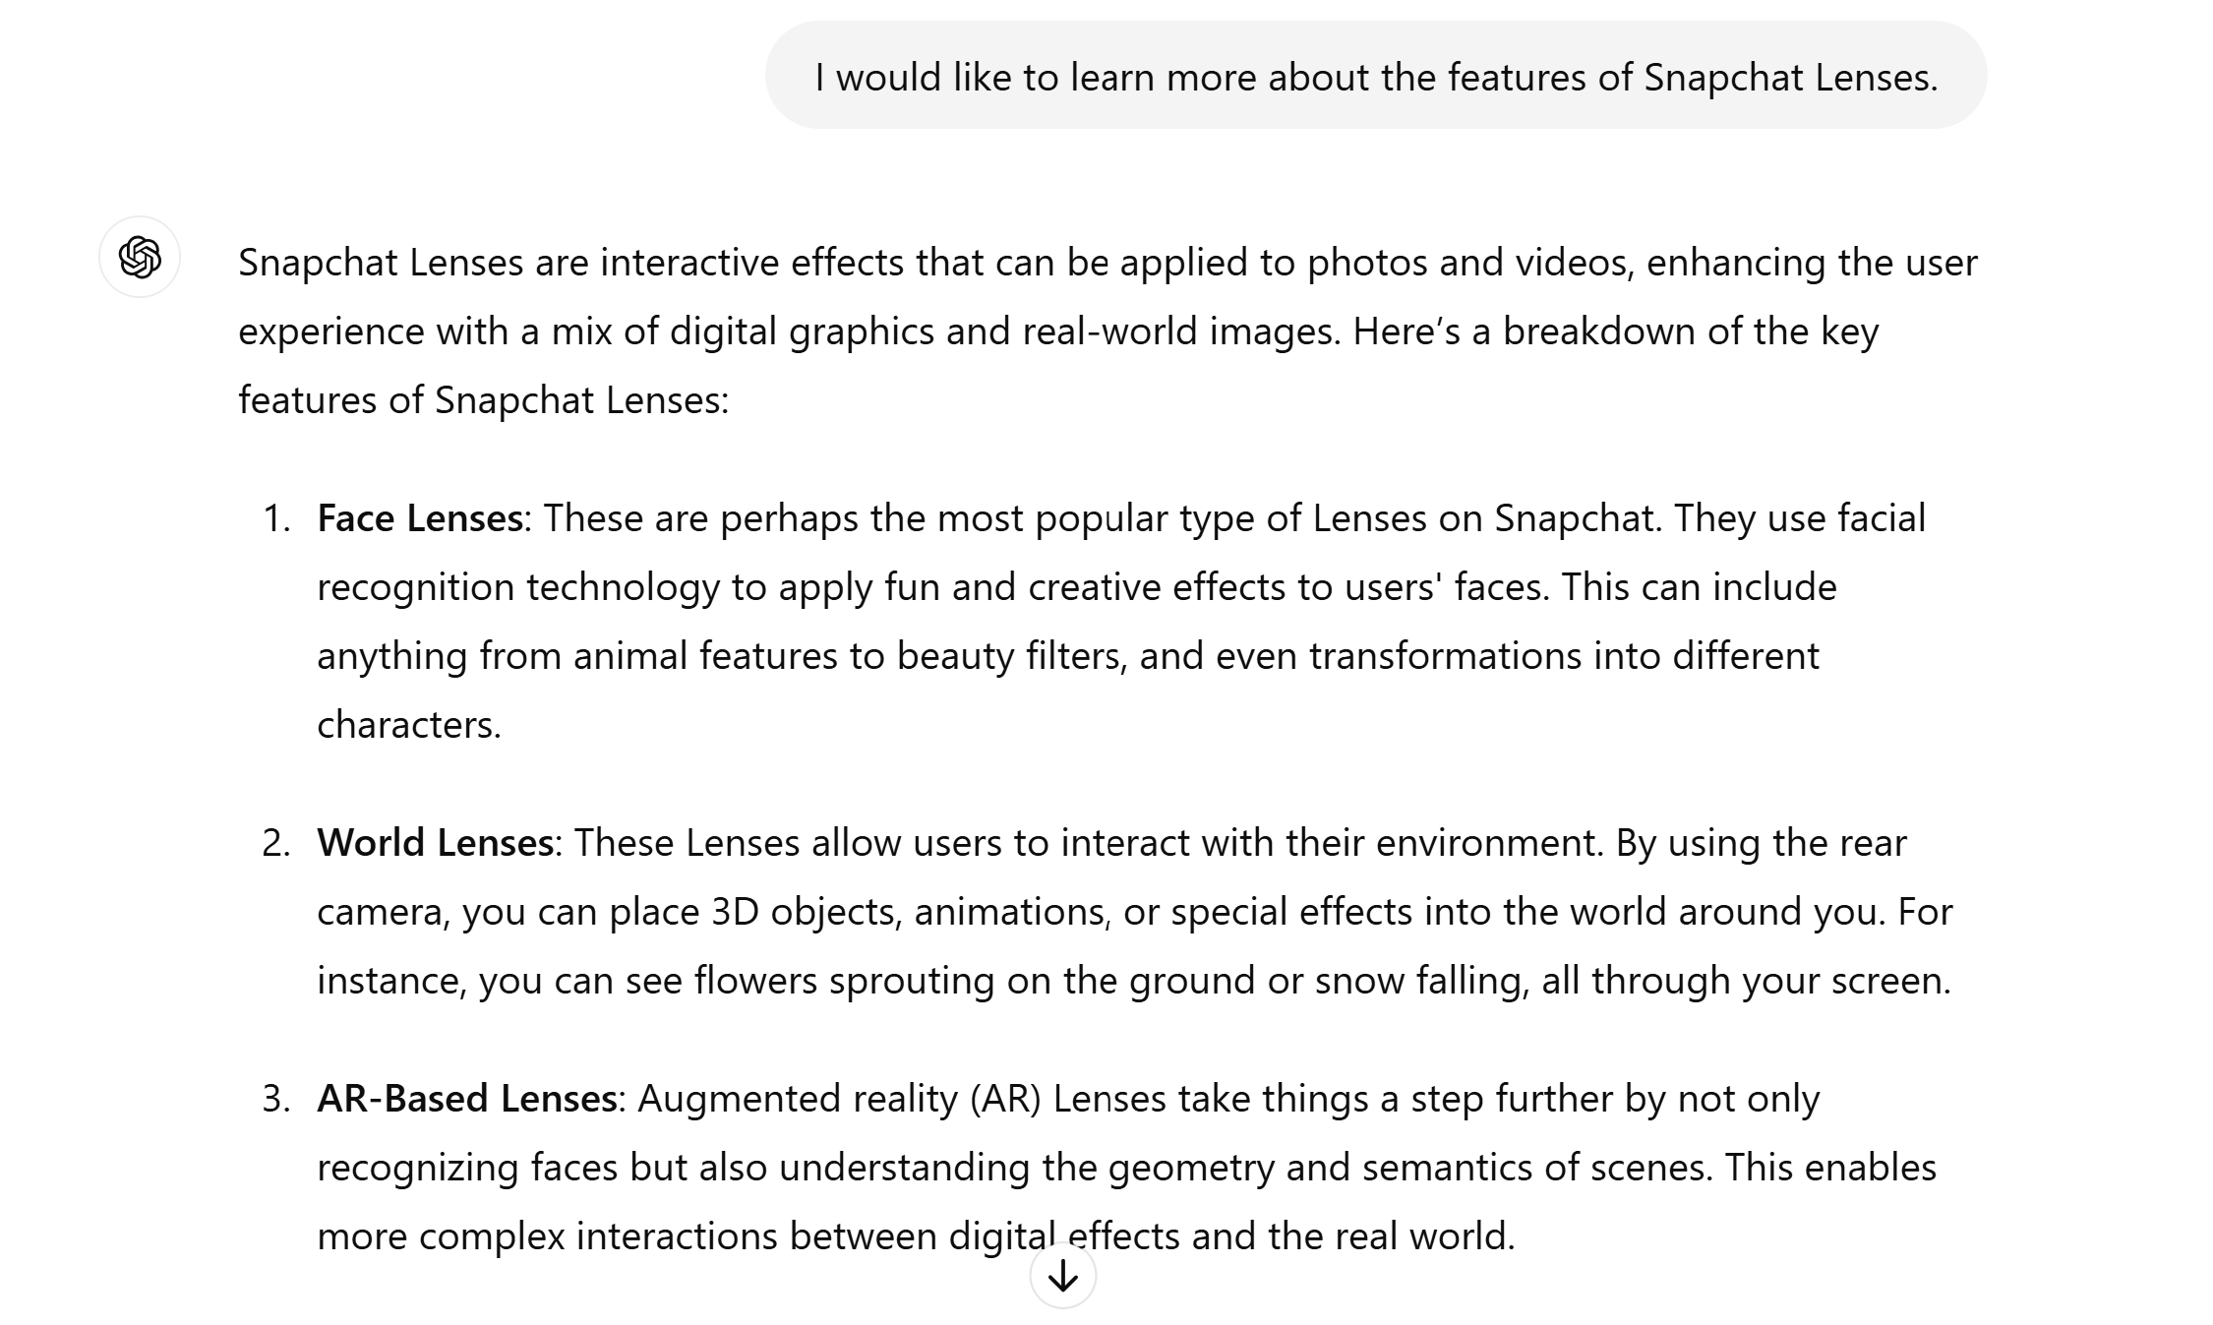

**Gemini Response**

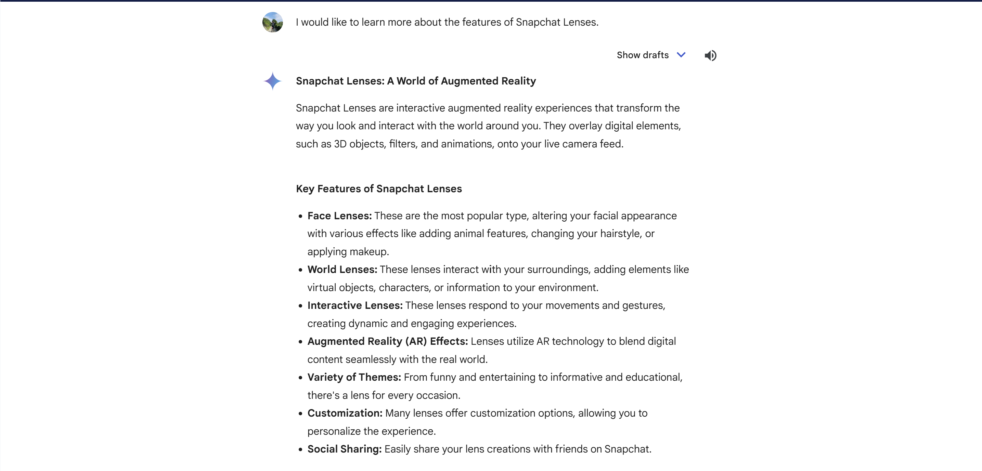

**Snap4Biz Response**

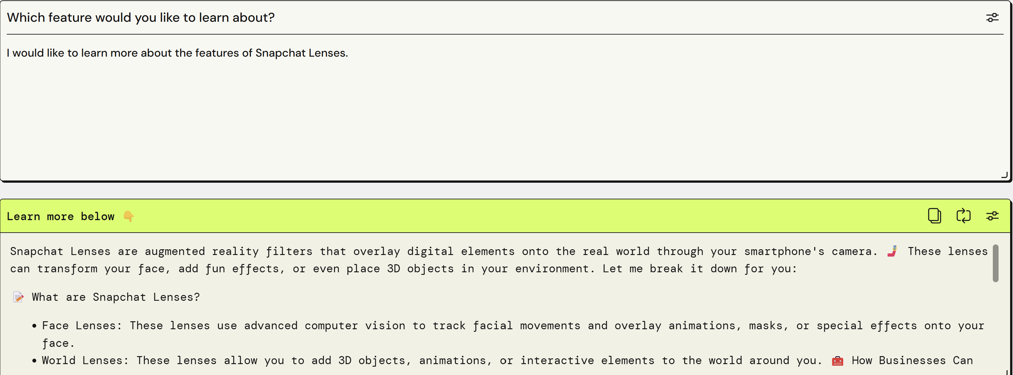

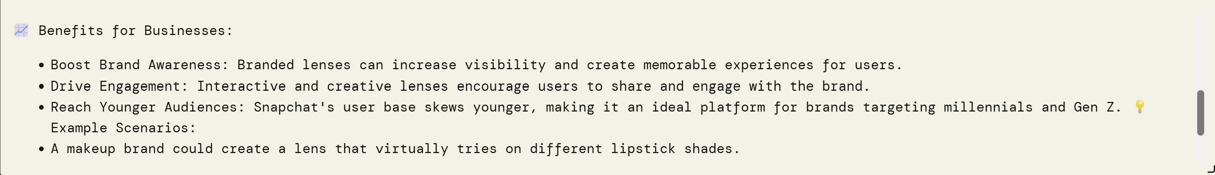

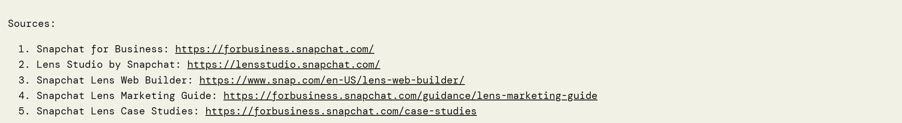

As you can see, when entering the same prompt on ChatGPT and Gemini, the response is quite similar and lacking any depth in the quality it produces. However, with Snap4Biz, it does not only tell you about the feature you want to know more about. But it goes above and beyond to provide you with examples, scenarios and strategies on how the user can leverage on the features to help them in their business planning. The content is more personalized to allow users to feel that the AI is not just providing suggestions, but recommending suggestions alongside them with the context that they are business owners wanting to leverage on these tools. So, it works alongside them understand the business context and how the features from Snapchat can apply and help in their business needs. Snap4biz also ensures that the information provided is reliable and accurate as it at least searches from 5 authoritative sources and ensure the information is similar before recommending to users. It also shows where they get the information down by showing the sources from unlike ChatGPT and Gemini. This helps users to trust Snap4biz more and differentiates itself from the other 2 by being reliable, accurate and informative. Making reading and understanding concepts and strategies easier than before.

#### **11.4.4.9 Feedback**

Once the app was done, I created a google form to gather constructive feedback on the app. Here are the statistics.

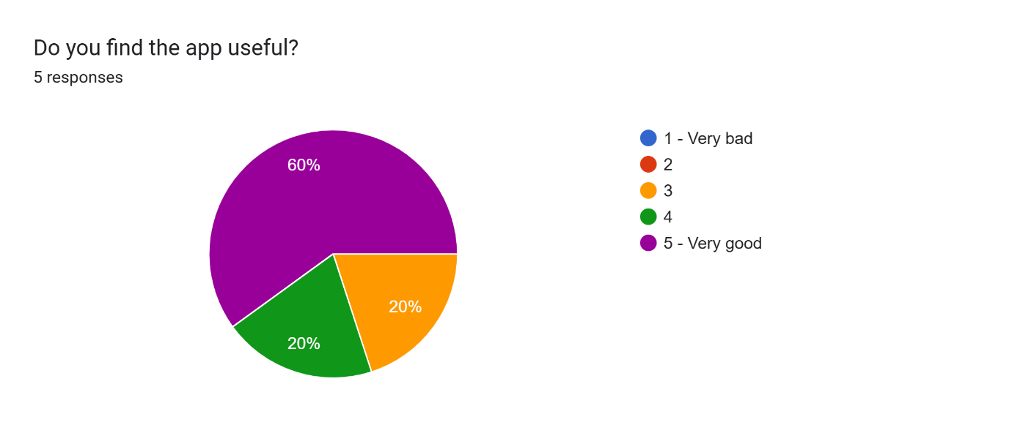

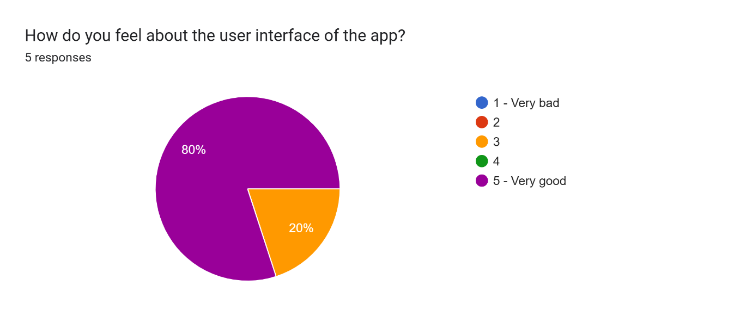

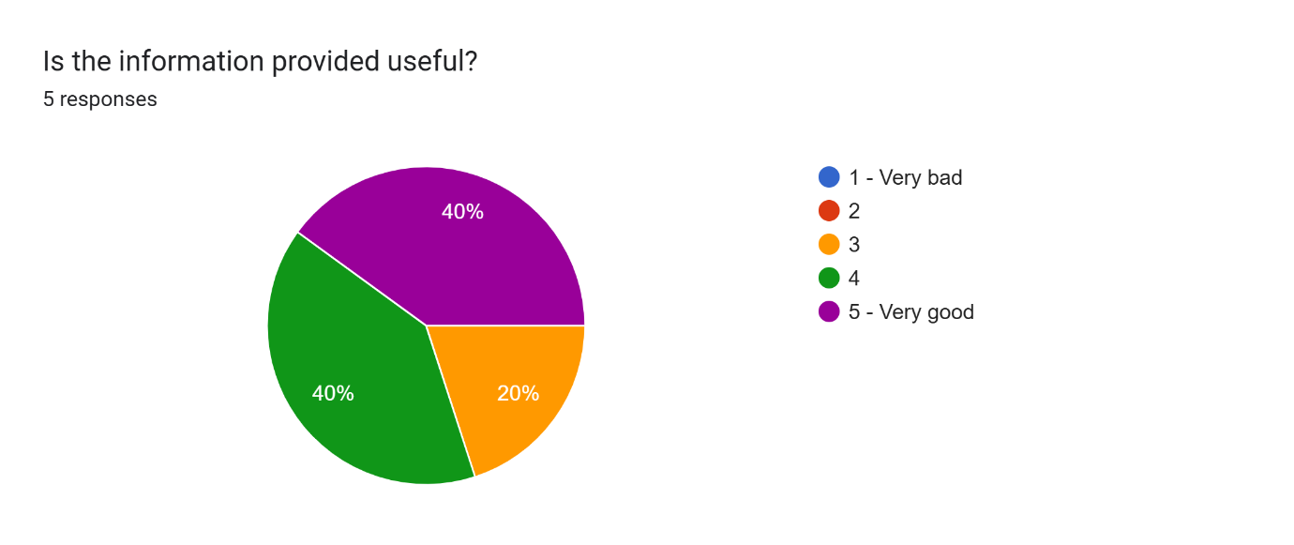

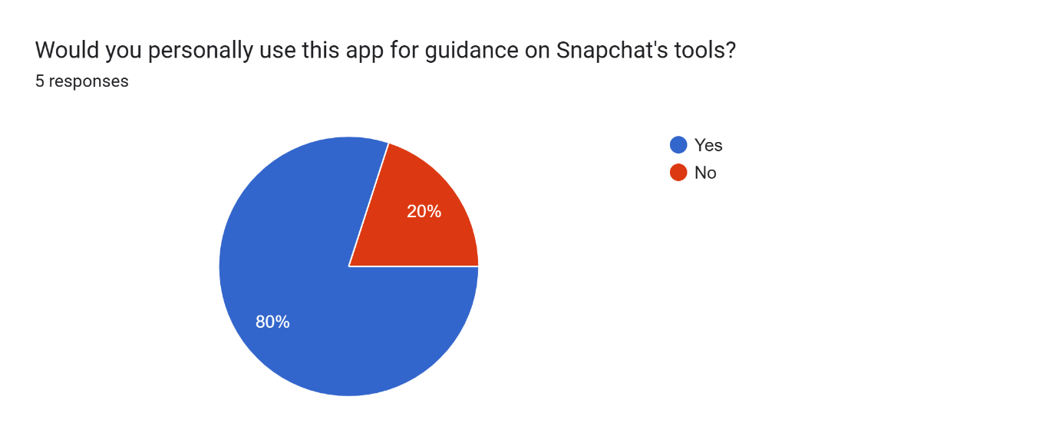

The survey results on the Snap4Biz app reveal a nuanced perspective from its users. The majority find the app itself quite useful, with 60% rating it as very good and another 20% giving it a moderate score. However, sentiments about the user interface are more positive, with 80% considering it very good, suggesting a strong appreciation for its design and functionality. The quality of the information provided, critical for such a tool, shows a split view: 40% find it very good, yet another 40% only rate it moderately, highlighting an area for improvement. Despite these critiques, a significant 80% of respondents would personally use the app for guidance on Snapchat's tools, indicating a strong overall approval and perceived utility of the app in leveraging Snapchat for business needs. This suggests that while there are areas for enhancement, particularly in making the provided information more valuable, the app's core functionality and interface are well-received.

#### **11.4.4.10 Reflection on using GenAI Tools for Group Report**

The first prompt used to help answer one of the questions in the group report.

**“Where is Snapchat placed within the BCG model currently?”**

AI Tools Chosen for cross-validation

1. OpenAI’s ChatGPT 4.0

2. Claude

3. Google Gemini

4.Microsoft Co-pilot

ChatGPT Response

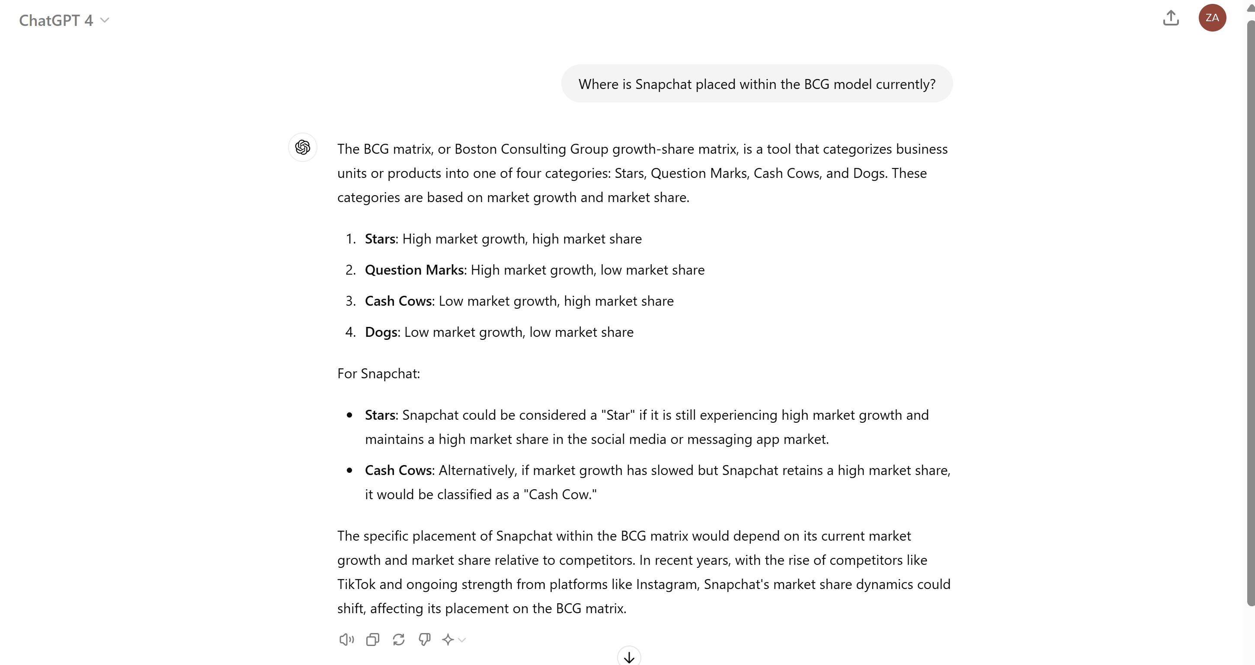

Claude Response

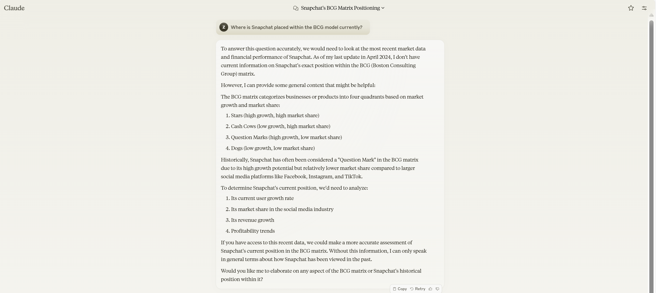

Gemini Response

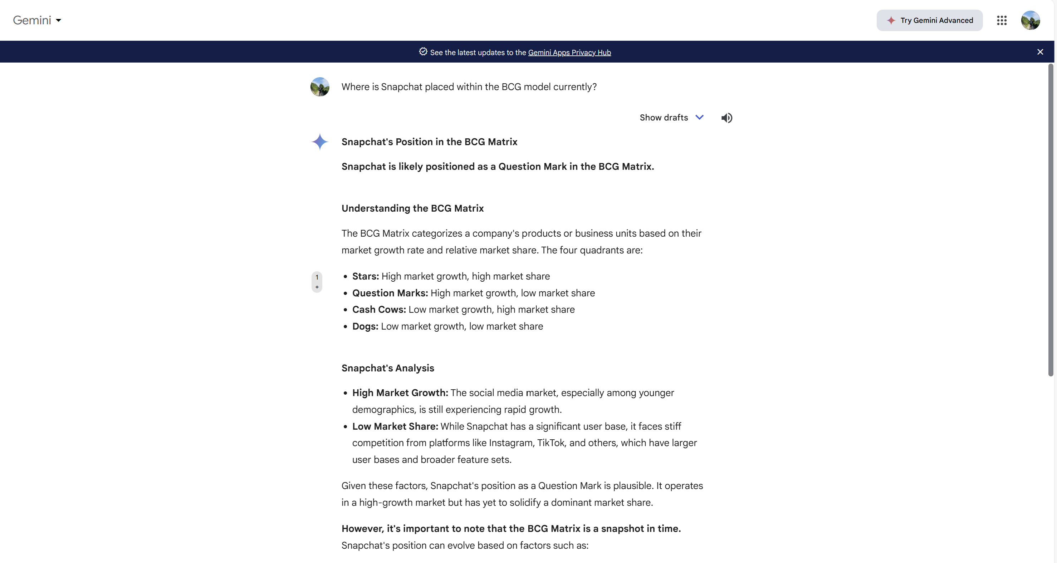

Microsoft Co-pilot

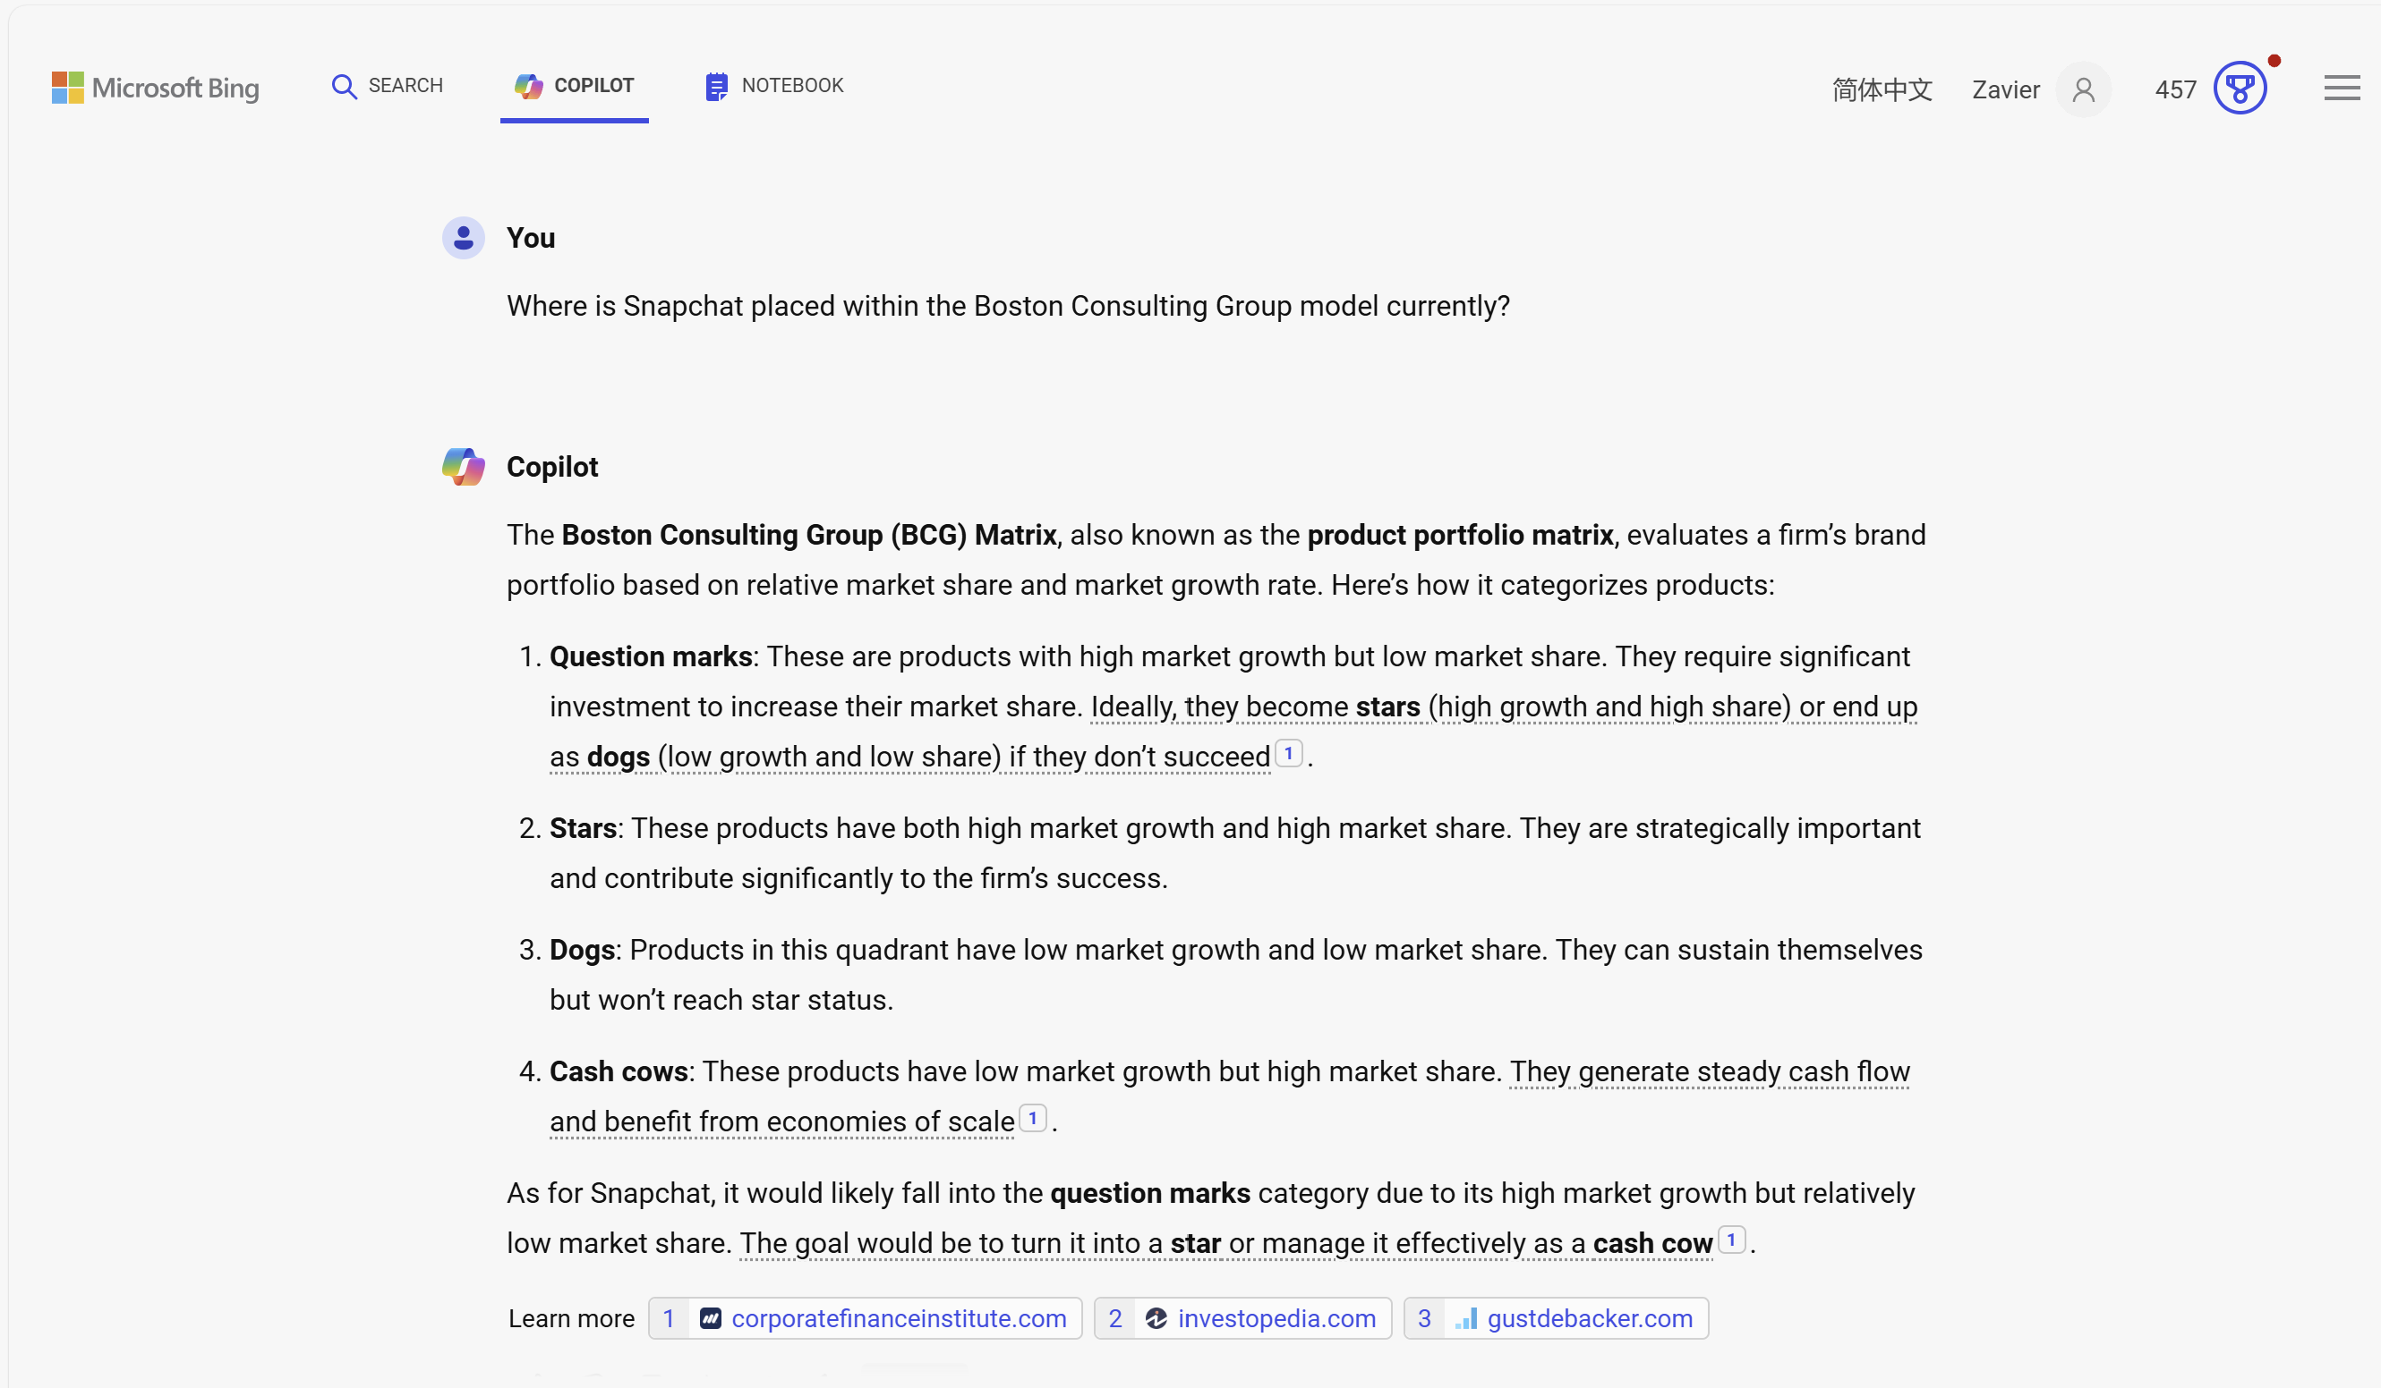

I further prompt the three AI Tools with this second prompt message

**“Provide me the sources where you extracted the information from?”**

ChatGPT response

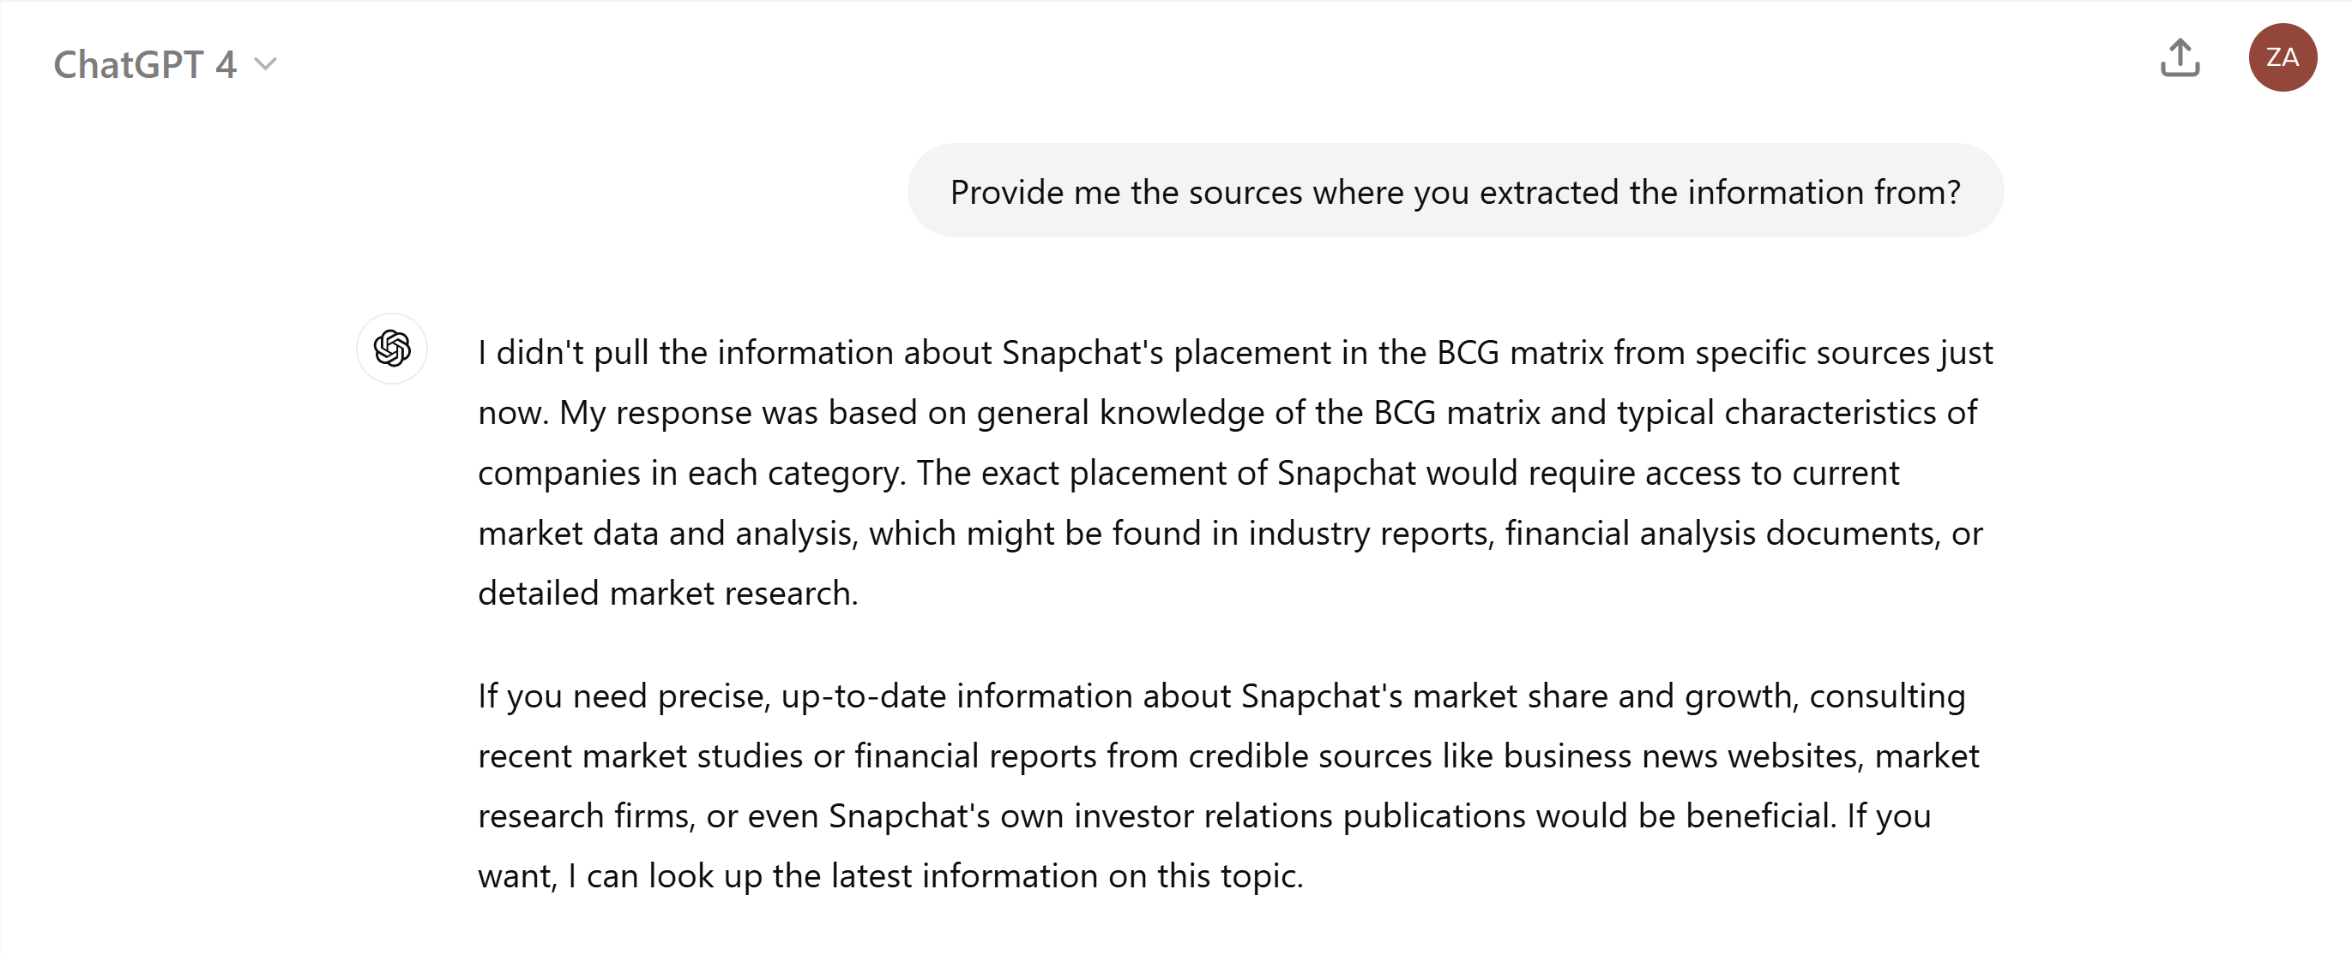

Claude Response

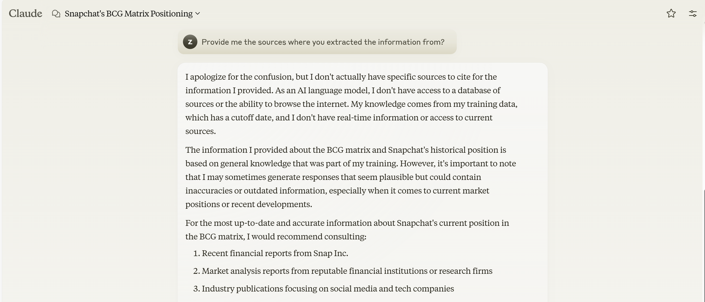

Gemini Response

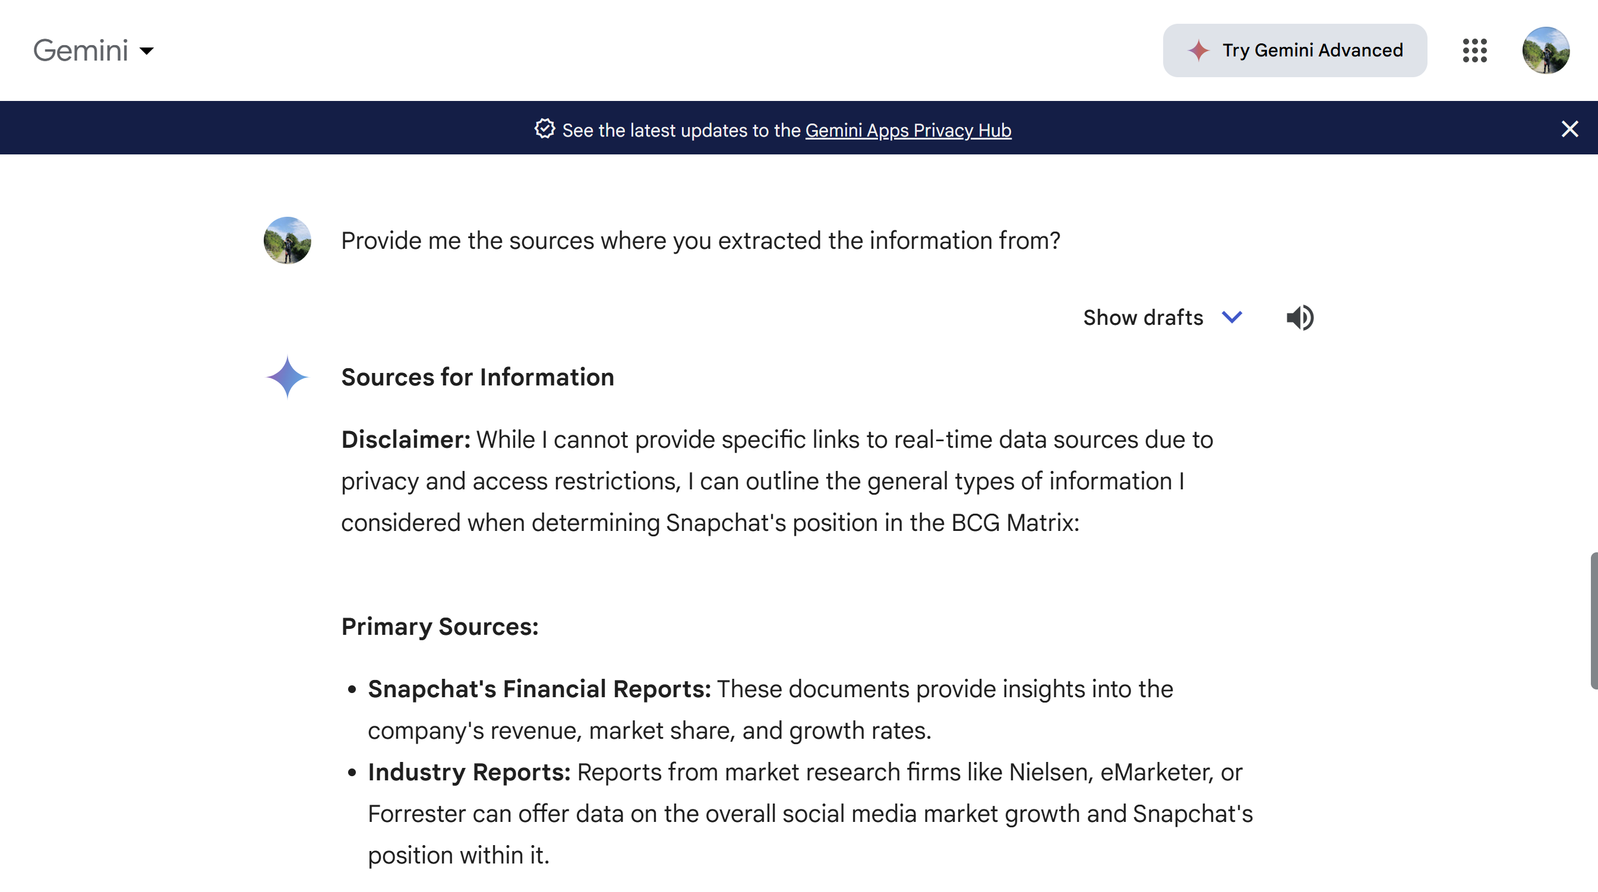

**Final Verdict**

**ChatGPT:** When putting in the first prompt, it was able to provide information related to my question. However, based on my findings and the other outputs produced by Claude and Gemini, the answer ChatGPT provided is by far the furthest away from our conclusion on the placement of Snap Inc. within the BCG model. When putting the second prompt, it was unable to provide me any concrete evidence to back up the information it provided. Hence, human intervention was needed and cross checking with the other 3 AI Tools I have chosen to ascertain if the information was true.

**Claude:** When putting in the first prompt, same as ChatGPT it was able to provide information related to my question. This time round, based on my findings and the output produced by Gemini, the answer Claude gave was like our conclusion on the placement of Snap Inc. within the BCG model. However, when putting the second prompt, it was also unable to provide me any concrete evidence to back up the information it provided. Hence, human intervention was needed and cross checking with the other 3 AI Tools I have chosen to ascertain if the information was true.

**Google Gemini:** When putting in the first prompt, same as ChatGPT and Claude, it was able to provide information related to my question. Similarly, it provided answer like what Claude provided on the placement of Snap Inc within the BCG model. However, when putting the second prompt, it was also unable to provide me any concrete evidence to back up the information it provided. Hence, human intervention was needed and cross checking with the other 3 AI Tools I have chosen to ascertain if the information was true.

**Microsoft Copilot:** When putting the first prompt, same as ChatGPT, Claude and Gemini, it was able to provide information related to my question. Similarly, it provided answer like what Claude and Gemini provided on the placement of Snap Inc within the BCG model. The second prompt was not needed as co-pilot automatically provides the links to where it gets the information from. Hence, slight human intervention is required by just checking to ensure the information is valid, otherwise it performed better than the other 3 AI Tools.

#### **11.4.4.11 Personal Reflection**

Going through the group report, I have learned quite a lot such as expanding my domain knowledge within the Social Media Industry, keeping up with past and present events within the industry and learn the various reasons why certain factors can impact a company of such a big scale like Snap Inc. In addition to that, I have learned more of Snap Inc history and how it has come a long way competing with relatively bigger companies like Meta which owns Facebook and Instagram and Twitter X.

While doing the group report, the use of AI tools was crucial to save time and ensure efficiency. However, we also needed to determine if the information provided by the AI tools were accurate. We made sure the prompts we entered were clear and detailed, such as giving the AI enough context to know what answer we are trying to seek and making sure it provides the source links from where it extracted the information out so human intervention like checking if the information is reliable and accurate.

To share more of my personal experience navigating my way when researching the social media industry and Snap Inc, at times I receive different inputs from the different AI tools used. With some providing information with source links included and some not being able to, some being constantly repetitive or even hallucinating, or some based off on the knowledge it got without any source to link to the facts. There have been a constant mix of responses, making it hard to tell which AI tool is telling the more accurate information.

Firstly, I ask the AI to provide me with the source links to determine where the information comes from. When I am sceptical of the information provided, I do fact check by searching it online to check if any articles can relate or confirm the information. Nonetheless, I do read up on the articles found on various website or news outlet to expand my domain knowledge of the social media industry to ascertain if the information is relevant or inaccurate.

Secondly, using some of the prompt engineering skillsets that I have picked up externally, I gave the AI better context, specific instructions and conditions to narrow the response so that the output when produced is more specific and accurate, one way to ensure the AI is not hallucinating or providing irrelevant/inaccurate information is by iterating the main context and constant memory update, when providing the information, I prompt to provide into the PEEL format (Point, Explanation, Example, Link) to ensure that it is able to clearly explain the information provided, which helps to increase result accuracy and better output performance across the AI tools I used.

All in all, with the techniques used and the constant reminder to me that some AI tools have a knowledge cut-off date. I was able to leverage on the AI Tools and utilize them ethically to provide as much accurate information as possible, as well as intervening using human judgment to determine if it make senses. Therefore, the ability to do self-research by looking up on the internet and the help of AI tools allowed me to provide the best version of the answer.

# **12. Reflection**

## **12.1 Is the marketing strategy adopted appropriate for the industry it is competing in?**

The marketing strategy, differentiation strategy that Snap Inc. adopted is appropriate for the industry it is competing in. By focusing on unique features such as ephemeral messaging and augmented reality, and maintaining a strong appeal among younger users, Snap Inc. has effectively carved out a distinctive niche. This strategy aligns with industry trends towards immersive and interactive content and supports Snap's brand identity as an innovative and playful platform.

## **12.2 Is the marketing mix adopted by the company well suited to its marketing strategy?**

The marketing strategy adopted by Snap Inc. is largely appropriate for the highly competitive and rapidly evolving social media industry. Snapchat's innovative product features, such as augmented reality lenses, ephemeral messaging, and engaging content formats like Stories and Spotlight, allow them to compete against competitors like Instagram and Facebook and foster user engagement and retention. The freemium pricing model attracts a large user base, while the introduction of premium features through Snapchat+ and the use of psychological pricing tactics effectively monetize the platform. Distribution through major app stores ensures broad accessibility and efficient updates, while partnerships with brands and influencers enhance its promotional appeal. Overall, Snapchat's strategy aligns well with industry trends and user expectations, positioning it favourably against competitors.

## **12.3 What is the value proposition to the target market segments? Is this a valid value proposition?**

Snapchat's value proposition is highly effective and well-aligned with its target market segments. The app's innovative features cater to the preferences of young adults, teenagers, and content creators, enhancing user engagement and satisfaction. The freemium model ensures accessibility for teenagers who may not afford the subscription model, thereby expanding Snapchat's reach and fostering a large, engaged user base.

# **13. Recommendations**

## **13.1 Expanding into E-commerce & Digital Services**

Based on the analyses completed, Snap Inc. should leverage its technology to address business challenges and diversify into new digital products beyond social media to improve its competitive position. Given the rise of e-commerce and digital services, Snap Inc. should implement in-app commerce features like TikTok Shop and Instagram Shopping. The e-commerce market is projected to reach USD 4,117 billion in 2024, with an annual compound growth rate (CAGR) of 9.49% from 2024 to 2029, resulting in a projected market volume of USD 6,478 billion by 2029 (Statista, n.d.). This integration can capitalize on the rapidly growing market, enhancing user engagement and creating new monetization opportunities.

Additionally, Snap Inc. should explore offering advanced digital services such as virtual events and experiences, including live streaming concerts, interactive virtual meetups, and webinars. These services would cater to the increasing demand for remote learning and skill development, which surged due to the COVID-19 pandemic and is expected to continue growing (McKinsey & Company, July 20, 2022). By offering educational content, tutorials, and workshops, Snap Inc. can attract a broader user base and establish itself as a platform for continuous learning.

Integrating professional networking features similar to LinkedIn could help users connect with industry peers, find job opportunities, and build professional relationships. This addition would expand Snap Inc.'s target market to include working adults seeking job opportunities, thereby increasing user engagement and retention.

These initiatives will enable Snap Inc. to generate additional revenue streams and diversify its income sources, thereby enhancing its competitive edge in the market. However, it is crucial to balance these new features with the core social and entertainment elements of Snapchat to maintain brand identity and user satisfaction.

## **13.2 Data Privacy & Security**

A strong focus on reinforcing data privacy and security can put Snap Inc. in a very advantageous position versus its competitors. Setting up the end-to-end encryption for all communications, following the policies of minimal data collection and anonymizing the user's data, and ensuring a greater degree of control over user data are the foremost measures. The company, for example, created a central point for all its privacy materials and policies by introducing Privacy and Safety Hub, a user-friendly area. With the said central point, users can now easily read the policy data and opt for privacy or whatever else they want to manage​ Improving privacy settings and affording the users the right to move the data between platforms and easy opt-out options are the means to empower users with better data control.

To fortify its security measures, Snap should encourage the use of two-factor authentication, conduct regular security audits, and develop a robust incident response plan.  The company has already initiated some measures like the dedicated page on its Privacy and Security Hub where the users can find the tips on how they can improve their account security by verifying their email and phone numbers and activating the two-factor authentication​. Informing users about the right way to protect privacy and security while simultaneously embracing knowledge of phishing and scams will further increase the level of trust.

Adhering to the GDPR and the CCPA regulations pair with the company's policy of allowing third-party auditors to audit their data practices. Snap's ad tech partners who are entrusted with the collected advertiser data are held accountable to the agreements Snap has for security and privacy. Finally, making transparency reports public and seeking constant user feedback about their policy and actions related to privacy and security through a dialogue will ensure the users' trust allowing Snap Inc. to comply with the user data protection.

# **14. Summary**

The report includes a Situational Analysis focusing on the industry, company, and portfolio analysis within the social media sector, specifically examining Snap Inc. and its product, Snapchat. The Industry Analysis utilizes Michael Porter’s Five Forces model to evaluate the competitive landscape, followed by an Industry Segmentation that covers demographic, geographic, behavioural, and psychographic aspects, highlighting Snap Inc.’s target audiences and market positioning. It also addresses the Industry Life Cycle, examining the current phase of the social media industry.

The Company Analysis explores Snap Inc.’s Management Orientation, Value Chain Analysis, and SWOT Analysis. In the Portfolio Analysis, Snap Inc. is categorized as a 'Question Mark' due to its low market share but significant growth potential, and its position in the maturity stage of the product life cycle is discussed.

The Marketing Segmentation and Mix section analyses Snap Inc.’s strategies, including product differentiation, pricing models, distribution channels, and promotional strategies, incorporating the development of apps using PartyRock, which serves as an innovative approach to enhance user engagement and expand market reach.

The final section suggests potential actions for Snap Inc. to enhance its competitive position in the social media industry, including diversifying revenue streams, enhancing data security measures, and exploring new technological advancements to stay ahead of competitors.

# **15. Citations & References**

*Data Privacy Day: Learn More About Snap’s New Privacy and Safety Hub & Privacy*

*Settings. (2023, January 26). Snap News.*

*Data Privacy Day: Our ongoing commitment to privacy and account security. Safety and Privacy Hub. (2024, January 26). Snap News.*

*Privacy policy: Snapchat privacy. Safety and Privacy Hub. (2023, August 15). Snap News.*

*Instagram statistics you need to know for 2024 [updated]. (2024, February 29). Sprout Social*

*Data Privacy Day: Our ongoing commitment to privacy and account security. Safety and Privacy Hub. (n.d.-a).*

*Top 20 new social media networks (Jul 2024). (2024, July 1). Exploding Topics.*

*Facebook (meta): Porter’s five forces industry and competition analysis. (2024, February 11) Hivelr.*

*Instagram Porter five forces analysis. (2023, June 22). Team, M. S*

*Which age group uses Snapchat the most? [Jun 2024 update]. (2024, June 12). Oberlo*

*Social media benchmarks by industry in 2024. Sprout Social. (2024, February 7). Gomez, R.*

*Download the 2024 Social Media Industry Benchmark Report. (2024, February 27). Rival IQ.*

*Social media demographics to inform your 2024 strategy. (2024a, February 14). Sprout Social.*

*2024 Social Media Industry Benchmark Report. (2024, February 28). Rival IQ.*

*U.S. leading social media platform users 2023, by income. (n.d.).*

*Social Network Usage & Growth Statistics: How Many people use Social Media in 2024 ? (2024, February 21). Backlinko.*

*Global Social Media Statistics - DataReportal – global digital insights. (n.d.). DataReportal.*

*Global Social Media Statistics Research Summary 2024 [May 2024]. (2024, June 12). Smart Insights.*

*Social media in China versus Western Social Media. (2019, December 26). Digital Marketing Les Roches 上海中国.*

*Who’s on Pinterest in 2024? top 10 Pinterest demographics. (2024, April 16). Social Champ.*

*Instagram user growth (2020–2028) [Jul 2024 update]. (2024, July 9). Oberlo.*

*Introducing Lens Studio 5.0 beta. Build and Share Augmented Reality for Snapchat. (n.d.).*

*The next inflection point: More than 100 million consumers are shopping with ar: Snapchat for business. (n.d.). Snapchat Ads.*

*How does Snapchat work? - the tech behind series - intuji: Creating Tomorrow®. (2024, February 4). Intuji.*

*Inside snap’s approach to Brand Safety: Snapchat for business. (n.d.-a). Snapchat Ads.*

*Wikimedia Foundation. (2024, July 18). Snapchat.*

*Empire success story: Snapchat for business. (n.d.-a). Snapchat Ads.*

*Snapchat partners with Billion Dollar boy, Influencer, and the Goat Agency. (2024, April 29). Mobile Marketing Magazine.*

*Snapchat support. (n.d.).*

*What are the strengths, weaknesses, opportunities and threats of Snap Inc. (SNAP)? SWOT analysis. (n.d.). dcf.*

*Decoding snap inc (SNAP): A strategic swot insight. (n.d.). Yahoo! Finance.*

*Snapchat daily active users 2024 (n.d.). Statista.*

*A developer ecosystem for Snapchat. (n.d.). Snap Engineering.*

*Global: Number of smartphone users 2014-2029. (n.d.-a). statista.*

*How does Snapchat Make Money? dissecting its business model (2024). Hendelmann, V. (2024, July 17). Productmint.*

*Snapchat data breaches: Full timeline through 2023. Reed, C. (2023, October 5). Firewall Times.*

*Smartphone penetration rates 2022. (n.d.-b). statista.*

*Snap revenue 2016-2024: Snap. (n.d.). Macrotrends.*

*Top social media hacking statistics & trends for 2024. (2024, February 7). StationX.*

*Snapchat statistics: Revenue and usage trends in 2024. Sukhanova, K. (2024, May 27). The Tech Report.*

*ECommerce - worldwide: Statista market forecast. (n.d.). Statista.*

*Snapchat daily active users 2024. (n.d.). Statista.*

*Snapchat Marketing Mix (4ps) & marketing strategy. Team, M. S. (2023, November 9).*

*Demand for online education is growing. are providers ready?. Diaz-Infante, N., Lazar, M., Ram, S., & Ray, A. (2022, July 20). McKinsey & Company.*

*Snapchat’s history: Evolution of Snapchat and Timeline (2024). Team, BuyCustomGeofilters. com. (2024, January 4).*

*Snapchat for marketers: Audience stats, ad types, trends, & concerns. Lebow, S. (2024, March 27). EMARKETER.*

*What is Snapchat?. (2023, September 7). YouTube.*

*Snapchat+. (n.d.). Snapchat.*

*Latest snapchat product news: Snap newsroom. (n.d.). Latest Snapchat Product News | Snap Newsroom.*

*Snap launches new privacy and Safety Hub & Privacy Settings on Data Privacy Day. (n.d.). Safety and Privacy Hub.*

*Data Privacy Day: Our ongoing commitment to privacy and account security. (n.d.-a). Safety and Privacy Hub.*

*Zacks. (n.d.). SNAP Introduces New Personalization Features for Snapchat+. Nasdaq. https://www.nasdaq.com/articles/snap-introduces-new-personalization-features-snapchat*